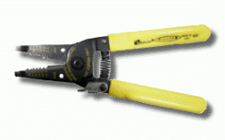
Required Equipment

Jacket Stripper (red handle, holes from .40 to 1.3 mm) used to remove the jacket from the outside of the cable

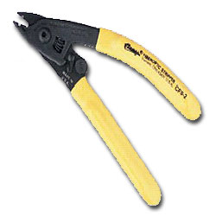

Miller Fiber Stripper (yellow handle, labeled Clauss Fiberoptic Stripper) used to remove the coating from the bare fiber, leaving only the core and cladding

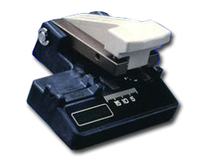

Cleaver (looks like a small stapler) used to break the fiber off cleanly

Cleaning equipment:

Kimwipes

Alcohol bottle

Two cable to splice together, with terminators on one end only.
Safety Rules
Wear glasses or safety glasses
Make sure there is sticky tape on the table to hold fiber shards. DISPOSE OF ALL SHARDS PROPERLY. Don't lose them or drop them on your clothes, etc.
I. Preparing the First Cable
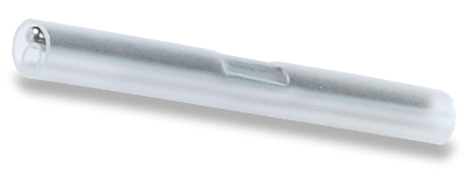
- Strip the jacket off about 5 inches of cable with the Jacket Stripper.
- Slide a splice sleeve (see image to the right) onto the fiber
- Strip the coating off about 2 inches of the fiber with the Miller Fiber Stripper.
- Clean the fiber with a Kimwipe and alcohol, squeeze hard and make it squeak.
- Cleave the fiber with the cleaver. Carefully remove the glass shard and put it on the sticky tape. Be careful not to touch the end of the cleaved fiber to any object – you need to keep it clean.
- Insert the fiber into the fusion splicer.
II. Preparing the Second Cable
- Strip the jacket off about 5 inches of cable with the Jacket Stripper.
- Strip the coating off about 2 inches of the fiber with the Miller Fiber Stripper.
- Clean the fiber with a Kimwipe and alcohol, squeeze hard and make it squeak.
- Cleave the fiber with the cleaver. Carefully remove the glass shard and put it on the sticky tape. Be careful not to touch the end of the cleaved fiber to any object – you need to keep it clean.
- Insert the fiber into the fusion splicer.
III. Fusion Splicing
- Just press the Splice button on the splicer. The process is automatic. Watch its progress on the screen. The splicer will automatically tell you if your splice is good or not.
- When you have a good splice, take it out of the splicer, slide the splice sleeve over it, and put it in the oven to shrink the tubing.
Grading
- When your spliced cable is done, label it with your name and show it to your instructor so your grade can be recorded..

Images from twacomm.com

Last modified 9-8-06

