General Information
Before termination, the cable should be properly secured to provide a tension-free length of fiber. When splicing fibers, mechanical or fusion, a splice tray is needed to properly store the completed splices. If connectors are to be used, trays or shelves should be used to support the fiber behind the connector. Proper strain relief sleeves provided with the connectors should always be used to prevent excessive bending of fiber. No shelf is necessary if terminating a breakout style cable (including Micro-Loose Tube™) with connectors.
It is acceptable to directly terminate the 900 mm tight buffer from a distribution cable with a connector, if the above precautions are taken. It is also acceptable to directly terminate the 250 mm coated fiber from a loose buffer tube with a connector if the termination is in a safe, enclosed box and the fiber is supported immediately behind the connector. However, it is usually recommended to use a breakout kit which converts a six or twelve fiber loose buffer tube to a six or twelve fiber 900 mm distribution style ready for termination.
To prepare the cable for termination, the outer jacket must be properly stripped. Two ring cuts should be made in the jacket; one about 2" from the end and the second at the point where the jacket is to be removed. Care must be taken not to cut all the way through the jacket and into the core. The 2" piece is removed from the end of the cable exposing the core and the aramid ripcord. Make a notch in the jacket alongside the ripcord (do not cut the ripcord!). Pull the ripcord with a needle-nose pliers, or similar, until it reaches the second ring cut. Remove the core from the sliced jacket and pull the jacket to tear it at the ring cut.
Outside plant cables will need to be cleaned with a solvent to remove the gel flooding material. The more thorough the cleaning, the easier the termination procedure will be.

From http://www.mohawk-cdt.com/tech/instguides-fiber.html
Safety Rules
Wear glasses or safety glasses when cutting and stripping cable
Wear gloves when using the box knife – the blade is hooked and sharp!
I. Getting a Long Cable
We have several large reels of cable. Unreel long cables, at least 200 meters long and longer if practical. Use the marks on the jacket to determine the length. Coil it up, leaving 2-3 yards free at each end, and put it on top of the workbench's central platform out of the way.
II. Removing the Jacket and Buffer Tubes
See instructions on next 3 pages to strip about 6 feet of jacket and buffer cable from each end of the cable.
From http://www.berktek.com/technical/Jacket_Removal_Procedure_for_Outside_Plant.pdf or Link 4s on my Web page (samsclass.info, CNIT 211 / ELEC 211)
III. Mounting the Cable Ends in Two Patch Panels
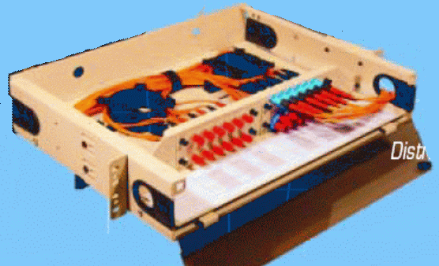
Mount each end in a patch panel, as shown in the figure below. Leave the excess looped neatly on the top of the workbench, out of the way. Attach the aramid yarn to the U-shaped washer as shown in the diagram on the next page for strain relief, and wrap the excess buffer tube length neatly in the patch panel. Use Velcro ties and/or cable ties as needed to make a neat, strong mount.

IV. Attaching Breakout Kits
If you are using outside-plant loose-buffer cable (black jacket), attach a breakout kit to each end of the cable as explained in the instructions in the kit. If you are using the yellow indoor distribution cable, no breakout kit is required.
IV. Terminating the Cable Ends With SC Connectors
Terminate the fibers you are using with either epoxy-polish or by fusion splicing pigtails onto them. Get two fibers connected to the patch panel, and the same two attached at the other end. According to the TIA/EIA-598 Color Code, the first buffer tube is the Blue one, and the first two fibers in it are the Blue and Orange ones, so if possible, connect those two.
Grading
When your patch panel is done, show it to your instructor so your grade can be recorded.

Last modified 9-21-06

