Names: _________________________________ Score: ________
_________________________________
_________________________________
_________________________________

Required Equipment

Two cables

Multimode (62.5 or 50 micron, any connectors, any length)

9 micron single mode (yellow)

A Sharpie black marker

Visual Fault Locator

I: Visual Inspection of modes

Shine the red light through the multimode cable, and onto a piece of white paper. Sketch the pattern of light you see below. Repeat for the singlemode cable (you will need to turn the room lights off, or go to a dark room)

Multimode Singlemode

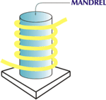
II: Mandrel Wrap

Then wrap the singlemode cable five times around the Sharpie (black marker) to form a Mandrel wrap, as shown to the right on this page. You should see some of the red light leaking out of the cable through the yellow jacket.

Sketch the pattern of light you see below.

Multimode Singlemode

