Starting the ANDO OTDR
- To turn the unit on, look on the right side. Just above the power connector there is a square white lid covering the floppy drive. Open that lid and find the power knob, which is a flat plastic wheel about ½ inch in diameter. Rotate the wheel clockwise to turn on the power. The green POWER light should light on the front panel. The same wheel controls the brightness of the screen. Turn it until the screen is easy to read.

Setting the ANDO OTDR to the ONE BUTTON Condition
- At the top of the screen, there are five labels like this:

MODE | TRACE | FILE | SPECIAL | SETUP

- These are the Modes. To select the Mode, press the blue MODE button at the top right of the OTDR face. The selected mode is highlighted with a blue background color. Press the MODE button until the TRACE mode is highlighted.
MARKER | F1
LABEL | F1
CONDITIONS | F3
MULTI  TRACE | F4
AUTO  SEARCH | F5
- On the right side of the screen, there are five squares, and five gray buttons next to them, as shown to the right:
- Press the F3 button to set the CONDITIONS.

- The words AUTO SETUP appear in white letters on a blue background, with one of these four "conditions" below it: OFF, AUTO RANGE, AUTO ATT, or ONE BUTTON, as shown to the right on this page.
AUTO SETUP
ONE BUTTON
- Press the blue triangular ENTER key on the OTDR front panel. The words AUTO SETUP are no longer highlighted, but the "condition" below AUTO SETUP remains highlighted. You can now adjust the condition by rotating the white wheel in the upper right hand corner of the OTDR front panel, just like you would rotate a wheel to tune in a radio. Rotate the wheel until you see the ONE BUTTON condition, and then press the ENTER button.

Cleaning and Connecting the Cable
- Clean the connector before inserting it into the OTDR! It is not easy to clean the OTDR port if it gets dirty.
- Insert the clean SC connector to your cable into the port at the top right of the OTDR. Connect the other end of the patch cord to your Patch Panel. Connect the whole Lab LAN together for its maximum length, so the signal goes through all three long links, and back through them all. It should be about 2 km long.

Measuring a Trace in REALTIME Mode
- Press the gray REALTIME button. For a few seconds, messages appear at the top of the screen saying things like Now doing autorange process…
- If it says your optical connection is bad, remove the cable, clean it, and re-insert it.
- When it accepts your cable, it will show an OTDR trace on the screen that refreshes several times a second.
- Your trace should look like the example below, except that your total length will be shorter – around 2 km. You should see spikes at each patch panel.
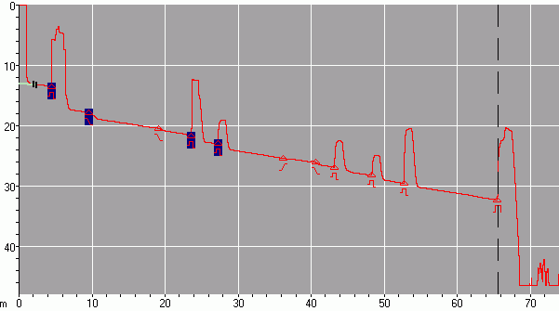
Start of cable
Connection Points
End of cable
Good Trace of
66 km CCSF Loop

- A bad trace will just fade to noise within 0.5 km, indicating that the launch cable is incorrectly connected. If your trace is like that, clean and re-connect the cables. If you want to over-ride the error condition, press the REALTIME button again.

Measuring a Trace in AVERAGING Mode
- Press the gray AVERAGING START/STOP button. Wait while the red progress bar moves across the screen – it takes about 10 seconds. When the averaging process is finishes, the trace vanishes and you see a screen full of labels and numbers, with a green-highlighted line showing one or more EVENTs.
- The OTDR has the ability to analyze the trace and find the end of the cable, and events like splices and connector pairs, but we don't want to do that on the OTDR – all we want to do is to save the trace so we can analyze it later on a computer.
- Press the red ESC key to make the trace visible again. It should look a lot smoother than the REALTIME trace did.

Saving a Trace on a Floppy Disk
- Insert a floppy disk into the right side of the OTDR.
- Press the blue MODE button to highlight the word FILE in the top row.
- Press the gray F2 button to SAVE. The OTDR reads the files on the floppy.
- When a screen opens saying SAVE FILE: LABEL in the upper left, press the gray F1 button to set the LABEL.
- Press the blue triangular ENTER key. A box appears on the OTDR screen showing all the letters of the alphabet, which can be used to enter text without a keyboard. But we will just use a normal keyboard. Type in your name and a short description of what you measured, like YourNameLabLAN. When you are done, press the F4 key on the keyboard. You cannot use spaces.
- Your name should now appear on the screen in the COMMENT section. Press the red rectangular ESC button.
- In the third line from the top of the screen, you should now see this line:
SAVE FILE: LABEL: YourNameLabLAN
- Turn the rotary knob until the FILE TYPE is highlighted. Press the blue triangular ENTER button.
- Turn the rotary knob until you see .SOR(Bellcore). Press the blue triangular ENTER button.
- Turn the rotary knob until an unused file name is selected, such as
001.SOR Unused File
- Write down the file name of your trace! Since we cannot give the traces long, descriptive names, it will be hard to tell your files apart.
- When an unused name is highlighted, press the gray F5 button to save the file. You should see the floppy drive's green light come on as the file is saved.

Collecting a Trace from the a Shorter Network
- Disconnect one of the patch cords to shorten the network. Repeat the process to collect and save a trace of the longer network.

Turning in Your Traces via Email
- Remove the floppy disk and take it to a computer. Copy the files onto the computer, and erase them from the floppy to make room for the next student.
- Email both files as attachments to a single email. Send them to cnit.211@gmail.com. Send a Cc: to yourself. Use a subject of CNIT 211 Proj 9 from Your Name.

Last modified 9-29-08

