Goal:
The goal is to get a good trace of the CCSF fiber loop, which is about 60 km long.

Starting the EXFO OTDR
- Turn it on with the button on the lower right of the front panel
- The screen dims a lot, just press the button several times to make it brighten again.
- The starting screen shows the module we have installed:

FTB-7300D-23B-EI-EIUL This is the OTDR.

Collecting a Trace
- On the bottom of the screen, there are three buttons:
Advanced OTDR Automatic OTDR Create Ref./Template
- Touch the Automatic OTDR button on the screen with the blue stylus. Don't use the tip of a pen because that will mark up the screen.
- Touch the square Start button in the lower right of the screen.
- An old trace is shown. Ignore it and connect the fiber to the CCSF network at the wall-mounted patch panel.
- In the Wavelength section, notice that both 1310 nm and 1550 nm are selected with X signs. That’s OK – we will use both wavelengths.
- Make sure the three dials: Distance (km), Pulse, and Time (s) are all set to Auto.
- Press the green Start button in the top right. If a box appears saying “Data Unsaved”, click No. While the trace runs. You will see a yellow warning box saying Warning! Laser is ON in the lower right of the screen. It will take 30 seconds for each wavelength.
- When the trace is collected, you will see a trace on the screen. Compare it to the figures on the next page.
- A good trace will show a spike at 0 km and a gradual slope going out to 66 km or so, with spikes in between at each patch panel.
- A bad trace will just fade to noise within 0.5 km, indicating that the launch cable is incorrectly connected.
Example OTDR Traces
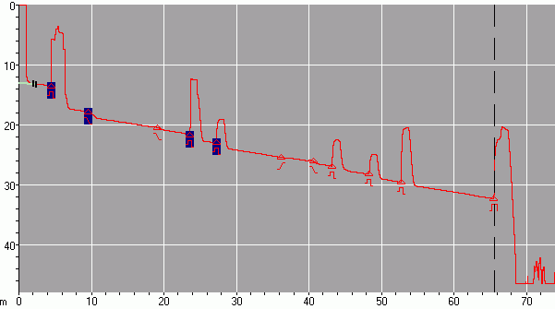
Start of cable
Connection Points
End of cable
Good Trace of
66 km CCSF Loop

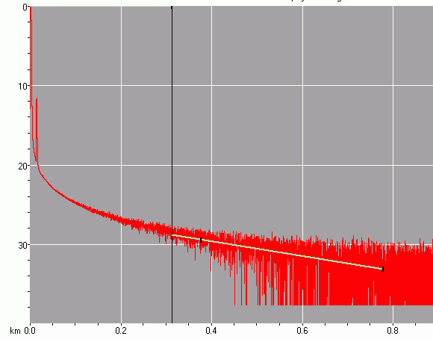
Bad Trace:
Launch Cable Improperly Attached

Savng the Trace
- Press the Quick Save button on the upper right part of the screen.
- Click in the File name: box to make an on-screen keyboard appear. Give your trace a file name with your first name in it, and an indication of what you were testing, like YourName CCSF Loop. Click the OK button on the lower left of the screen.
- Make sure the little box at the lower left of the Save file window says Bellcore – otherwise the file will be saved in a proprietary EXFO format that we cannot use later on the computer.
- Make sure a USB flash drive is inserted into the OTDR. Click the Location button. Click the Removable Disk folder. Click the Traces folder. Click OK.
- In the Save file window, click OK. Watch for the green blinking light on the USB flash drive. If the light does not blink, you saved the file into the OTDR instead of on the flash drive – repeat the saving process.
- Click the red X button in the lower right.

Turning in Your Traces via Email
- Email your file to me, as an attachment. Send it to cnit.211@gmail.com. Send a Cc: to yourself. Use a subject of CNIT 211 Proj 9 from Your Name.

Last modified 10-20-06

