Starting the ANDO OTDR
- To turn the unit on, look on the right side. Just above the power connector there is a square white lid covering the floppy drive. Open that lid and find the power knob, which is a flat plastic wheel about ½ inch in diameter. Rotate the wheel clockwise to turn on the power. The green POWER light should light on the front panel. The same wheel controls the brightness of the screen. Turn it until the screen is easy to read.

Setting the ANDO OTDR to the ONE BUTTON Condition
- At the top of the screen, there are five labels like this:

MODE | TRACE | FILE | SPECIAL | SETUP

- These are the Modes. To select the Mode, press the blue MODE button at the top right of the OTDR face. The selected mode is highlighted with a blue background color. Press the MODE button until the TRACE mode is highlighted.
MARKER | F1
LABEL | F1
CONDITIONS | F3
MULTI  TRACE | F4
AUTO  SEARCH | F5
- On the right side of the screen, there are five squares, and five gray buttons next to them, as shown to the right:
- Press the F3 button to set the CONDITIONS.

- The words AUTO SETUP appear in white letters on a blue background, with one of these four "conditions" below it: OFF, AUTO RANGE, AUTO ATT, or ONE BUTTON, as shown to the right on this page.
AUTO SETUP
ONE BUTTON
- Press the blue triangular ENTER key on the OTDR front panel. The words AUTO SETUP are no longer highlighted, but the "condition" below AUTO SETUP remains highlighted. You can now adjust the condition by rotating the white wheel in the upper right hand corner of the OTDR front panel, just like you would rotate a wheel to tune in a radio. Rotate the wheel until you see the ONE BUTTON condition, and then press the ENTER button.

Cleaning and Connecting the Cable
- Clean the connector before inserting it into the OTDR! It is not easy to clean the OTDR port if it gets dirty.
- Insert the clean SC connector to your cable into the port at the top right of the OTDR. Connect the other end of the patch cord to your Patch Panel. Connect the whole Lab LAN together for its maximum length, so the signal goes through all three long links, and back through them all. It should be about 2 km long.

Measuring a Trace in REALTIME Mode
- Press the gray REALTIME button. For a few seconds, messages appear at the top of the screen saying things like Now doing autorange process…
- If it says your optical connection is bad, remove the cable, clean it, and re-insert it.
- When it accepts your cable, it will show an OTDR trace on the screen that refreshes several times a second.

Measuring a Trace in AVERAGING Mode
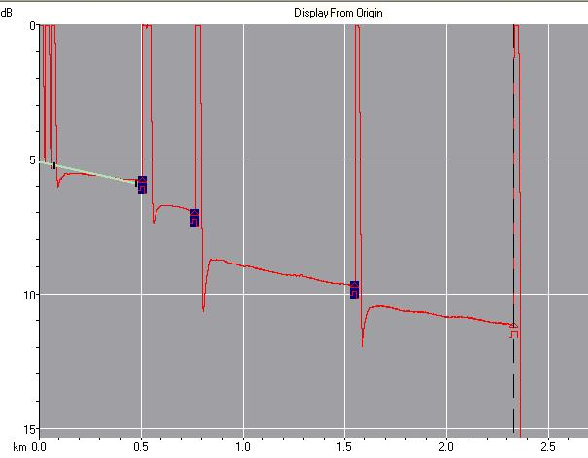
- Press the gray AVERAGING START/STOP button. . When the averaging process is finishes, the trace vanishes and you see a screen full of labels and numbers.
- Press the red ESC key to make the trace visible again. It should look like the example shown to the right on this page.

Sketching Your Trace
- Use a blank piece of paper and sketch your trace. Draw it large enough so you can label the distances.

Measuring Distances on the OTDR Screen
- Refer to the next page of these instructions, which is from the OTDR’ s manual, titled 2.5 Measuring the distance. By rotating the wheel you can measure the distance to each feature in the trace. Label the four major reflective events with the distances.

Get Your Instructor to Break the Network
- Ask your instructor or a lab assistant to break the network. Measure another trace. Figure out how far down the network the break is, and write the distance down. Show your result to your instructor to get points for this project.

Last modified 11-1-06

