Name: _________________________________ Score: ________
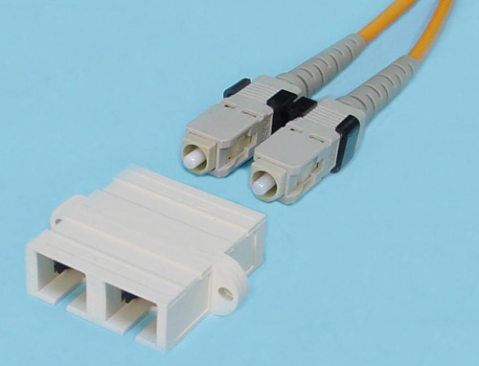
Required Equipment

Visual Fault Locator

Microscope

Connector cleaning equipment:

Kimwipes

Alcohol bottle

Connector Cleaner (white tape in blue plastic dispenser)

Power meter, including source and detector, with adapters and lead cords as needed for SC connectors

Three cables to test, labeled A, B, and C, all SC-to-SC

A duplex SC to SC adapter as shown in the photo above

A Sharpie black marker (to wrap cable around)

I: Visual Fault Locator

Use the VFL to shine red light through cable A. Observe that the light shines brightly out the other end. Use one side of a duplex SC to SC adapter to connect cable C to cable A. Observe that the light shines brightly out the end.

Can you see any light lost through the adapter connecting cables A and C? (write answer below)

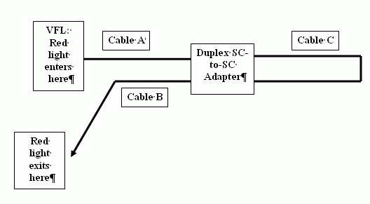
________________________

Connect the free end of cable C into the other portion of duplex SC to SC adapter. Connect cable B to the network as shown to the right. The light should travel into cable A, then into cable C, then into cable B. Observe that the light shines brightly out the end.

Can you see any light lost through the adapter connecting cables C and B? (write answer below)

________________________

II: Visual Inspection With Microscope

Use the microscope to inspect one end of each of the cables. Sketch what you see below. Decide if these cables are singlemode (SM) or multimode (MM).

Cable A Cable B

SM or MM (circle one) SM or MM (circle one)

III: Power Meter Measurement

Use the power meter to measure the dB loss through each cable, at both 850 and 1300 nm. Record your results below.

Cable A Cable B

850 nm: 850 nm:

1300 nm: 1300 nm:

IV: Mandrel Wrap

Connect cable A to the power source and meter at 850 nm so you see the loss you recorded in section III again. Then wrap the cable five times around the Sharpie (black marker) to form a Mandrel wrap. How much additional loss does the Mandrel Wrap cause? Record your results below for both 850 and 1300 nm.

Cable A

850 nm:

1300 nm:

