Name: _________________________________ Score: ________

Examine the labeled cable samples and write down the cable letters by the correct descriptions below.

__________ 4-Fiber Armored Cable

__________ 216-Fiber Ribbon Cable

__________ Zipcord Cable

__________ 36-Fiber Loose-tube Cable

__________ 12-Fiber Laser-Optimized Distribution Cable

__________ 12-Fiber 62.5/125 Multimode Distribution Cable

__________ Simplex Cable

__________ 6-Fiber Gel-Filled Cable

Which of these cables are Distribution Cables? _________________________
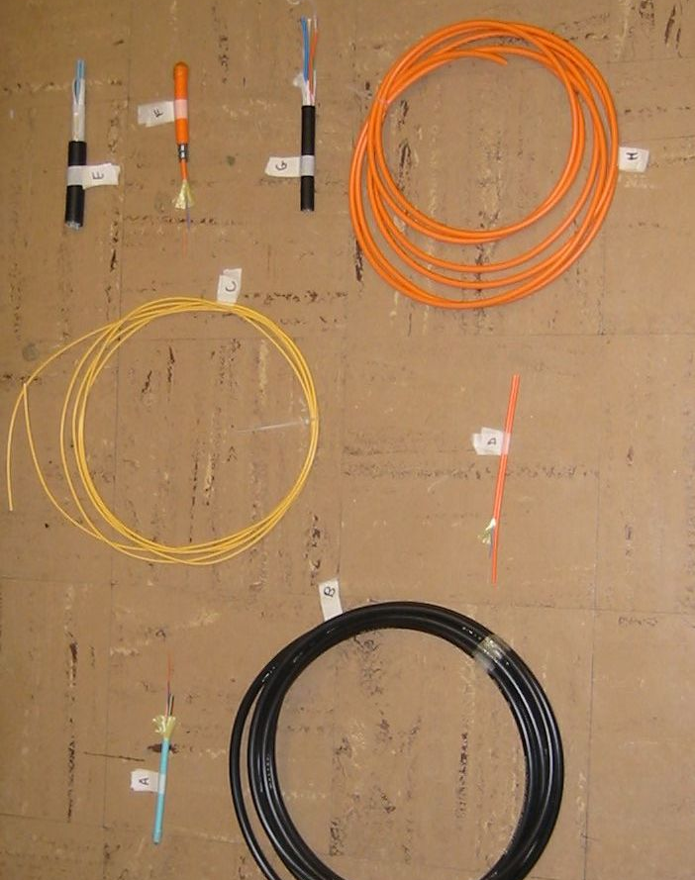
H
G
F
E
D
C
B

