Office Core Applications

Office contains these applications:

Microsoft Word word processor

Microsoft Excel spreadsheet

Microsoft PowerPoint presentation software

Microsoft Outlook e-mail, calendar and contacts

Microsoft Access database

Stand-alone Programs

These are purchased separately, but are part of the Office family

Microsoft Visio making diagrams

Microsoft FrontPage designing Web sites

Microsoft Publisher desktop publishing

Microsoft Project project management

Old Office Versions

Office 95

Office 97

Office 2000

Office XP

Office 2003 Editions

Microsoft Office Professional Enterprise Edition 2003

Microsoft Office Professional Edition 2003

Microsoft Office Standard Edition 2003

Microsoft Office Small Business Edition 2003

Microsoft Office Basic Edition 2003

Microsoft Office Student and Teacher Edition 2003

Stand-alone Applications

See link Office 1a on my Web page

Office Categories

Retail Editions

available online and in stores

Preinstalled Editions

for computer manufacturers

Volume-License Editions

For companies that will make many installations with the same product key

Academic-License Editions

For schools

Installing Office

Manual installation

User types in responses to on-screen prompts

Automated installation

Using an installation script

Upgrade

From a previous version of Office

All these can work from a CD, or from a network share

Manual installation

User types in responses to on-screen prompts

Automated installation

Using an installation script

Upgrade

From a previous version of Office

All these can work from a CD, or from a network share

Automated Deployment of Office

Group Policy

The method we used in Science 214

Microsoft Systems Management Server (SMS)

A Microsoft product that can be purchased and added to networks to manage software in Windows networks

See link Office 1b

Installation Types

Typical

requires 331 MB

Complete

requires 577 MB

Minimal

requires 251 MB

Custom

You choose

Unless you use the Complete install, you may need the CD later

Office Activation

You can launch office 50 times before you must activate it

Activation sends product key to Microsoft by Internet or telephone

Prevents multiple installations from a single-user CD

Office Integration with Applications

XML

eXtensible Markup Language

Lets applications share data much more easily

Demonstrate with Word

See link Office 1c

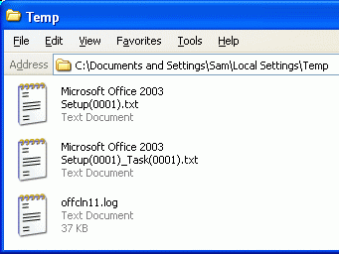
OLE DB

Used to connect to databases

Windows SharePoint Services

Helps people collaborate on a team project

Installation Log Files

These are in the Temp folder of the user profile you were logged in during the install

Office Professional Edition 2003 Setup(000x).txt

Office Professional Edition 2003 Setup(000x)_Task(000x).txt

MSI*.log

Offcln11.log

if you uninstalled Office 2003 previously

Office Updates

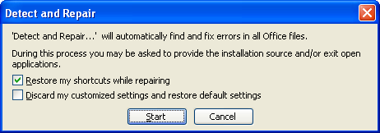
They are important, just like Windows Updates

Go to office.update.com (Link Office 1f)

Click on “Check for Updates”

Repairing Office Applications

Office uses the Microsoft Windows Installer (see Link Office 1g)

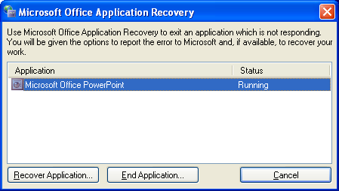
Therefore Office is self-repairing

If Office detects a missing registry key or file, it just automatically repairs itself

In Add or Remove Programs, select Microsoft Office, Change, Reinstall or Repair

Detect and Repair

On the Help Menu of any Office 2003 program, click “Detect and Repair”

You can choose to retain your customizations or to reset them to the defaults

Recovering Office Application Files

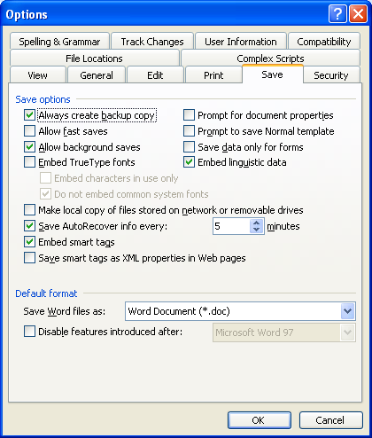
If Office hangs or crashes, you can recover your documents

Click Start, All Programs, Microsoft Office, Microsoft Office Tools, Microsoft Office Application Recovery

Use the Recover Application button to save your data

End Application will not save data

AutoRecover

In Word, click Tools, Options

By default, AutoRecover files are saved every 5 minutes in Microsoft Word

Just restart the application to see the AutoRecover files

This was introduced in Office XP and intended to recover from power outages

Outlook

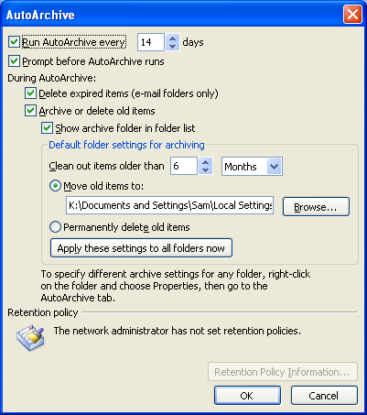
The Microsoft Office e-mail, contact, and schedule program that replaces Outlook Express

Outlook Archiving

Outlook archives your mail, unlike Outlook Express

Tools, Options, Other tab, AutoArchive

Archive Folders appear in the Folders bar

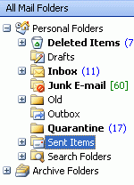

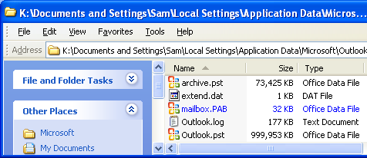

Outlook Data – PST Files

Stored in your profile, in

Local Settings\Application Data\Microsoft\Outlook

The location cannot be moved, unless you are using Exchange (an E-mail server)

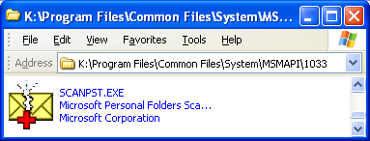

Outlook Inbox Repair Tool

Scanpst.exe installs automatically during setup into this directory (usually):

C:\Program Files\Common Files\System\MSMAPI\1033

Last modified 12-8-04

