Chapter 1: What's New in Windows XP

Windows XP Versions

Windows XP Home

Basic Networking, Low Security

Windows XP Professional

Includes everything in Windows XP Home Edition

Plus features for corporate network users and power users

Media Center Edition, Tablet PC Edition, and 64-Bit Edition

Built on Windows XP Professional

Designed for use with specific hardware devices

Windows XP with Service Pack 2

Bug fixes and updated drivers

Security enhancements, including Windows

Internet Explorer now blocks pop-up windows and some downloads.

Wireless network wizard

Windows Update runs automatically by default

New Features in Windows XP

Simple File Sharing is a completely new security model that controls access to

Shared resources on networks.

Fast User Switching

Remote Desktop feature (Professional edition only)

The System Restore and Driver Rollback

Security in Windows XP

Windows XP users will face viruses and worms

The security enhancements in Service Pack 2 help, but do not really solve this problem

Think about security all the time; it will be a large part of your job

Windows XP Home Edition

Budget-priced version

Pre-installed on home and small business PCs

Cannot connect to corporate networks (domains)

Minimal security options

Only allows a single CPU and a single video display.

Windows XP Professional

Includes everything in Home Edition

All the networking and security components required to join a Windows domain run by Windows 2000 Server or Windows Server 2003

Allows high-performance hardware, such as a dual-processor motherboard

Windows XP Tablet PC Edition 2005

Sold only with Tablet PCs

Notebook computers with custom screens you write on with a digital pen

Includes all capabilities of Windows XP Professional

Windows XP Media Center Edition 2004

Sold only with special hardware

Supports TV, movies, and music

Windows XP 64-Bit Edition

For 64-bit processors such as Intel’s Itanium

Not popular yet

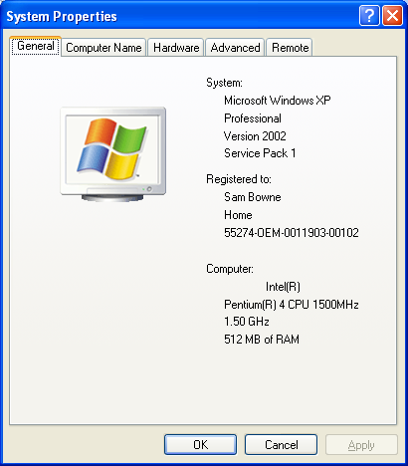
To See Your Version

System Properties

Start, Control Panel, System or

Windows Logo + Break

Service Pack 1

Released in Fall 2002

Program updates, bug fixes, security patches, and drivers

Support for USB 2, the latest version of Universal Serial Bus

Set Program Access And Defaults option in Add Or Remove Programs

Before SP1, Microsoft components often opened by default even after you installed components from another company

Service Pack 2

Released in summer 2004

Includes SP1, new bug fixes, more drivers

Security Center

Windows Firewall

Automatic Updates

Internet Explorer enhancements

Wireless Networking

Movies

Link Ch1b on my Web Page (samsclass.info)
Chapter 2: Installing and Configuring Windows XP

Avoiding Compatibility Problems

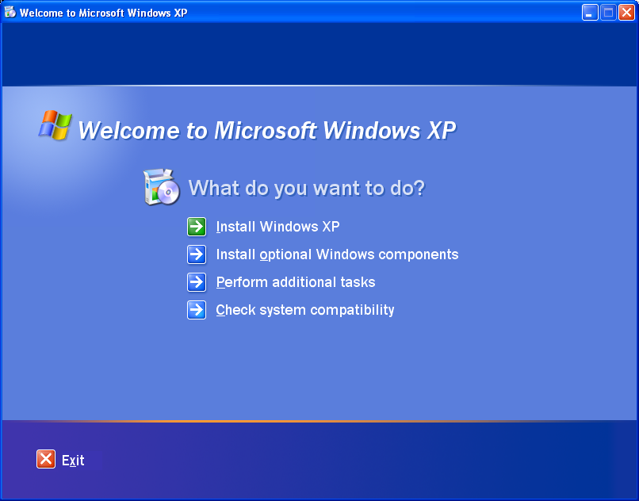
Old programs written for Windows 95, Windows 98, or Windows Me may not run properly under Windows XP

Old hardware may not have XP drivers

Windows XP Upgrade Advisor

Choose it after inserting the Windows XP CD, or

d:\i386\winnt32-checkupgradeonly

at a command prompt.

Check System Compatibility (shown to right)

Dynamic Updates

When you upgrade over an existing Windows version, Setup offers to check for dynamic updates.

That loads service packs, updated drivers for hardware detected on your system, and upgrade packs for programs you’re currently running

Use it – it's a good feature

Windows 2000 Pro and Windows XP

Applications that use Windows 2000 Pro should work with Windows XP

Applications written for Windows 98 or Windows ME are more likely to cause problems

The Windows Catalog (http://www.microsoft.com/windows/catalog) is regularly updated, and it includes links to additional information and updated drivers.

Preparing to Install Windows XP

Hardware Requirements (bare minimum)

233 MHz processor from the

Intel Pentium/Celeron family or the AMD K6/Athlon/Duron family

64 MB of RAM (128 recommended)

1.5 GB of available disk space

Video adapter capable of Super VGA (800 × 600) resolution

Gather network details

IP address and subnet mask

The name of your workgroup or domain

Check hardware and software compatibility

Back up your data files and system setting

Disable antivirus software and other system utilities

Three installation Strategies

Clean install

Erase a partition and install XP on it

Stable and simple, the most common method

Upgrade Paths

You can upgrade to Windows XP Home Edition or Professional from Windows 98 or Windows Me

You can also upgrade to Windows XP Professional from Windows NT Workstation 4 (Service Pack 6), Windows 2000 Professional, or Windows XP Home Edition

See link Ch 2a on my Web page: samsclass.info

Upgrading preserves installed software and settings, but often creates an unstable system

After the upgrade:

Reset passwords for migrated user accounts

Run the Network Setup Wizard

Check that all essential programs and devices work properly

Consider upgrading your system drive to NTFS

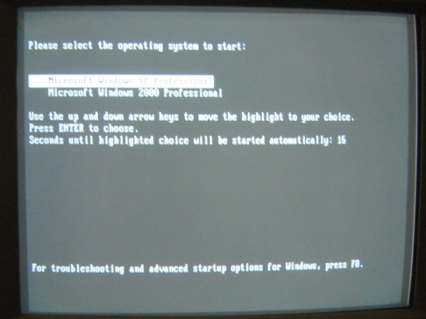
Save your Administrator password

Side-by-side (multiboot) installation

Install Windows XP on a separate partition

Choose the OS each time you start up Install the OS versions in chronological order

BIOS Upgrades

If, during setup, some peripherals don’t work properly:

Update your system BIOS

To find out whether an update is available, check with the manufacturer of your computer or its motherboard

For BIOS info, see link Ch 2s

Use the BIOS setup program to select the “non–Plug and Play operating system” option

Four Steps of a Clean Install

1. File copy

Puts Windows Setup files to a folder on hard disk (not performed for CD installations)

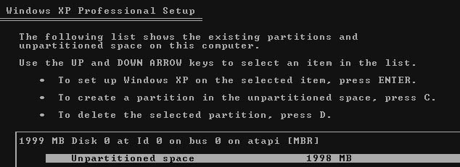
2. Text mode setup

Select (and if necessary, create and format) the partition you want to use for the Windows XP system files.

3. GUI mode setup

Regional settings, product key, computer name, and administrator password.

4. Windows Welcome

Create user accounts and activate Windows

Performing a Clean Install

Boot from the Windows XP CD

If your system doesn’t allow booting from a CD, download the Windows XP setup disk file from www.microsoft.com/downloads and use it to create a set of bootable floppy disks or

Start your computer from a Windows 98/Me emergency boot disk; then use the CD or installation files copied to another partition

Location of Windows XP System Files

On a clean install, C:\Windows (or the other drive you chose)

On an upgrade, Setup uses the current %WinDir% — C:\Winnt or C:\Windows

Partitions

On most machines, the whole C drive is one big partition with Windows XP, applications, and the user's data sharing it

It's a good practice to put Windows and applications on one partition and the user's data on a second one

For multiboot systems like the ones in S214, there are separate partitions for each operating system

Installation Logs

Setuperr.log in the %SystemRoot% folder (normally C:\Windows)

Lists any errors and warnings that occurred during setup

For more information, run Winnt32.exe with the /Debug switch

There are several other logs (see page 25)

Avoiding Dual-Boot Disasters

Do not install two or more versions of Windows on a single partition, because

The two systems share the same registry

Executable files and dynamic link libraries for are different for Win 95/98/Me and Win NT/2000/XP

A program won’t work properly in at least one Windows version

Program preferences, options, and settings you’ve chosen in one operating system don’t show up when you use the other operating system

If you uninstall an application, it will still appear in the other OS, but it won't work

Command-Line Setup Switches for Winnt32.exe

/checkupgradeonly

Runs the Upgrade Advisor without installing Windows XP

/cmdcons

Adds the Recovery Console to the Windows XP startup menu

/udf:ID[,UDB_file]

Identifies a Uniqueness Database (UDB) file for Automated Installation

/unattend[:answer_file]

Used for unattended Setup

Windows Product Activation (WPA)

Within 30 days of installing Windows XP, you must activate the software

by Internet or phone

Activation is not registration

The activation process is completely anonymous

A message will pop up reminding you to activate, or you can click Start, All Programs, Accessories, System Tools, Activate Windows

Windows Product Activation (WPA)

You’re allowed to reinstall Windows an unlimited number of times on the same hardware.

Multiple hardware upgrades may require you to reactivate Windows

Copies of Windows XP sold with new computers may be exempt from WPA

Volume License Installations are also exempt from WPA requirements

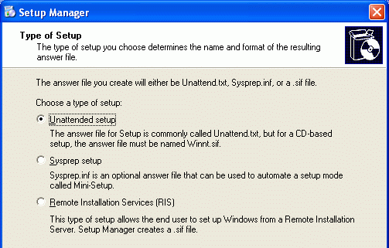
Automated Setup Options

Unattended setup

Uses a batch file and a script (called an answer file)

Disk imaging (also called cloning or sysprep setup)

Set up Windows on a sample computer

Run the System Preparation utility (Sysprep.exe), which removes the Security identifier (SID)

Then use a disk cloning program such as Symantec Ghost to copy the entire partition to a new computer

When it starts up, it runs a Mini-Setup program

Remote Installation Services (RIS)

Automatically installs Windows XP from Windows 2000 Servers or Windows 2003 Servers

Requires Active Directory, DNS, and DHCP, which are only commonly used on large company networks

Deployment Tools

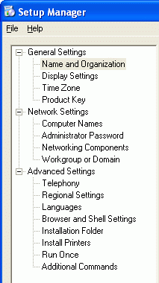
In the \Support\Tools\Deploy.cab file on the Windows XP CD

Setupmgr.exe

Setup Manager Wizard used for creating answer files

Sysprep.exe

Used for creating and deploying disk images (don't run it on a computer that is being used)

Demonstration of Setup Manager

Slipstreaming Service Packs

Your Windows XP CD probably does not include the latest Service Packs

Slipstreaming lets you incorporate a service pack into the installation file so new installations made from the modified files include the service pack

Moving Windows Settings and Files

If you upgrade to Windows XP

Your data and programs should survive Setup intact

If you do a clean install, or get a new computer, you can move your settings with FAST or USMT

Moving Windows Settings and Files

Files And Settings Transfer Wizard (FAST)

Moves one user account at a time

Start, All Programs, Accessories, System Tools

User State Migration Tool (USMT)

Can only be used on domain, can move many accounts

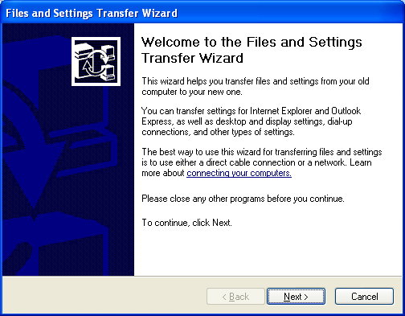
See link Ch 2m

File and Settings Transfer Wizard (FAST)

Moves the data using either

A direct connection with a cable between two computers

By saving your settings to a file

Saves:

Desktop settings,

Internet settings

E-mail

Application settings

Files and folders

Accessibility Options

Helpful for persons with vision, hearing, or mobility impairments.

Start, All Programs, Accessories, Accessibility

Magnifier

Enlarges part of the screen

Narrator

Reads text aloud

On-Screen Keyboard

Lets you type with a pointing device

Java Virtual Machine

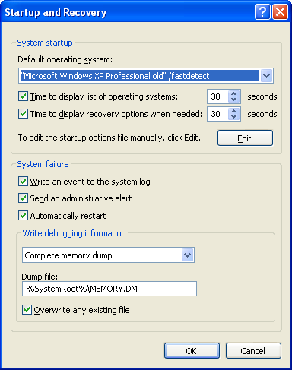
Allows Java applets to run in a browser

Java applets are used on many Web sites

Because of a longstanding legal dispute between Microsoft and Sun, the Microsoft Java Virtual Machine was removed from Windows XP Service Pack 1a and later

The best thing is to get the machine from Sun

See links Ch 2t, Ch 2u, and Ch 2v on my Web page

Customizing Multiboot Menus

Start, right-click My Computer, Properties, Advanced

In the Startup And Recovery section, click Settings

Or edit Boot.ini directly (be careful – errors can stop your machine from booting up)

Modifying Boot.ini

Because this file is set with the hidden and system attributes, it doesn’t ordinarily appear in Windows Explorer; to edit it, use either of these techniques:

Start, Run, enter c:\boot.ini.

Open System in Control Panel, click the Advanced tab, click the Settings button under Startup And Recovery, and click the Edit button in the System Startup section.

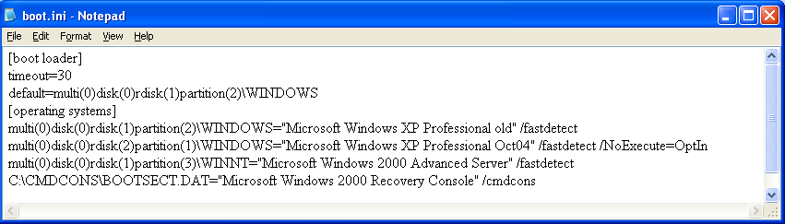

Overview of the Startup Process

POST

Power-On Self Test

MBR

BIOS then reads the master boot record (MBR)—the first sector on the first hard disk—and transfers control to the code in the MBR

Boot Sector

The MBR reads the boot sector—the first sector of the system partition—which starts Ntldr, the bootstrap loader for Windows XP

System Partition

Must contain Ntldr, Ntdetect.com and Boot.ini. Ntldr reads the Boot.ini file, and displays the boot menu.

Error in the book on page 73: these files are in the system partition, not the active partition. See link Ch 2v on my Web page

Ntdetect.com

After you select Windows XP from the boot menu, Ntldr runs Ntdetect.com to gather information about the currently installed hardware.

Boot.ini

Ntldr then uses the Advanced RISC Computing (ARC) path specified in Boot.ini to find the boot partition—the one where Windows XP is installed.

Kernel

The Windows XP kernel is in two files: Ntoskrnl.exe and Hal.dll. Both files must be located in the %SystemRoot%\System32 folder (in the boot partition)

Registry

Ntldr then loads the registry, hardware profile, and device drivers.

Log On

Ntoskrnl.exe takes over and starts Winlogon.exe, which in turn starts Lsass.exe (Local Security Administration), the program that allows you to log on with your user name and password.

Adding the Recovery Console

The Recovery Console is a no-frills command-line environment that you can use to recover from serious startup problems. It looks like DOS.

You can run the Recovery Console by booting directly from the Windows XP CD, or add it as a startup option on your boot menu.

To add Recovery Console as a startup option on your boot menu.

Insert the Windows XP CD into your drive.

At a command prompt, type d:\i386\winnt32.exe /cmdcons (replacing d with the letter of your CD drive)

This does not work on machines that were upgraded to Service Pack 2

See Link Ch 2w on my Web page
