Chapter 10 - Tuning Up System Performance

Home Edition

All of the tools described in this chapter are available in both editions of Microsoft Windows XP

Msconfig.exe is also available in both editions

Group Policy console (Gpedit.msc) is not included with Windows XP Home Edition, however.

Reality Check

Nothing speeds up a sluggish system like a healthy dose of extra RAM.

Swap File Confusion

Virtual memory uses disk space to simulate physical RAM, allowing a Windows user to work beyond the limits of installed RAM

Swap File Myths

With 1 GB or more RAM, you should eliminate the swap file

Windows XP wasn't designed to run without a swap file

Creating a swap file of a fixed size improves performance

This was true on 1990s-vintage hardware, but not any more

Registry tweaks can speed up virtual memory

This has some truth for 1 GB of RAM or more

Prefetch Pros and Cons

The Prefetch folder contains a record of all the files loaded and, more importantly, the order in which to load pages (4-KB segments of data and code)

This speeds up the boot process

Don't turn it off

Detecting Common Performance Bottlenecks

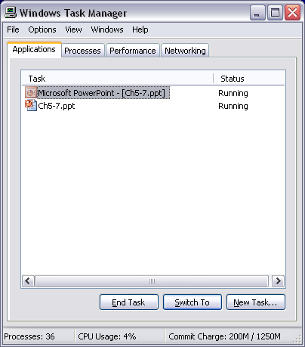
Windows Task Manager

Continuously updated display of key internal resources

Shows applications and processes, with memory and CPU each process is using

Match programs with processes

A process is any program code that runs in its own address space

Generally, the entry in the Processes list corresponds to the name of an executable program

Right-click the program name on the Applications tab of Windows Task Manager and then choose Go To Process

Ctrl+Alt+Del

If you’re using the Welcome screen to log on to Windows, open Windows Task Manager with Ctrl+Alt+Delete

If you’re not using the Welcome screen or you’re joined to a Windows domain, press Ctrl+Alt+Delete and then click the Task Manager button in the Windows Security dialog box

You can always go directly to Task Manager by pressing Ctrl+Shift+Esc

Task Manager

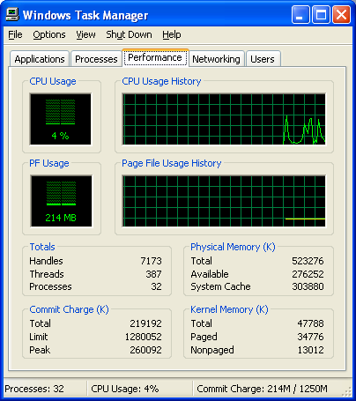
Applications, Processes, and Performance tabs are always present

Networking tab is visible if the computer has a network adapter

Users tab is shown only if Fast User Switching is enabled

Double-click in the Task Manager window for a stripped-down interface

Task Manager – Status bar

Status bar at the bottom of the window displays

Number of processes currently running

Percentage of your CPU in use

Current memory usage (Commit Charge)

Task Manager -- Performance tab

CPU Usage and PF Usage graphs show % CPU and Page File

PF Usage is misleading – it shows total amount ever reserved, not amount in current use

Monitoring Memory Usage

Most common bottleneck – out of RAM, forcing Windows to use paging

Blocks of program code and data files are moved out of memory and onto disk

Commit Charge in Task Manager, lists two numbers

The first number (the numerator) is your current total commit charge —the total amount of physical and virtual memory in use by all running processes

The denominator represents your total available memory, physical and virtual

Task Manager Performance Data: Totals

Handles

Unique identifiers that allow a program to access system resources such as files, registry keys, fonts, and bitmaps

Threads

An object within a process that runs program instructions

Processes

Programs, subsystems, and services running for all users of the local computer

Task Manager Performance Data: Commit Charge (K)

Total

Total amount of physical and virtual memory currently in use

Limit

Total amount of physical and virtual memory available for use

Peak

The highest amount of memory that has been in use during the current session

If this value regularly approaches the Limit value, your system might need more memory

Task Manager Performance Data: Physical Memory (K)

Total

Total physical RAM

Available

Physical RAM that Windows will make available to programs before swapping data to virtual memory

System Cache

Physical RAM used to store recently accessed programs and data

Task Manager Performance Data: Kernel Memory (K)

Total

RAM used by core components of the operating system, including device drivers

Paged

Memory used by Windows core components and mapped to pages in virtual memory.

Nonpaged

Amount of operating system and driver code that must be run in physical memory and cannot be paged to virtual memory

Detecting a Low RAM Bottleneck

When Total Commit Charge is higher than Total Physical Memory, the result is excessive paging—and reduced performance.

Adding RAM is very often a way to improve performance

Avoiding CPU Overload

Processes tab

Shows how much processor time each process is consuming

Keep an eye on your CPU

Open Windows Task Manager

From the Options menu, choose Hide When Minimized

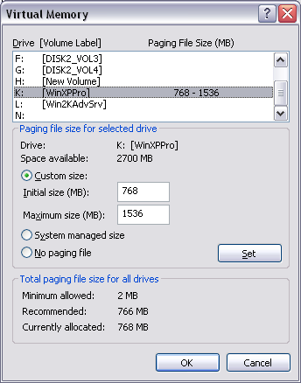
Making the Most of Virtual Memory

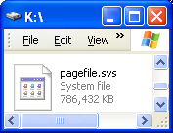
Page File

A hidden file on your hard disk used to swap data out of physical memory when necessary

Also called the paging file (named pagefilesys)

For best performance, put the page file on a different physical disk than the system disk

But, if there is no page file on the system disk, the system cannot save a memory dump if it crashes (see link Ch 7a)

To adjust the Page File

Control Panel, Performance and Maintenance, System

On the Advanced tab, click the Settings button in the Performance section

In Performance Options, on Advanced Tab, click Change button at bottom

Managing Programs

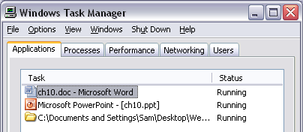
Windows Task Manager’s Applications tab lists all running programs with Status column

Running or Not Responding

For each process, Windows Task Manager includes the following information by default

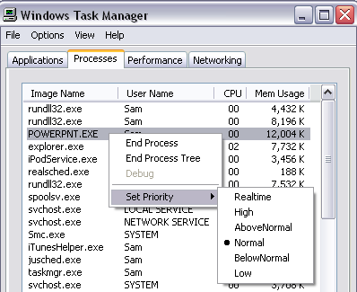
Image Name (the name of the process), User Name (which user started the process), CPU, Mem Usage

End Task button on the Applications tab is a normal shutdown

End Process button on the Processes tab zaps a process immediately and irrevocably

Giving Programs an Extra Dose of CPU

You can change the base priority of any process by selecting the name of the process, right-clicking, and choosing Set Priority

Or use command-line START command

This does not work in S214 because of our special processors

Processor Affinity

On a dual-CPU system running Windows XP Professional

You can assign a process that is normally shared by both processors to a single processor by right-clicking its entry in the Processes list and choosing Set Affinity from the shortcut menu

You cannot do this on a single-processor computer

But you can do it in S214 because our processors act like dual processors

Configuring Programs That Run Automatically

Many programs auto-launch at startup, consuming resources

Some programs, such as antivirus utilities, need to start up automatically

You should set the others not to load until you need them

"Hide Inactive Icons" makes it less obvious that your Notification Area has a lot of icons

Ways to Make a Program Run at Startup

Items in these folders start when a user logs on

Startup folder (User) %UserProfile%\Start Menu\Programs\Startup

Startup folder (Common) %AllUsersProfile%\Start Menu\Programs\Startup

Registry Run keys and other keys

Scheduled Tasks folders

Win.ini in %SystemRoot%, a legacy of the Windows 3.1 era

Group Policy Run These Programs at User Logon

Logon scripts specified in Group Policy

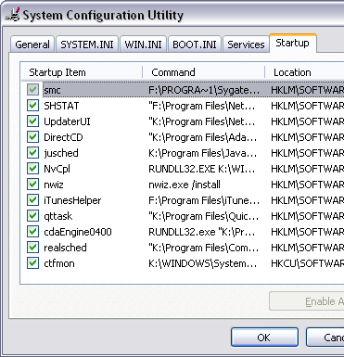
Configuring Programs That Run Automatically

Windows XP includes a System Configuration Utility

Msconfig.exe

Shows all programs that are running at startup.

To start it, Start, Run, msconfig

Does not recognize startup applications specified in Group Policy

To stop a program from starting up automatically, clear the check box next to its entry

Third-party utilities to control startup programs are also available, such as Startup Control Panel and Startup Cop

You can also manage Services here

Don’t make permanent changes in Msconfig – test things, then stop them from starting elsewhere

Starting Msconfig With Elevated Privileges

Click Start, Run,

runas /user:Administrator %systemroot%\PCHEALTH\HELPCTR\Binaries\msconfig.exe

Advanced System Performance Measurement

Using the Performance Console

Open Administrative Tools in Control Panel, double-click the Performance icon

Or type perfmon.msc at a command prompt

Two Parts of Performance Monitor

System Monitor

Provides information about your system's current state and recent history.
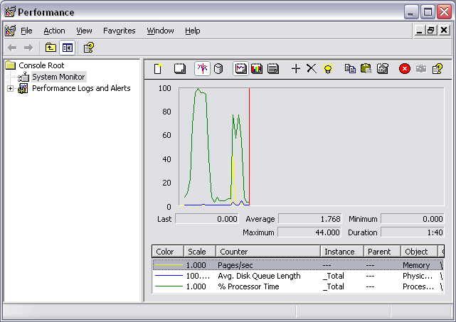

Performance Logs And Alerts

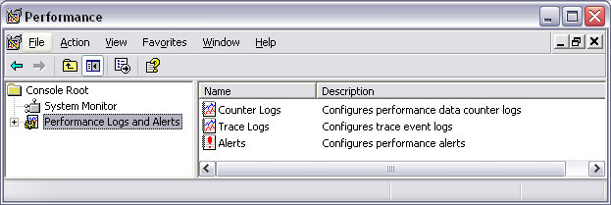
Lets you track your system over longer periods of time, recording data in disk files for subsequent analysis

Object and Counter

Each line in Performance Monitor represents an Object and a Counter

Typical objects on most computers include

Processor, memory, page file, and physical and logical disks

Counter

This tracks information about an object

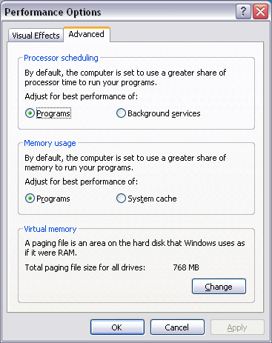
For the Processor object, for example, the available counters include % Interrupt Time, % Processor Time, Interrupts/sec, and others.

Performance Options

Right-click My Computer, Properties

On the Advanced tab, click the Settings button in the Performance section

Click the Advanced tab

Processor Scheduling and Memory Usage

Processor Scheduling

Programs gives more CPU to the foreground application

Background doesn’t

Memory Usage

Programs uses more RAM for programs

System Cache option reserves more RAM for the cache

Useful if you use extremely data-intensive applications, such as video editing programs or large databases

