Chapter 11 - Tweaking the Windows XP Interface

Home Edition

This all works the same in Home and Pro (except the Group Policy things, which are not available in Home Edition)

A Road Map to the Windows XP User Interface

Basic Terms: Start Button, Taskbar, Notification Area, Desktop Icon, Desktop

By default, the taskbar doesn’t include the Quick Launch toolbar or any other toolbar

Many Ways to Start a Program

Start menu.

Quick Launch toolbar

Double-click the program’s icon on the desktop or in another folder

Press the shortcut key assigned to a program shortcut

Type the name of the program’s executable file in any of these locations:

In the Run dialog box (choose Start, Run or press the Windows logo key+R)

In the Address bar in Windows Explorer (include the file’s path)

In the Address toolbar (right-click taskbar to turn on Address toolbar)

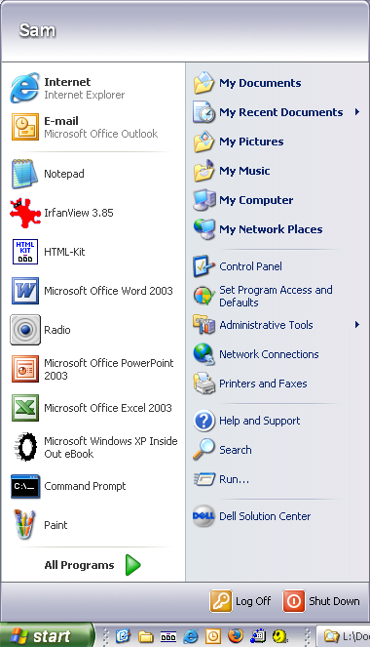
Setting the Appearance of the Start Menu

Classic v. Default Start Menu

Right-click the Start button and select Properties

To get small icons,

Default Start menu

Click Customize and then, on the General tab of the Customize Start Menu dialog box, select Small Icons

Classic Start menu

Click Customize and then, in the Customize Classic Start Menu dialog box, select Show Small Icons In Start Menu

Programs on the Default Start Menu

Pinned items list

At top of left column

You choose these -- Right-click, Pin to Start Menu, or drag

Most frequently used programs list

Windows chooses these

All Programs button

To sort a single submenu

Default Start Menu

Click the Start button and then release the mouse button

Move the mouse pointer to the submenu you want to sort

Right-click an item on the submenu and choose Sort By Name from the shortcut menu

To sort a single submenu

Classic Start Menu

Right-click the Start button and choose Properties

On the Start Menu tab, click Customize

In the Customize Classic Start Menu dialog box shown, click Sort

Managing the Most Frequently Used Programs List

To specify the number of programs that appear on the most frequently used programs list

Right-click the Start button, choose Properties, and click Customize

On the General tab of the Customize Start Menu dialog box, enter the value you want

Using Personalized Menus

Only in the classic Start menu

Windows displays the menu items you use most frequently and hides the others

To enable or disable personalized menus, follow these steps:

Right-click the Start button and choose Properties

On the Start Menu tab, click Customize

In the Advanced Start Menu Options list in the Customize Classic Start Menu dialog box, select or clear the Use Personalized Menus check box

Scrolling the Programs menu

Classic Start Menu

Select Scroll Programs in the Advanced Start Menu Options box

Default Start Menu

Right-click the Start button, choose Properties, and click Customize. In the Customize Start Menu dialog box, click the Advanced tab and then select Scroll Programs in the Start Menu Items box

Using the Quick Launch Bar and Other Desktop Toolbars

Address: Internet address or the name and path of a program, document, or folder

Links: Internet addresses

Desktop

Creating a New Toolbar

Any folder on your system can become a toolbar.

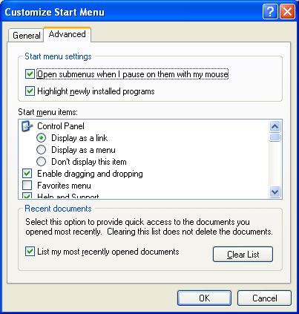
Right-click an existing toolbar or a spot on the taskbar, choose Toolbars, and then choose New Toolbar

Or, create a toolbar by dragging a folder to the edge of the desktop

Working with Recently Opened Documents

The Start menu contains an item called My Recent Documents

Windows keeps shortcuts to all recently used documents in the %UserProfile%\Recent folder

Displays only the most recent 15 on the My Recent Documents menu

To clear the whole menu

Right-click the Start button, Properties, Customize, Advanced tab, Clear List

Customizing the Start Menu

Right-click the Start button and choose Properties to open Taskbar And Start Menu Properties

Click Customize and then click the Advanced tab. Make your selections in the Start Menu Items box

Displaying Web Content on Your Desktop

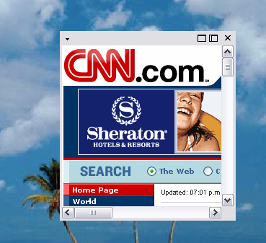
Right-click desktop, Properties, Desktop tab, Customize Desktop

On Web tab, click New

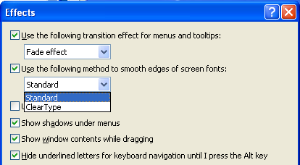

Themes and ClearType

Open Display Properties

ClearType

Display Properties, Appearance, Effects

Commands to Open Control Panel Items (p. 420-423)

Folder Options control folders

Network Connections control netconnections

Firewall control firewall.cpl

Opening Control Panel Items With Elevated Privileges

Firewall runas /user:administrator "control firewall.cpl"

BUT this does not work

Network Connections runas /user:administrator "control netconnections"

That's because network connections uses explorer, and explorer.exe cannot be started with elevated privileges without stopping the existing instance of explorer.

But if you set up this command in a command prompt, then open Task Manager, end the existing explorer process, and execute the runas command, a whole series of interesting processes go by in Task Manager. The final effect is a lot like using Fast User Switching.

