Chapter 12 - Advanced Internet Explorer Options

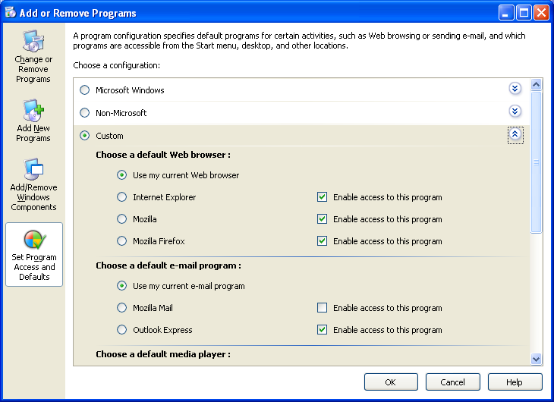
Home Edition

This all works the same in Home and Pro (except the Group Policy things, which are not available in Home Edition)

Default Web Browser

Uninstalling Internet Explorer in Add/Remove Programs does not really remove it.

It just removes its icons and Start menu shortcuts

But a better option is to use Set program Access and Defaults in Add or Remove Programs (in Control Panel)

Customizing the Internet Explorer Menu and Toolbars

Three optional toolbars

Standard Buttons Toolbar

Links Toolbar

Address Toolbar

To display a toolbar that isn’t currently displayed, choose View, Toolbars

tip - Press F11 for full-screen display

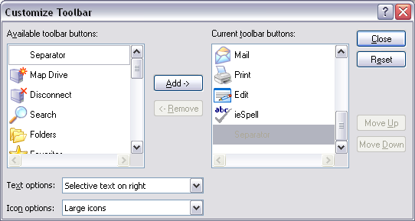
Tailoring the Standard Buttons Toolbar

View, Toolbars, Customize

To add a button, drag it from the Available Toolbar Buttons window

To remove an item, select it in the right window and click Remove.

Customizing the Links Toolbar

To remove an item from the Links toolbar, right-click it and choose Delete

To add an item, drag the Internet Explorer icon at the left edge of the Address bar and drop it on the Links toolbar

Configuring Internet Explorer to Work with Other Programs

Internet Explorer maintains connections with six programs:

An HTML editor

An e-mail client

A newsgroup reader

An Internet conferencing program

A calendar program

A contact manager

To configure: Tools, Internet Options, Programs

Managing Your Favorites

In the folder %UserProfile%\Favorites

Adding an Item to Your Favorites List

Choose Favorites, Add To Favorites.

Use your wheel mouse to change text size

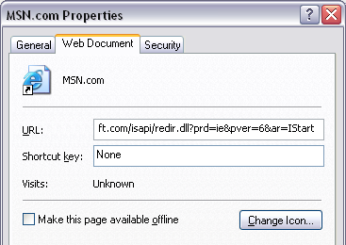
View, Text Size,

Hold down Ctrl while you roll the wheel

tip - Open Internet shortcuts in new windows

Tools,Internet Options, Advanced tab

In the Browsing section of the Settings list, clear the Reuse Windows For Launching Shortcuts option

Making a Favorite Available Offline

Select Make This Page Available Offline on the Web Document tab of the favorite's Properties

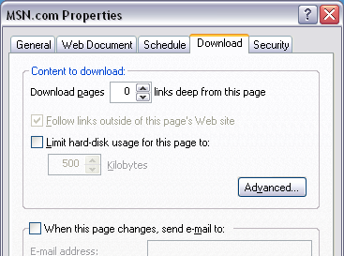
Internet Explorer downloads a copy of the page to your Temporary Internet Files and updates that page at periodic intervals

Close the favorite’s Properties and open it again to see the Schedule and Download tabs

Download pages

Limit hard-disk usage for this page to

When this page changes, send e-mail to

Organizing Favorites

Favorites, Organize Favorites

Add subfolders to your Favorites tree, move items between folders, rename folders and shortcuts, and delete favorites or folders.

Importing, Exporting, and Sharing Your Favorites

File, Import And Export
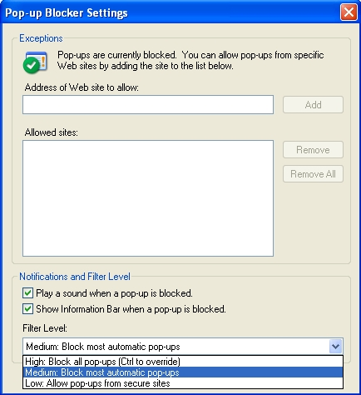

Blocking Pop-Ups

This is a new feature in Service Pack 2

By default, it blocks pop-ups from the Internet and Restricted zones

To allow a pop-up, hold down Ctrl key while you click

Setting the Filter Level

Tools, Pop-up Blocker, Pop-up Blocker Settings

Managing Cookies

A cookie is a small text file that enables a Web site to personalize its offerings in some way

Cookies are in %UserProfile%\Cookies

Cookies are used recording logon information, shopping preferences, pages at a site that you have visited, searches that you have performed, etc.

Privacy Concerns

Cookies can provide Web sites with personal information about you

A cookie can provide a Web site only with information that you supply while visiting the

This information can be read only by the site that created the cookie

BUT: Third-party cookies cheat and get around this rule (See link Ch 12a – very good explanation)

Cookie Management

In previous versions of Internet Explorer, cookie management options were limited to:

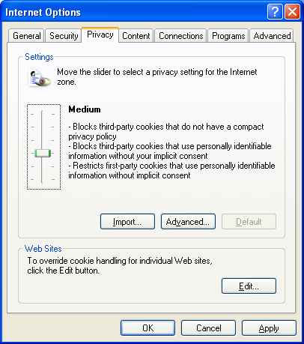
Allowing all cookies

Blocking all cookies

Being prompted every time a site wanted to read or write a cookie

In practice, the second and third of these options created so much inconvenience that most users gave up and accepted all cookies

Platform for Privacy Preferences P3P

Internet Explorer 6 supports the Platform for Privacy Preferences (P3P) standard

You can now choose to block certain kinds of cookies, while allowing the rest

Cookie Privacy Settings

Tools, Internet Options, Privacy tab

Block All Cookies

High

Medium High

Medium

Low

Accept All Cookies

The default setting is Medium.

Viewing a Site's Privacy Report

When Internet Explorer blocks a cookie, it displays an "eye" icon on your status bar

To find out what cookie was blocked and why, double-click this icon to see

Privacy Report Privacy Policy
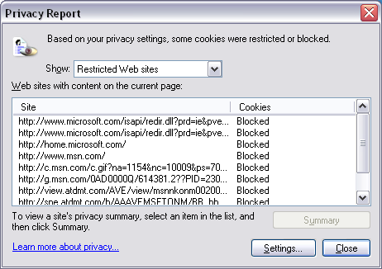
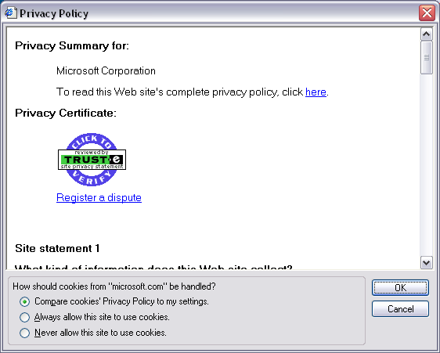

Click on a site in Privacy Report, click Settings to see Privacy Policy

Always Allow This Site To Use Cookies

Never Allow This Site To Use Cookies

Searching

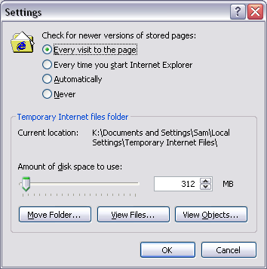
Search button in IE brings up Rover, the Search dog

Default engine is MSN

Automatically send your search to other search engines offers others, including Google

Managing the Web Cache

When you browse sites on the Internet, Internet Explorer stores copies of everything you download (including HTML pages and graphics) in a Temporary Internet Files folder

This cache of recently visited sites enables Internet Explorer to redisplay pages more quickly

Controlling How Internet Explorer Uses the Cache

Tools, Internet Options, General tab, Settings button

Every Visit To The Page

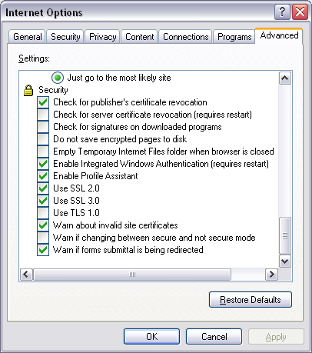
Every Time You Start Internet Explorer

Automatically

Never

Changing the Size of the Cache

Temporary Internet Files are stored by default in the hidden system folder %UserProfile%\Local Settings\Temporary Internet Files

By default, Internet Explorer
reserves a maximum of about
3 percent of the space on your
system disk for the Web
cache – too much

Emptying the Cache Automatically

To purge the Web cache when the browser closes:

Tools, Internet Options, Advanced tab.

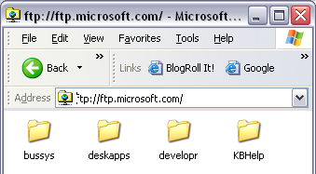
In the Security section of the Settings list, select Empty Temporary Internet Files Folder When Browser Is Closed.

Problem: Internet Explorer can only save images as bitmaps

The cure is to empty the cache (see link Ch 12c)

Using Internet Explorer as an FTP Client

To view an FTP site that allows anonymous access, simply type the URL in the Address bar-of either Internet Explorer or Windows Explorer

To connect to an FTP server that requires you to provide your user name and password, you can include your logon information in the Address bar, like this:

ftp://name:password@ftp.microsoft.com

Alternatively, after you arrive at the site, you can choose File, Login As and provide your credentials

This is not secure

