Chapter 13 - Managing User Profiles

Home Edition

Home Edition uses local profiles the same as Windows XP Professional. However, Roaming Profiles are usually used in domains, and are therefore unavailable for Home Edition users. Group Policy settings are also unavailable in Home Edition.

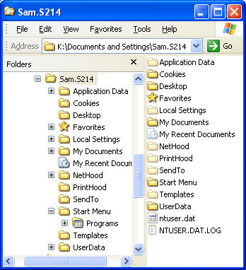
Location and Content of User Profiles

By default, each user who logs on to a computer has a local user profile, which is created when the user logs on for the first time

Local user profiles are stored in %SystemDrive%\Documents And Settings

The entire path for the current user’s profile is %UserProfile%

Complete list of environment variables at link Ch 34a

Viewing a Local Profile

Right-click Start button, Explore

Ntuser.dat

The root of the profile contains Ntuser.dat, which is the user portion of the registry
HKEY_CURRENT_USER

It’s a hidden file

Profile Folders

Make sure you understand what these folders are, as explained on pages 469-470

Three Types of Profiles

Local user profiles

Roaming user profiles

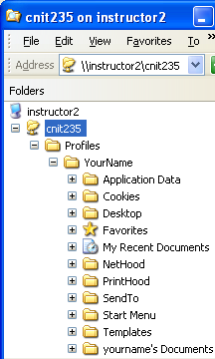
Mandatory user profiles

Local User Profiles

Stored in

%SystemDrive%\ Documents and Settings

On the local hard disk

Windows creates a local user profile the first time a user logs on to the computer

Home Edition uses only Local user profiles

Unless you use unusual tricks

Roaming User Profiles

Stored on a network server

Available when a user logs on to any computer on the network

Windows creates a local copy of the user profile the first time a user logs on to a computer

If the user changes the profile, Windows updates the server copy when the user logs off

Mandatory User Profiles

Can be changed only by an administrator

Stored on a network server

Windows creates a local copy when a user who has been assigned a mandatory profile logs on for the first time

Unlike a roaming user profile, a mandatory profile is not updated when the user logs off

All Users

The content of the All Users folder appears for all users in addition to the content of each user’s own profile folder

Includes Desktop items, Start Menu, Documents

Default User

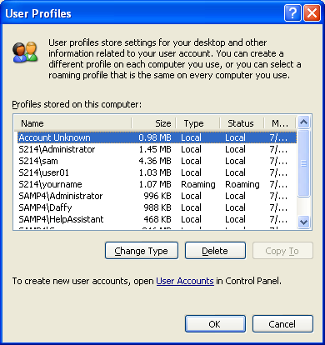
When a user logs on to a computer for the first time

Windows creates a new local profile by copying the contents of the Default User folder to a new folder and giving it the user’s name

User Profiles

Control Panel, System, Advanced tab, click Settings under User Profiles

This is the right way to manage profiles, because it adjusts permissions correctly

Removing a User Profile

Control Panel, User Accounts, delete the user account

or

From the User Profiles dialog box, select a profile and click Delete

If An Error Prevents You From Logging On

Access permissions

Your account must have (at least) Read access to the %UserProfile% folder

Everyone should have Full Control access to %SystemDrive%\Documents And Settings

Your system is low on hard disk space

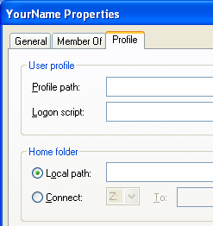
The profile has been corrupted

Use System Restore, or delete the profile

Assigning a Profile to a Local User Account

Computer Management

Local Users and Groups

Users Folder

User’s Properties

Profile tab

On the Profile tab

The location of the user profile

Logon script

The path to the user’s home folder

The initial current folder for Command Prompt sessions

Redirecting My Documents

Right-click My Documents, Properties, Target tab, Move

Useful to make sure My Documents is available from all workstations and for backups

To move My Music or My Pictures, simply use Windows Explorer to move the folder to the desired location

Windows XP automatically updates all references to the folder, including those on the Start menu

Roaming User Profiles

A Roaming User Profile allows a user to log on to a workstation and see his or her familiar settings on the desktop, the Start menu, and so on

Roaming user profiles work by storing the user profile in a shared network folder

See project 14 to see how to do it

Mandatory User Profiles

A mandatory user profile works much like a roaming user profile

When a user logs on, the profile is copied from a network location to a local folder, thereby providing familiar settings

The difference is that a mandatory profile isn’t updated with user changes when the user logs off

To Make a Mandatory User Profile

Change the name of the hidden Ntuser.dat file to Ntuser.man

If you want to prevent the user from changing it back:

Change the profile folder permissions to remove Full Control, Modify, and Write permissions for the user

Leaving them with only Read & Execute, List Folder Contents, and Read permissions.

