Chapter 14 - Configuring Shutdown and Power Management Options

How Does Your Computer Manage Power?

System enters low-power mode when inactive

System can be wakened by an application, modem, a network connection, or other devices.

If it’s a host, it can wake up when a client needs an Internet connection or a printer

A computer set up as a telephone answering device can wake when the phone rings

How Does Your Computer Manage Power?

Security devices such as break-in detectors or cameras can wake the computer so it can send e-mail or pager alerts

Tasks in the Scheduled Tasks folder can be configured to wake the computer at the appointed time and perform the task

Configuring Your Computer’s BIOS

For Windows XP power management features to work properly, you should disable all power management features in your computer’s BIOS (Basic Input/Output System).

Run its setup program

Usually accessed by pressing Del or F1 during the computer’s power-on self test; watch the screen for a message explaining how to enter setup

browse the menus for all settings related to power management.

What Is OnNow?

OnNow is a Microsoft initiative to advance PC hardware so it supports instant-on capability, yet appears to be off when it’s not in use.

Microsoft set the following design goals for a typical consumer PC running Windows XP:

Boot from power off to a usable state in 30 seconds.

Resume from hibernation in 20 seconds.

Resume from standby in 5 seconds.

Power Options

Right-click the desktop and choose Properties

In the Display Properties dialog box, click the Screen Saver tab and click Power.

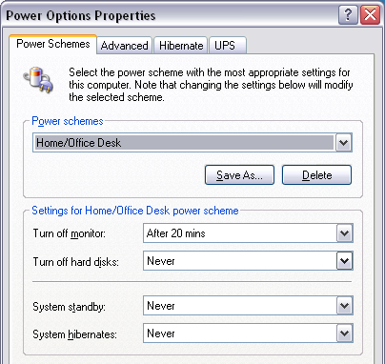
Power States: Standby vs. Hibernation

Standby

Shuts down hard drives, fans, the CPU, and other power-hungry components

Continues to draw some power for RAM

Loses data if power fails

Hibernation

Saves the contents of memory to the hard disk and then shuts off all power

Does not lose data if power fails

Shutting Down Your Computer

On the Start menu, choose Turn Off Computer, Turn Off

On a domain, click Start, Shut Down, select Shut Down, and then click OK

Press the computer’s power button

A hung application prevents shutdown.


Press Ctrl+Alt+Del to display Task Manager

Open the Shut Down menu and hold down the Ctrl key as you click the Turn Off command. Poof!

On a domain, press Ctrl+Alt+Del and then hold down Ctrl when you click Shut Down.

Hibernating

Hibernating gives Maximum Power Savings

Hiberfil.sys

During hibernation, the RAM data are stored in a file named hiberfil.sys on the root of your system drive

Hiberfil.sys is the size of your total RAM

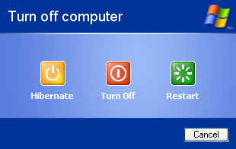
Turning on Hibernation

Press the power button that you’ve configured to hibernate (in Power Options)

On the Start menu, click Turn Off Computer

If the yellow button says Standby, hold down the Shift key.

Waking Up Your Computer

Press the power button

You can also configure various devices and applications to wake the computer

In Device Manager double-click the name of the device

In the device’s properties dialog box, click the Power Management tab

If there is no Power Management tab, you cannot use that device to wake the computer

There is a LOT more to it – see link Ch 9a

Conserving Power on Portable Computers

When the computer's lid is closed, the display is switched off.

When a portable computer is running on battery power, the display is dimmed

It automatically returns to full brightness when the computer is plugged in.

Conserving Power on Portable Computers

A portable computer can be configured so,

When it’s running on battery power, the processor runs at a lower speed

When it enters a low-battery condition, it automatically

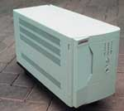
Raises an alarm

Switches to a low-power state, or

Runs a program

Protecting Your Data During a Power Outage

Use your program's autosave feature if it has one

Get in the habit of saving frequently

Establish-and follow-a regular backup routine

UPS (Uninterruptible Power Supply)

Has a battery and provides enough power for 20 minutes or so

Permits an orderly shutdown of your server

Link Ch 9c

Pic from http://spazioinwind.libero.it/zaccasoft/3hm220dp4all/vendo.htm

ACPI v. APM

Windows provides three levels of power-management support: ACPI, APM and OS alone

Advanced Configuration and Power Interface (ACPI)

The operating system cuts power to monitor, disk drives, peripherals, and motherboard components when your computer is inactive

Older Systems are not ACPI-compliant but use an Advanced Power Management (APM) 1.2 BIOS

A less versatile form of power management (see link Ch 9d)

On some earlier systems without even an APM 1.2 BIOS

OS can still conserve power by shuting down the monitor and disk drives during periods of inactivity

ACPI v. APM

The advantage of ACPI over APM:

ACPI puts power management completely in the control of the operating system

That makes it reliable and consistent.

APM, on the other hand, is a BIOS specification

Different motherboards have different APM BIOSs

APM-enabled systems differ considerably in their power-management behavior

Other advantages of ACPI

Control of USB and FireWire devices

Support for wake-on-LAN and wake-on-ring

User definition of the power and reset buttons

Better battery management

Dynamic configuration of PC cards (hot-swap)

Multiprocessor support

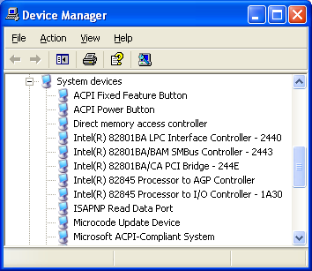
APM power management is not available on multiprocessor systems.

Determining Whether Your System Is ACPI-Compliant

During setup, Windows XP decides whether your computer is ACPI-compliant

If it is, Setup installs an ACPI hardware abstraction layer (HAL)

Otherwise, Setup installs a standard APM (non-ACPI) HAL.

Look in Device Manager

To see whether your computer is using ACPI for power management

Open the System Devices entry in Device Manager

Look for Microsoft ACPI-Compliant System

