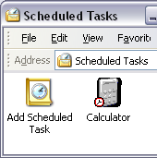
Chapter 15 - Automating Windows XP

Three Ways To Automate Tasks

Task Scheduler

Batch programs

A throwback to MS-DOS

Windows Script Host

VBScript, JScript, and other languages

Scheduling Tasks to Run Automatically

In Control Panel, choose Performance And Maintenance, Scheduled Tasks

or Start, All Programs, Accessories, System Tools, Scheduled Tasks

There are several details about when login and startup tasks run if different people log on pages 324-325

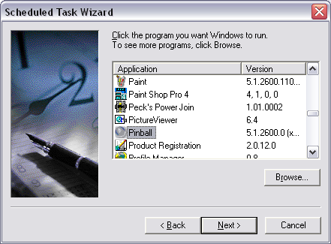
Running a Program at a Scheduled Time

Any program you want

Any time schedule you want

Monitoring Scheduled Tasks

Tasks that fail to run because the computer is off at the appointed hour are recorded as missed tasks.

If you miss a task because your computer is off, a message to that effect appears at your next logon.

You can also run tasks with the Schtasks Command at the command-line

Skip Batch Files and Scripting

You should understand what they can accomplish in general terms, but you do not need to create Batch files or scripts as a MCDST.

Your book’s explanation of Batch files is excellent, however

Appendix C - MMC (Microsoft Management Console)

Home Edition

MMC works the same in Home Edition, but some snap-ins are missing, including

Local Users and Groups

And these snap-ins which are used for Group Policies

Group Policy

Resultant Set of Policy

Security Templates

The Purpose of MMC

MMC provides a uniform way to access administrative tools called snap-ins

Snap-ins are written in ActiveX

MMC functions like Control Panel, but has more advanced items in it

By itself, MMC is an empty shell – the snap-ins do all the work

Launching MMC

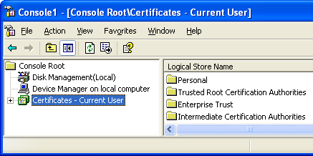
Start, Run

MMC

Or

runas /user:administrator mmc

Remote Administration

Many MMC tools can be used to administer other computers over the network (with permissions)

