Chapter 16: Windows Explorer for Experts

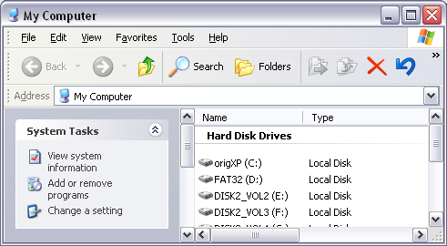
Choosing Between Common Tasks and Classic Folders

The task pane is on by default. To turn it off, follow these steps:

In Windows Explorer, choose Tools, Folder Options.

On the General pane of the Folder Options dialog box, select Use Windows Classic Folders.

The Details Section of the Task Pane

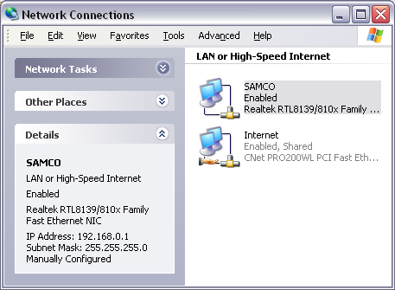
The lowest section of the task pane is like a miniature properties dialog box

It provides useful information about the currently selected item or items

Customizing the Toolbars

Windows Explorer offers three toolbars

Standard Buttons, Address bar, Links

To display or hide a toolbar

Choose View, Toolbars, and then select the toolbar

Or right-click any toolbar to show the View, Toolbars submenu.

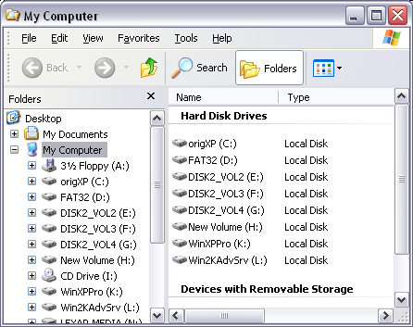
Go button, be gone! (right-click it)

Displaying the Status Bar

Unlike earlier versions, the Windows XP version of Windows Explorer does not display the status bar by default.

To make the status bar visible, choose View, Status Bar.

Using Explorer Bars

The View, Explorer Bar command opens a menu on which you can choose from five Explorer bars: Search, Favorites, Media, History, and Folders.

Using the Folders Bar

Folders is probably the most useful Explorer bar from a file-management perspective.

Navigating the Folders Bar in Simple Folder View

If you click a folder name in the Folders bar, Windows Explorer displays the folder's contents and expands the folder branch you clicked

Click another folder name, and Windows Explorer closes the branch where you were, opening the one you just clicked in its place.

Choosing View Options

Windows Explorer provides six distinct ways of viewing items in a folder:

Details

List

Thumbnails

Tiles

Icons

Filmstrip

Show in Groups (see figure to the right)

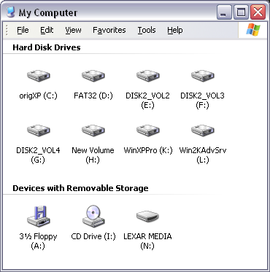
Choosing Advanced Folder Options

Tools, Folder Options, View tab, Advanced Settings

Display the Contents of System Folders

Display the Full Path in the Address Bar and Title Bar

Hidden Files and Folders

Hide Extensions for Known File Types

Choosing Advanced Folder Options (continued)

Hide Protected Operating System Files (Recommended)

Show Encrypted or Compressed NTFS Files in Color

Use Simple File Sharing (Recommended)

tip - Show extensions for particular files only

Tools, Folder Options, File Types tab

Select the file type, click Advanced, check the Always Show Extension check box.

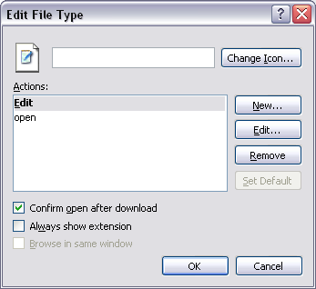
Working with File Types and File Associations

The File Types tab of the Folder Options dialog box (choose Tools, Folder Options, File Types) displays a list of your registered document file types.

Working with File Types and File Associations

By selecting file types from the Registered File Types list, you can perform a number of tasks:

Change the default action for a file type

Change the application associated with a file type

Change a file type's icon

Specify whether the file type's extension should be displayed in Windows Explorer

Specify whether a file type should be opened immediately after being downloaded

Add commands to the file type's shortcut menu

Changing the Default Action for a File Type

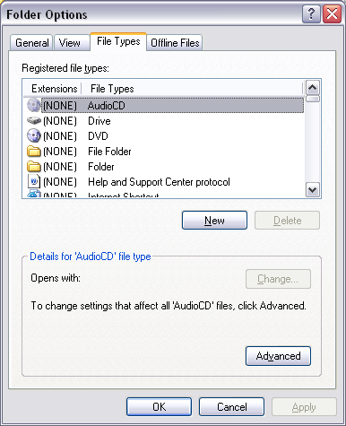
A file type's default action is the one that occurs when you double-click it.

Right-click a file -- default action is bold

To change a file type's default action

In the File Types list, select the file whose default action you want to change.

Click Advanced.

In the list of available actions, select the action you want to be the default.

Click Set Default

Changing the Application Associated with a File Type

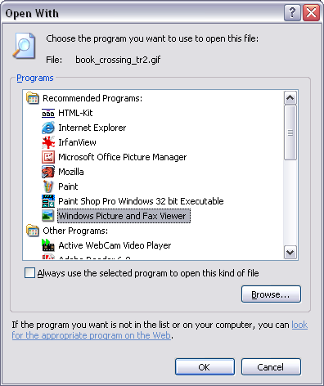
Right-click, Open With

In the Open With dialog box, select the application you want associated with the file type, and then select

Always Use The Selected Program To Open This Kind Of File

Other options

Changing a File Type's Icon

Making the Extension of a Particular File Type Visible

Confirm Open After Download

Editing a File Type's Shortcut Menu

These are all done with the Advanced button on the File Types tab of Folder Options

Using Windows Explorer's Command-Line Syntax

Start, Run

explorer %systemroot%

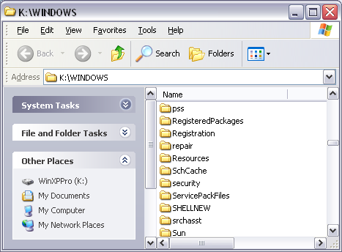
Using GUIDs to Open Shell Folders in Windows Explorer

A GUID, or globally unique identifier, is a string of 32 hexadecimal digits enclosed within braces, with hyphens separating the digits into groups of eight, four, four, four, and twelve-like this:

{20D04FE0-3AEA-1069-A2D8-08002B30309D}

For My Computer

Using GUIDs to Open Shell Folders in Windows Explorer

You might find it convenient to incorporate command strings that use GUIDs in shortcuts for opening Windows Explorer, or in batch programs or in scripts.

explorer ::{208D2C60-3AEA-1069-A2D7-08002B30309D}

Chapter 17 - Managing and Finding Files

Seven Principles of Effective File Management

Use My Documents

Adopt consistent methods for file and folder naming

Keep names short

Segregate current and completed work

Store like with like

Avoid flat folder structures

Use shortcuts and OLE links instead of multiple document copies

Using Tools for File Management

You can move and copy by copying or cutting to the Clipboard and then pasting in a new location

Manipulating Files with the Folders Bar

Inspecting and Setting File Properties

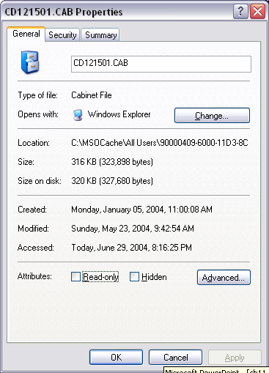
General Tab

File’s size, location, dates, parent application, and other attributes.

A button you can use to change the parent application

Summary and Custom tabs

Details and properties whose value you can set yourself

Indexing Service can search by the values of custom properties

Creating and Customizing Document Shortcuts

To create a shortcut

1. Display the document in Windows Explorer

2. Hold down the Alt key and drag the document to your desktop

Or, right-drag and select Create Shortcut

Protecting Files with the Read-Only Attribute

Right-click, Properties. On General tab, select Read-Only.

NTFS Compression and Zipped Folders

Windows XP supports two forms of file compression

NTFS file compression

Zipped folders

NTFS compression

Only a modest degree of compression but is extremely easy to use

Files are decompressed when they are used and recompressed when you save

If you move files to a FAT disk, they lose compression

NTFS compression is incompatible with NTFS encryption. A file can be Compressed or Encrypted (or neither), but not both.

Zipped Folders

More compressed than with NTFS compression

A zipped folder stays compressed, no matter where it is

These are the same as Winzip files – many people can use them, even if they don’t use any version of Windows

You have to open zipped files before you can use them in applications

Zipped folders are good for

Creating compressed archives of files that you no longer need on a regular basis

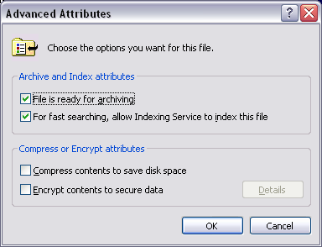
E-mailing large attachments or uploading files to FTP or Web sites

Squeezing the maximum amount of free space out of a disk that’s nearly full

NTFS compression provides modest compression but is easy to use

Implementing NTFS Compression

Right-click the file or folder, Properties

On the General tab of the properties dialog box, click Advanced

Select Compress Contents To Save Disk Space and then click OK in both dialog boxes

Creating a New Zipped Folder

Right-click an empty space in any folder

Choose New, Compressed (zipped) Folder

Adding Files and Folders to a Zipped Folder

Copy or move them into the zipped folder

Right-click a file, select Send To Compressed (zipped) folder

Password-protecting a Zipped Folder

Select any file in the zipped folder (not the folder itself).

Choose File, Add a Password

These steps apply the same password to every file in the archive

If the archive includes folders, their contents are password protected as well

New files added to a password-protected zipped folder do not inherit the password

Copying Files to CDs

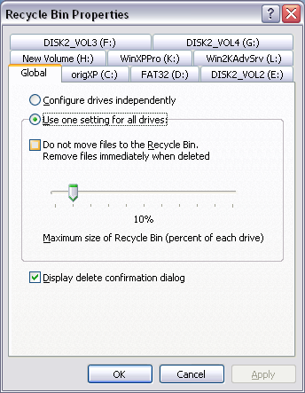
You don’t need special software to write files to a disk in your CD-R or CD-RW drive.

The simplest procedure is as follows:

Right-click a file or folder, Send To, CD Drive

Repeat for all the items that you want to copy

Open your CD drive in My Computer

Click File, Write These Files To CD

But you can’t use ISO images without 3rd-party software

Using and Configuring the Recycle Bin

The following do not go to the Recycle Bin:

Files stored on removable disks

Files stored on network drives

Files deleted from compressed (zipped) folders

Changing the Amount of Space Allocated to the Recycle Bin

By default, 10% of each drive is used for the maximum Recycle Bin size

Right-click the Recycle Bin icon on the desktop.

Choose Properties from the shortcut menu.

Restoring Files and Folders

To restore an item, select it and then click Restore This Item in the task pane

The Restore command puts the item back in the folder from which it was deleted.

Or drag an item out of the Recycle Bin and drop it wherever you want it

Purging the Recycle Bin

To purge one file

Display the Recycle Bin, select the item, and then press Delete.

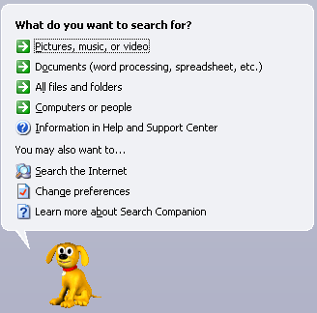
To empty the Recycle Bin entirely

Right-click the Recycle Bin icon on your desktop and choose Empty Recycle Bin

Locating Files with Search Companion

Click Start, Search

Rover, the search dog

Search Companion can perform three basic kinds of file searches:

Digital media

Documents

All files and folders

Using Indexing Service and Query Language

Indexing Service speeds up searching

Indexing Service’s query language lets you find files on the basis of many different properties in addition to the size, date, and file type:

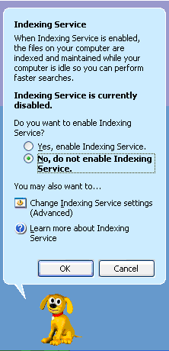
Word count, most recent editor, most recent printing time, and many other attributes

Indexing Service never indexes encrypted documents.

Limitations of Indexing Service

Requires disk space

Catalogs the content of only certain kinds of files

HTML files (their text), Text files, Documents created by Microsoft Office, and others for which a suitable filter is installed

Ignores "noise" words

Ignores case

Indexed searching is not always available, even if you have enabled Indexing Service

Activating Indexing Service

Choose Search from the Start menu.

Click Change Preferences.

Click With Indexing Service.

Before you can use Indexing Service for queries, the service needs time to generate a catalog

Let it run overnight

Submitting Queries

Type a word or phrase in the

“A Word Or Phrase In The File” box

When Search Companion begins searching, it should display the words Searching by Index.

In my test, Indexer did not save any significant amount of time

