Chapter 23 - Setting Up a Small Network

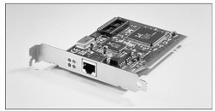
Workgroups Only in This Chapter – They are the same for Windows XP Home Edition and Windows XP Professional

A Workgroup Lets You
NIC

Share folders

Share printers

Share an Internet connection

But no central administration of accounts or resources – each machine has to be set up individually

Network adapters

Each computer needs an adapter (also called a network interface card, or NIC)

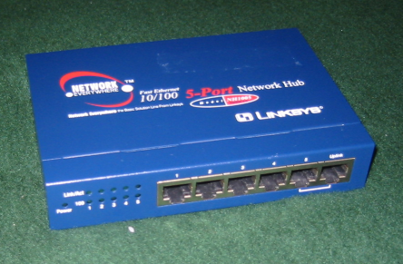
Network adapters can be internal (usually installed in a PCI slot) or external (typically connected to a USB port)
Hub

Ethernet is the most popular by far

Pic from Network+ Guide to Networks, Second Edition by Tamara Dean

Hub

A hub or switch can be used to connect the computers in an Ethernet network

To connect two computers, you can use a crossover cable and no hub

Router(see photo to the right)

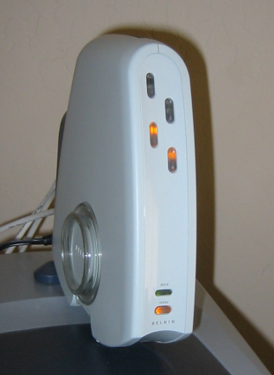
You can also use a router or residential gateway, which typically adds network address translation (NAT) capabilities and security features
Router

Wireless Network Access Point

On wireless networks, a wireless access point handles these duties

Cables

On an Ethernet network, eight-wire Category 5 patch cable with RJ-45 connectors on each end

Installing and Configuring Network Adapters

Happens automatically for Plug and Play adapters

Ethernet, Wireless, or Phone Line?

Three popular technologies, all supported by Windows XP

Ethernet/Fast Ethernet

10, 100 or 1000 Megabits per second

Wireless

IEEE 802.11b, also known as Wi-Fi -- 11 megabits per second

IEEE 802.11g and 802.11a, -- 54 megabits per second

Phone Line
Network Access Point

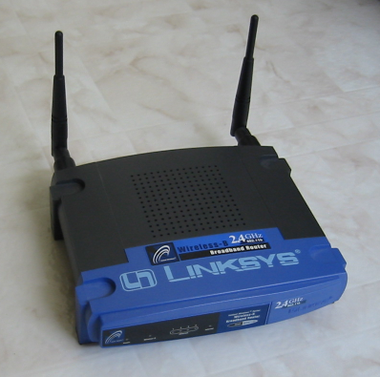
Home Phoneline Networking Alliance (HomePNA) -- 10 megabits per second, using normal phone lines.

Making Connections: Cables and Hubs

Place the hub in a central location

The segment length (distance between furthest points) should not exceed 100 meters (328.1 feet)

All the ports are the same on a hub, except the uplink port

Uplink ports are used to expand a network’s capacity by connecting two hubs

The uplink port achieves the same purpose as a crossover cable

In addition to (or in place of) a hub, your network may use a router, switch, or residential gateway

Often used to share a fast Internet connection

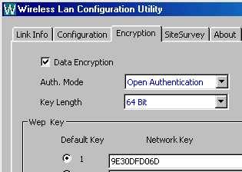
If you plan to use Internet Connection Sharing and you have an external DSL or cable modem, you’ll need to install two network adapters in the computer with the shared Internet connection

Wired Equivalent Privacy

On wireless networks, anyone who comes into range of your wireless access point can tap into your network and intercept signals from it.

To add basic security, use Wireless Equivalent Privacy (WEP)

WEP encrypts the data with a 40-bit or 104-bit key (sometimes called 64-bit and 128-bit)

For details, see Link Ch 23a

Wi-Fi Protected Access (WPA)

WEP has weaknesses – because it uses only a 24-bit initialization vector, it can be cracked by collecting a lot of traffic and analyzing it mathematically

WPA is a newer, more secure, encryption technique

Use it if your hardware supports itInfrastructure and Ad Hoc Modes

Infrastructure and Ad Hoc Modes

Wireless LANs have two modes

Infrastructure mode

Connects to a Network Access Point

Several computers can share an Internet connection

Ad hoc mode

Connect directly to other computers

No Network Access Point

At a coffeehouse, a single laptop in ad hoc mode can stop other laptops from accessing the Internet

Pic from http://www.hardavenue.com/reviews/adhocguide.shtml

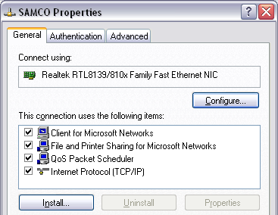
Configuring a Default Network Connection

Windows creates a local connection with four default items

Start, Right-click My Network Places, Properties, Right-click a connection, Properties

Client For Microsoft Networks

Lets you connect to other Windows computers as a client

File And Printer Sharing For Microsoft Networks

This service allows other computers on your LAN to access shared resources on your computer – your computer acts as the server

QoS Packet Scheduler

Not used much yet, will ensure Quality of Service in IPv6

Internet Protocol (TCP/IP)

Used for all modern network traffic, and on the Internet

To See Network Connections

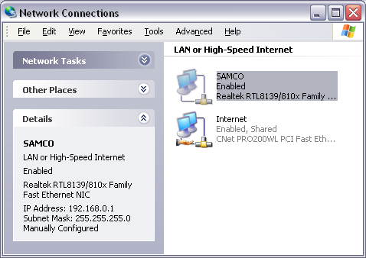
Open Control Panel, Network Connections

To see more detailed information about a network connection, double-click its icon in the Network Connections window

Or Right-click, Properties

Or look in left pane at the bottom

The Network Setup Wizard

Sets the proper permissions on shared folders

Adds required keys to the registry

Configures protocols and binds them to network cards

Enables or disables the internet connection firewall

Adjusts system policies so that file sharing works properly over the network

Internet Connection Sharing

If you use Internet Connection Sharing run the Network Setup Wizard on the Internet Connection host first

If all your networked computers have separate Internet connections, or if you use a router or residential gateway to share an Internet connection, you can start with any computer.

To start the Network Setup Wizard

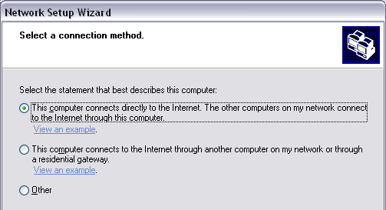
Start, My Network Places, Set up a home or small office network

Select A Connection Method

This Computer Connects Directly To The Internet…

Select this option if you’ve already set up the Internet connection on the computer

This Computer Connects To The Internet Through Another Computer …

If you use a router or residential gateway to manage shared Internet access, select this option

If you use Internet Connection Sharing and you see this screen, stop and check your Internet connection

If ICS is properly set up, the wizard should display a different page

Other

Select this option if your computer is connected to the Internet directly or through a hub, or if your network has no Internet access

Other Internet Connection Methods

If you selected “Other”, you see this

This Computer Connects To The Internet Directly…

This configuration exposes your system to serious security risks

This Computer Connects Directly To The Internet. I Do Not Have A Network Yet

This Computer Belongs To A Network That Does Not Have An Internet Connection

Select Your Internet Connection

Confirm that the wizard has selected the correct connection and click Next to continue

Give This Computer A Description And Name

Next, Workgroup Name and Ready To Apply Network Settings page.

Network Setup Disk

The network setup disk is used on systems running previous versions of Windows that are connected to the same network

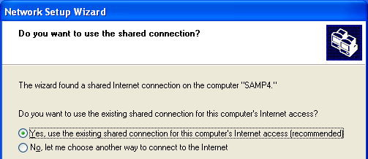
Run the Network Setup Wizard on Other Computers Using ICS

Choose the first option: Yes, Use The Existing Shared Connection For This Computer's Internet Access.

Adjusting Network Settings

Although the Network Setup Wizard is the preferred way to work with network settings, you may need to adjust settings manually under some circumstances

Installing and Configuring Protocols

For virtually any networking task, TCP/IP is the preferred solution

But if you have old networks, you may be using an old protocol like

IPX/SPX

Originally developed for Novell NetWare

NetBEUI

Originally developed for use on small networks running Windows 3.x

Short for NetBIOS Extended User Interface

To Install an Additional Protocol

Start, Right-click My Network Places, Properties

Select the connection and click the Change Settings Of This Connection link under Network Tasks

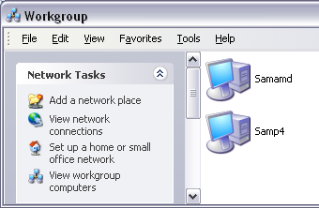
From the properties dialog box, click the Install button

Choose Protocol and click Add

Configuring Workgroup Settings

In My Network Places, click the View Workgroup Computers link under Network Tasks in the left pane

You should see the other computers on your workgroup

Workgroup Name

To communicate properly, all the computers on must be members of the same workgroup

To change your workgroup name: Right-click My Computer, Properties, Computer Name tab, Change

IP Addresses

On a TCP/IP network, every computer has a unique IP address, which consists of four 8-bit numbers (each one represented in decimal format by a number between 0 and 255) separated by periods

TCP/IP configuration has three additional settings:

Subnet Mask

Default Gateway

DNS Server

Subnet Mask, Default Gateway, DNS Server

Subnet mask

Tells the network how to distinguish between IP addresses that are part of the same network and those that belong to other networks.

Default Gateway

A computer that can send packets outside the local network

Domain Name System (DNS) Servers

Computers that translate domain names (such as www.microsoft.com) into IP addresses

Methods For Assigning IP Addresses

Dynamic Host Configuration Protocol (DHCP)

The most common method

IP configuration is set automatically by the server

Automatic Private IP Addressing (APIPA)

If DHCP fails, the machines make up their own addresses starting with 169.254.

Static IP Addressing

Administrator must manually type in the IP address for each machine

Servers typically use static IP addresses

Requires more administrative effort and not commonly used for workstations anymore

Alternate IP Configuration

New feature in Windows XP

You set the address used if DHCP fails

Useful for a laptop that travels between two different LANs

Public IP Addresses

Public IP addresses are like public telephone numbers – every computer that is directly connected to the Internet needs one

When you connect to an Internet service provider, you’re assigned a public IP address from a block of addresses registered to that ISP

Dynamic IP Address

If you use a dial-up connection, your ISP probably assigns a different IP address to your computer (drawn from its pool of available addresses) each time you connect

Static IP Address

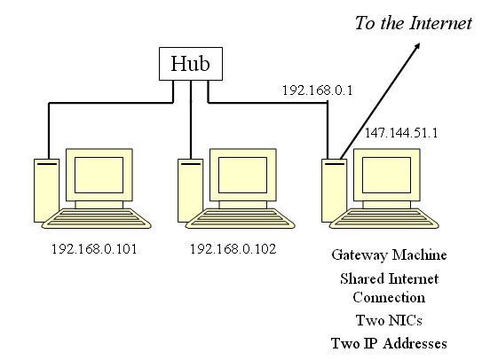
If you have a persistent connection to your ISP via a DSL or cable modem, your IP address may be permanent.

Private IP Addresses

A whole network can share a single Public IP Address

Better Security

Lower Cost

Each of the computers on the local network has a Private IP Address that is not reachable from the outside world.

The gateway computer uses network address translation (NAT) to pass packets back and forth between the single public IP address and the many private IP addresses on the network.

Reserved Private IP Addresses

The Internet Assigned Numbers Authority (IANA) has reserved the following three blocks of the IP address space for use on private networks that are not directly connected to the Internet:

10.0.0.0 – 10.255.255.255

172.16.0.0 – 172.31.255.255

192.168.0.0 – 192.168.255.255

In addition, the Automatic Private IP Addressing feature in Windows 98 and all later versions uses private IP addresses in the range from 169.254.0.0 to 169.254.255.255.

See link Ch 23b

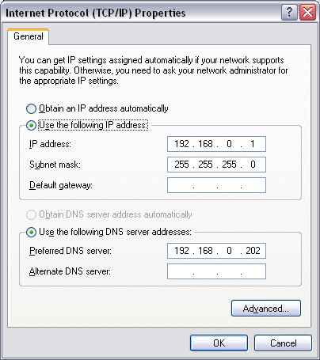
Routers, switches, and residential gateways that use NAT almost always assign addresses from these private ranges

The RG-1000 residential gateway from Agere uses 10.0.0.x addresses

Linksys routers use 192.168.1.x

Internet Connection Sharing in Windows XP uses 192.168.0.x

To set a static IP address

Start, right-click My Network Places, Properties, right-click the connection, Properties

Select Internet Protocol (TCP/IP), click the Properties button

To set up an alternate IP configuration

On the General tab of the Internet Protocol (TCP/IP) Properties dialog box, select Obtain An IP Address Automatically.

Click the Alternate Configuration tab and then select the User Configured option.

Configuring a Dial-Up Internet Connection

Control Panel, Network Connections

Create A New Connection link in the Network Tasks pane

Connect To The Internet

Set Up My Connection Manually

Connect Using A Dial-Up Modem

Sharing an Internet Connection

To share an Internet connection safely on a small network, you have two options:

Install a router or residential gateway

Use Internet Connection Sharing (ICS)

Your Shared Internet Connection Isn’t Working.

The Internet Connection Sharing service is not be running

Control Panel, Administrative Tools, Services, restart the Internet Connection Sharing service

The wrong network adapter is shared

The settings on other network computers are incorrect

They should all be set to obtain an IP address automatically and obtain DNS servers automatically. Leave the default gateway field blank.

Security Risks of a Peer-to-Peer Network

If you have an external DSL or cable modem and you connect it to an Ethernet hub along with other computers on your network, one of two things will happen:

If you use the Internet Connection Firewall on each computer, you are safer but you cannot share folders or printers

If you disable the Internet Connection Firewall, every computer on your network can see the other computers and access shared resources, and so can everyone on the Internet.

Making a Peer-to-Peer Network More Secure

Upgrade to Service Pack 2

Use a third-party firewall on each machine, like Zone Alarm

Alternatively, you can Disable File and Printer Sharing on the TCP/IP protocol and enable it on the IPX/SPX protocol for each computer on your network
Chapter 24 - Tweaking and Troubleshooting a Small Network

These commands work the same in Windows XP Home Edition and Windows XP Professional

Command-line TCP/IP Troubleshooting Utilities

PING

PATHPING

TRACERT

NSLOOKUP

IPCONFIG

PING

To see if you can communicate with a machine, use PING at a command prompt

PING machine_name

PING IP_Address

PING

If PING times out, you could have:

A bad cable or hub

A bad TCP/IP connection on your computer

A problem with another computer on that network

Loopback

Ping your own machine using either of the following commands:

ping 127.0.0.1

ping localhost

This standard IP address corresponds to your computer

If you receive an error, then TCP/IP is not configured properly on your system

Tracing a Path

Ping your computer’s IP address.

Ping the IP address of another computer on your network

Ping the IP address of your router or the default gateway on your network

Ping the address of each DNS server on your network

Ping a known host outside your network

PathPing the same known host

DNS Problems and NSLOOKUP

If you can ping a Web site using its IP address but not by using its name, DNS problems are indicated

You can test DNS with

NSLOOKUP domain_name

Tracert

tracert target_name

Sends a series of packets out, measuring the time it takes to reach each "hop" along the route

Timeouts or unusually slow performance indicate a connectivity problem

PATHPING does the same thing, but also sends several packets to each site and shows % loss for each one

Simplify the Problem

If you’re using a third-party firewall program, disable it temporarily

Try bypassing your router

Connecting directly to a broadband connection such as a DSL or cable modem.

Check your Firewall

Look in the Network Connections folder for a padlock icon and the word Firewalled on the connection icon in question

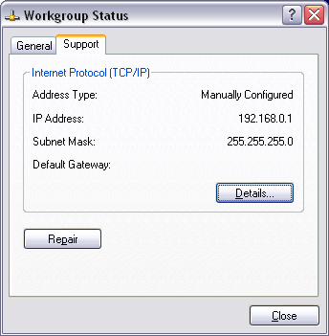
Diagnosing IP Address Problems

To see details of your current IP configuration, follow these steps:

Control Panel, Network Connections

Double-click the connection

Support tab

Network Connection Details

In the Connection Properties, on the Support tab, click the Details button

IPCONFIG

IPCONFIG displays the DNS suffix, IP address, subnet mask, and default gateway of your primary network connection

For more details use IPCONFIG /ALL.

IP Addresses to Look For

169.254.x.y

Your computer is using Automatic Private IP Addressing (APIPA)

Your computer was unable to reach a DHCP server

If your address is a Private IP Address like 192.168.x.y or 10.x.y.z

Private IP addresses cannot connect directly to the Internet

Make sure that another computer (an Internet Connection Sharing host) or a router or residential gateway is routing your Internet requests to a properly configured public IP address

0.0.0.0 – No communication is possible with that IP address

The network is disconnected, or

The static IP address for the connection duplicates an address that already exists on the network

Subnet Mask

Compare IP settings on the machine that’s having problems with those on other computers on the network

The default gateway and subnet mask should be identical for all network computers

The first one, two, or three sets of numbers in the IP address for each machine should also be identical, depending on the subnet mask

A subnet mask of 255.255.255.0 means the first three IP Address numbers of computers on your network must be identical

192.168.0.83 and 192.168.0.223 can communicate

192.168.1.101 will not be recognized as belonging to the network

With a subnet mask of 255.255.0.0, the first two sets of numbers must match

172.16.2.34, 172.16.4.56, and 172.16.83.201 are all valid addresses on a subnet with this mask

172.17.4.1 would not be able to communicate on that subnet

In every case, the gateway machine must also be a member of the same subnet

Network and Host Portion

Class A Addresses

When the subnet mask is 255.0.0.0

The first number in the IP address is called the network portion of the IP address

The last three numbers are called the host portion

Example: 10.15.19.101 with a subnet mask of 255.0.0.0 has

Network portion 10

Host portion 15.19.101

Class B addresses

When the subnet mask is 255.255.0.0

The first two numbers in the IP address are called the network portion of the IP address

The last two numbers are called the host portion

Example: 172.16.1.101 with a subnet mask of 255.255.0.0 has

Network portion 172.16

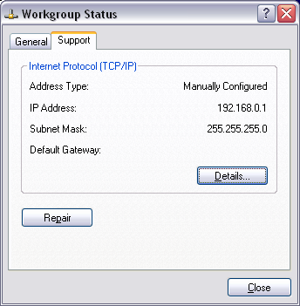
Host portion 1.101

Class C addresses

When the subnet mask is 255.255.255.0

The first three numbers in the IP address are called the network portion of the IP address

The last number is called the host portion

Example: 192.168.1.101 with a subnet mask of 255.255.255.0 has

Network portion 192.168.1

Host portion 101

Repairing Your TCP/IP Configuration

Run the Network Setup Wizard

Use the automated repair option

Double-click the connection icon in the Network Connections folder and click the Repair button on the Support tab

What Repair Does

The Repair button has the same effect as typing these commands :

ipconfig /renew. Automatically renews your IP address from a DHCP server

arp –d. Flushes the Address Resolution Protocol cache

nbtstat –R. Reloads the NetBIOS name cache

ipconfig /flushdns. Clears the DNS cache

ipconfig /registerdns. Registers the computer’s name on the appropriate DNS server

Resolving DNS Issues

DNS servers translate host names (www.microsoft.com, for instance) into numeric IP addresses

If you can use the Ping command to reach a numeric address outside your network but are unable to browse Web sites by name, the problem is almost certainly related to your DNS configuration

To make sure, try NSLOOKUP domain_name at a command prompt

For example, NSLOOKUP YAHOO.COM

DNS Problems

Do your TCP/IP settings point to the right DNS servers?

Is your ISP experiencing DNS problems?

Have you installed any "Internet accelerator" utilities?

These may use a static Hosts file on your machine which has become out-of-date

The Hosts file

Hosts can be used instead of DNS, but it is rarely used in modern networks

Can be useful on a mid-size network where all computers have static IP addresses

By entering computer names and IP addresses in a Hosts file, you eliminate the need to broadcast messages around the network looking for each machine

Instead, Windows finds the machine name and matching IP address in the Hosts file and goes straight to the correct address

%SystemRoot%\System32\Drivers\Etc\Hosts

Fixing Problems with My Network Places

Often, computers are missing from the My Network Places folder

The Browser service fills that folder, and it is often very slow (up to 24 minutes)

See links Ch 30a-d

You can usually connect by typing in the name of the other computer in the Run box, such as

\\Instructor1\CNIT235

Network Troubleshooting Tools

Ipconfig

Displays all current TCP/IP network configuration values and refreshes DHCP and DNS settings

Nslookup

Displays information about Domain Name System records for specific IP addresses and/or host names, so you can troubleshoot DNS problems

PathPing

Combines functions of Traceroute and Ping to identify problems at a router or network link

Ping

Verifies IP-level connectivity to another Internet address by sending ICMP packets and measuring response time in milliseconds

Tracert

Determines the path to an Internet address and lists the time required to reach each hop; useful for troubleshooting connectivity problems on specific network segments

Nslookup

Resolves a domain name to an IP address; useful to test DNS server function

Bridging Two Networks

Windows XP can create a network bridge, which brings two network segments together seamlessly and creates a virtual connection between them

