Chapter 25 - Managing Shared Folders and Printers

Introducing Windows XP Sharing and Security Models

Simple File Sharing

A share created this way is available to all network users; you can’t selectively set permissions for different users

With Simple File Sharing, Windows uses the Guest account for all network logons.

Classic sharing

When you share a folder, you must set appropriate shared resource permissions and NTFS file permissions to control the folder’s use

You’ll need to set up appropriate user accounts on each computer that allows network access (unless you’re on a Domain)

Windows XP Home Edition v. Professional

Windows XP Home Edition uses Simple File Sharing exclusively

Windows XP Professional can use either Simple File Sharing or classic sharing

To switch between these models, use Folder Options

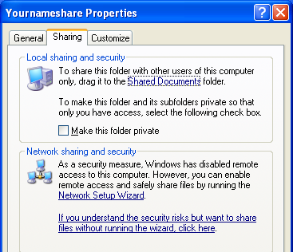
Domains

If your computer is joined to a domain, it always uses the classic sharing model, regardless of your setting in Folder Options.

Sharing a Folder Over a Network

Enabling File Sharing

Sharing is disabled on a clean installation of Windows XP

That’s because the Guest account is disabled

The easiest way to configure your computer for sharing folders, files, and printers is to run the Network Setup Wizard

If you haven’t yet run the Network Setup Wizard, when you right-click a folder that you want to share and choose Sharing And Security, you see the box shown to the upper right on this page

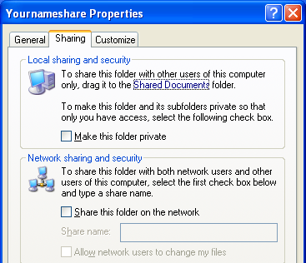
Using the Guest Account for Simple Sharing

After running the Network Setup Wizard:

To share a folder or drive, Right-click it and click Sharing And Security.

In the Network Sharing And Security box, select Share This Folder On The Network, as shown to the lower right on this page.

What Simple File Sharing Does:

It creates a share and grants shared resource permission to the built-in Everyone group

If the shared folder is on an NTFS-formatted drive, Windows adds an entry for Everyone to the folder’s access control list (ACL)

It shares the Shared Documents folder with all network users

Restricting Access to Network Shares With Classic Sharing

Note: Classic sharing is not available in Windows XP Home Edition.

You specify shared resource permissions on a per-user basis

If the shared folder is on an NTFS volume, you specify ACLs for each object in the share.

Users who connect to your computer over the network are not automatically authenticated as Guest

Shared Resource Permissions and NTFS Permissions Work Together

Shared resource permissions control network access to a particular resource

Shared resource permissions do not affect users who log on locally

You set shared resource permissions on the Sharing tab of a folder’s properties dialog box.

NTFS permissions apply to folders and files on an NTFS-formatted drive

Sharing And NTFS Permissions Are Combined In The Most Restrictive Way

If a user is granted read perm ission on the network share, it doesn’t matter whether the account has Full-Control NTFS permissions on the same folder; the user gets only read access when connecting over the network

In determining the effective permission for a particular account, you must also consider the effect of group membership

Permissions are cumulative; an account that is a member of one or more groups is granted all the permissions granted explicitly to the account as well as all permissions granted to each group of which it’s a member

The only exception to this rule is Deny permissions, which take precedence over any conflicting Allow permissions

Preparing for Classic Security: Setting Up User Accounts

Each machine in the workgroup must have an account for each u ser who needs access to shared resources, with the same name and password

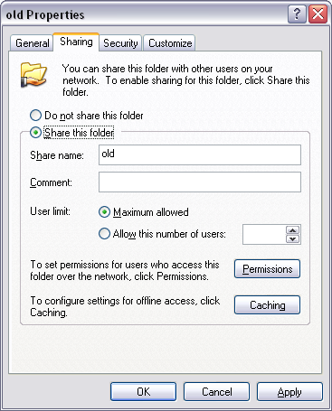
To share a folder or drive

Right-click the folder or drive and click Sharing And Security.

Select the Share This Folder option.

Accept or change the proposed share name.

Assigning Permissions to a Shared Folder

The default shared resource permission associated with a new share is Full Control to Everyone

In the Group Or User Names list, select the name of the user or group you want to manage.

Select Allow, Deny, or neither for each access control entry

The Three Share Permission Levels

Full Control

Allows users to create, read, write, rename, and delete files in the folder and its subfolders. In addition, users can change permissions and take ownership of files on NTFS volumes.

Change

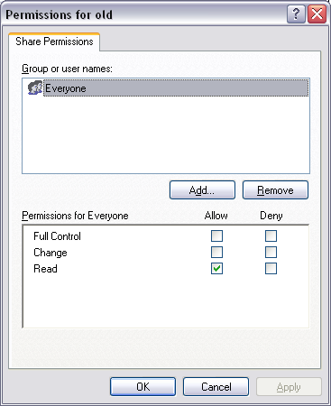
Allows users to read, write, rename, and delete files in the folder and its subfolders, but not to create new files.

Read

Allows users to read files but not write to them or delete them.

Neither Allow Nor Deny

If you select neither Allow nor Deny, the user or group can still inherit the permission through membership in another group that has the permission

If the user or group doesn’t belong to another such group, the user or group is implicitly denied permission.

Authenticated Users is more Restrictive than Everyone

Setting up a share grants permission to the built-in Everyone group by default

The Guest account is included in Everyone

Network users who don’t have an account on the local computer are Guests

Therefore, anyone on your network has access to a share

If you want to exclude anyone who does not have a user account on your computer

Remove Guests

Use Authenticated Users instead

Share Permissions Don’t Restrict Local Access

Shared resource permissions apply only when the folder is accessed over a network

They don’t protect files or folders when opened locally from the computer on which they reside

NTFS permissions protect the files locally, and they also apply to network users.

Managing Shared Folders

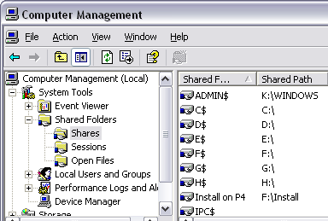
Start the Shared Folders snap-in by opening Computer Management

You can modify the properties of any folder by right-clicking it and choosing Properties

Administrative Shares

The Administrative shares end with a dollar sign ($), which makes them "invisible" because they do not appear in the browse list (in Windows Explorer)

But that’s only because Windows clients hide them; a Mac or Linux machine on your network could see them

You can’t view or set permissions on most of these shares

The operating system restricts access to them to accounts with administrative privileges

C$, D$, E$, and so on

ADMIN$ (used for remote admin)

IPC$ (used by programs and for remote admin)

PRINT$

FAX$

I skipped pages 922-931

The Shared Folders snap-in and Adding a Network Place seem unimportant and you have already done Drive Mapping in the projects

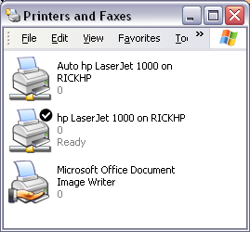
Printer Terms (not in textbook)

Print device

The mechanical object that makes actual physical marks on paper

Printer

The software interface between the operating system and the print device

The icons you see in the Printers and Faxes window are Printers

Print job

A document sent to the printer (can be many pages long)

Printer Driver

A software program that enables programs to communicate with a particular

Print spooler

A software program that catches a print job on its way to the printer and sends it to a temporary storage place (on a hard disk, or in RAM), where it waits for its turn to print

Print queue

A buffer where documents wait to be printed

Printer port

A software program that catches a print job on its way to the printer and sends it to a temporary storage place (on a hard disk, or in RAM), where it waits for its turn to print

Print queue

A buffer where documents wait to be printed

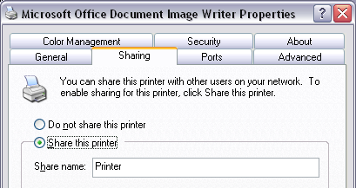
Sharing a Printer

Click Start, Printers And Faxes

Right-click the printer, Properties, Sharing tab, Share This Printer

Using a Local Printer

Local printers are connected directly to one computer through a local ports such as a parallel port (LPTx), a serial port (COMx), an infrared (IrDA) port, a universal serial bus (USB) port, or a 1394 port

Using a Network-Interface Printer

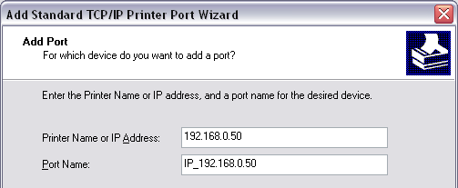
If your print device has a built-in Ethernet adapter

On the Local Or Network Printer page of the Add Printer Wizard, select the local printer option and clear the automatic-detection option.

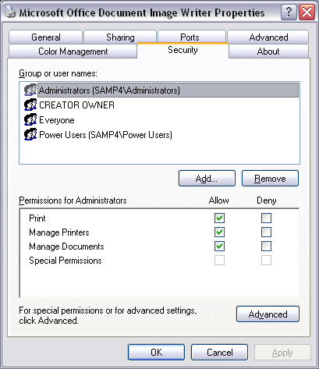
On the Select A Printer Port page, select Create A New Port and then select Standard TCP/IP Port

On the Add Port page, type the IP address of the printer

Setting Permissions on Shared Printers

When you set up a printer, initially all users in the Everyone group have Print permission for documents they create

Provides access to the printer

Ability to manage their own documents in the print queue

And by default, members of the Administrators and Power Users groups also have Manage Printers and Manage Documents permission

Printer Permissions: Print, Manage Printers, Manage Documents

Print

Print documents

Control properties of owned documents

Pause, restart, and remove owned documents

Manage Printers

Share printer

Change printer properties

Remove printer

Change printer permissions

Pause and restart the printer

Manage Documents

Pause, restart, move, and remove all queued documents

A user account that doesn’t have any of these permissions can’t connect to the printer, print to it locally, or view its queue.

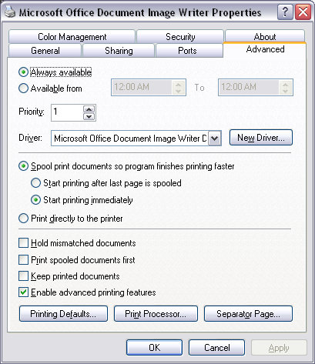
Hours of Availability

The Advanced tab of the printer’s properties dialog box

Always Available and Available From

Priority and Drivers

Priority

If you create multiple printers for a single print device, documents sent to the printer with the higher Priority setting print ahead of those sent to the other printer

Driver

Shows all installed printer drivers

Spooling

Spool settings

A Spooled document is spooled to a hard disk before sending it to the printer

Spooled documents are then sent to the print device in the background

Hold Mismatched Documents

Documents that can’t print because the document’s properties don’t match printer properties are held in the queue

A mismatched document typically occurs when an application specifies a form that’s not currently assigned to a printer tray

Print Spooled Documents First

Selecting this option maximizes printer efficiency because the print device doesn’t have to wait for an incomplete, high- priority document to finish spooling before it can begin printing a complete, lower-priority document.

Keep Printed Documents

Spooler doesn’t delete documents from the queue after they print

Command-Line Utilities for Managing Shared Resources

Net Share

The Net Share command lets you view, create, modify, or delete shared resources on your computer.

Net Use

The Net Use command connects your computer to shared resources on other computers

Chapter 26 - Remote Access Options

Win XP Home Edition

Remote Desktop is not available in Windows XP Home Edition

However, you can use Remote Desktop Connection on a computer running Home Edition to connect to a computer running Windows XP Professional

If you want to connect to a remote computer that’s running Windows XP Home Edition, you can use Remote Assistance or NetMeeting, but not Remote Desktop

Remote Desktop and Virtual Private Network (VPN)

With Remote Desktop, you use your office computer by controlling it from home.

With a VPN, you use the Internet to connect a computer to your network

In effect, this adds your home computer to your office network, just as if your computer were physically connected to the local area network (LAN)

Both Remote Desktop and VPN connections are encrypted, so your information is secure, even if you’re making a connection over the public Internet.

The basic difference between Remote Desktop and a VPN is

With Remote Desktop, your computer takes over control of a remote computer

With a VPN connection, your computer becomes another node on the network

Setting Up a Remote Desktop Connection to Another Computer

Remote Desktop

Allows you to work on your Windows XP Professional computer from any other computer

Based on the Terminal Services technology from Windows NT Server and Windows 2000 Server

What You Need to Use Remote Desktop

You need two computers that are connected via a local area network, the Internet, or a dial-up connection.

The computer that you want to control—the one at the remote location—is called the remote computer

The computer you want to use to control the remote computer is called the client computer

Requirements for the Remote Computer

Windows XP Professional

Must have a connection to a local area network or to the Internet

Or it must have a modem that’s configured to answer incoming calls automatically

If you’re going to connect to this computer over the Internet, its Internet connection must have a known, public IP address

Requirements for the Client computer

Can use nearly any version of Windows

Windows XP (all versions), Windows 2000 (all versions), Windows Me, Windows 98, Windows 95, Windows NT, or Windows for Workgroups

You must install client software (included on the Windows XP Professional CD-ROM) on the client computer

This computer must have access to the remote computer

Via a network connection, a virtual private network, or a dial-up connection

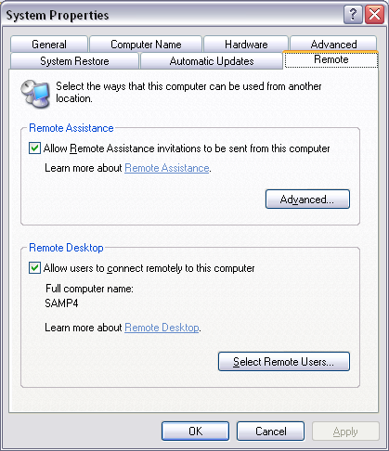
Setting Up the Remote Computer

Right-click My Computer, Properties, Remote tab.

Under Remote Desktop, select Allow Users To Connect Remotely To This Computer as shown in the figure to the right on this page.

These accounts can be used to connect remotely to the remote computer:

The account currently logged on

All members of the local Administrators group

All members of the local Remote Desktop Users group

To add more users, System Properties, Remote tab, Select Remote Users, as shown in the Remote Desktop Users box to the right on this page

Setting Up the Remote Computer

If you’re going to connect from another computer on your local area network, that’s all you need to do to set up the remote computer.

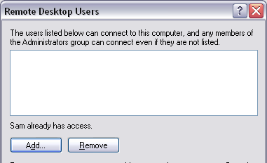
If you’re planning to connect to the remote computer via a dial-up connection, you must install a modem, configure it to answer automatically, and then set up an incoming connection.

Connecting Over the Internet

If you connect via the Internet, you must open port 3389 for Remote Desktop

If you use Windows Firewall from Service Pack 2, that port opens automatically

If you’re going to connect over the Internet, and it’s not connected directly to the Internet, you must create a virtual private network

Setting Up the Client Computer

If the client computer has Windows XP, you don’t need to install any additional software.

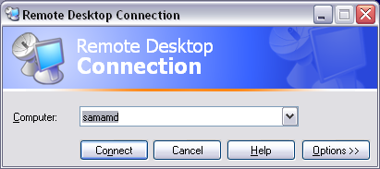
Remote Desktop Connection, the client software, is installed by default in both Windows XP Professional and Windows XP Home Edition.

Connecting to a Remote Desktop

Start, All Programs, Accessories, Communications, Remote Desktop Connection

Logging On

If another person is logged in, they will have to log off to let you use the machine.

While you use the remote computer, the remote computer’s monitor displays the Welcome screen, or the Unlock Computer dialog box.

Ctrl+Alt+Del

If you press Ctrl+Alt+Delete on the client computer, it will affect the client computer, not the remote computer.

You must press Ctrl+Alt+End to send a Ctrl+Alt+Delete to the remote computer

Configuring Performance Options

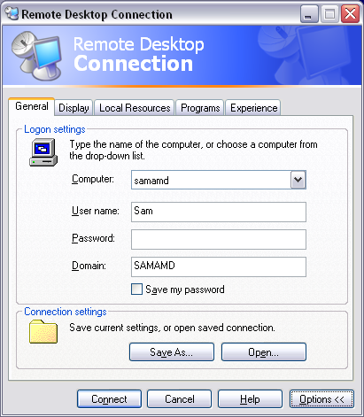
Start Remote Desktop, but before you connect, click Options.

Virtual Private Networks (not in textbook)

Tunneling provides a secure, cost-effective way to connect two computers (or two networks) that are each connected to the Internet

This path is created by

Encrypting each IP packet or frame

Wrapping it inside another packet or frame with new header information

For traveling through the intervening network

L2TP/IPSec v. PPTP

Windows XP can use:

Point-to-Point Tunneling Protocol (PPTP), or

Layer 2 Tunneling Protocol (L2TP)

Both can encapsulate network traffic so that it can travel over the Internet

The traffic starts out as PPP (Point to Point Protocol) – telephone modem traffic

L2TP/IPSec

Layer 2 Tunneling Protocol / IP Security

Uses either a 56-bit key for DES or three 56-bit keys for 3-DES

Requires a certificate infrastructure

PPTP

Point-to-Point Tunneling Protocol

Includes encryption with 40, 56, or 128-bit encryption keys

See link Ch 32a for more details

Windows Versions

Windows XP can be either a server or a client for PPTP connections

Windows XP can be the client for a L2TP/IPSec connection, but the server must run Windows 2000 Server or Windows 2003 Server

Configuring a VPN Server

Win XP Pro can act as a remote access server so that others can connect to it via a VPN

You can improve security by requiring encryption.

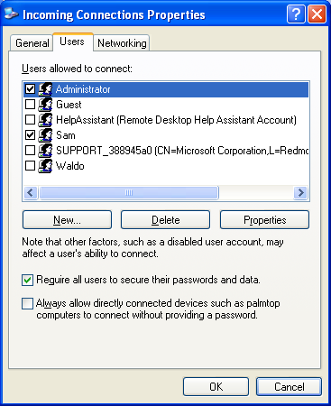
To Require Encryption

In Network Connections, right-click Incoming Connections, Properties, Users tab, Require All Users To Secure Their Passwords And Data

Internet Connection Firewall and VPN Access

At the server, when you use the New Connection Wizard to create an incoming VPN connection, the wizard automatically configures the built-in Internet Connection Firewall appropriately

Internet Connection Properties, Advanced tab, Settings

Incoming Connection VPN (L2TP) and Incoming Connection VPN (PPTP should both be selected

Other Firewalls

For PPTP connections (the type most commonly used with a Windows XP–based VPN), you must open port 1723 for TCP communication

L2TP connections, which use port 1701, require a machine certificate for authentication and are available only when the VPN server is on a network with Windows .NET Server or Windows 2000 Server.

Connecting to a Virtual Private Network

To connect to your Windows XP VPN server, you don’t need to run Windows XP; you can connect with any version of Windows.

