Chapter 27 - Using and Customizing Outlook Express

Identities

Allows multiple users to send and receive mail, each using a separate account

Outlook Express identities can effectively share a common address book

The Windows Address Book application that is integrated with Outlook Express lets each identity maintain a separate contact list

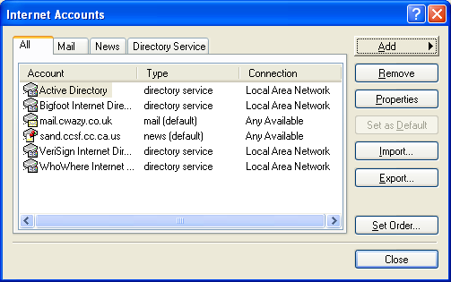
But identities can also post contacts into a Shared Contacts folder to which all identities have access

Newsgroups

Outlook Express is both an e-mail client and a newsgroup client

Hotmail

Only the paid version of Hotmail permits you to access it through Outlook Express now.

Getting Started with Outlook Express

Setting Up Accounts

Tools, Accounts

Mail

News

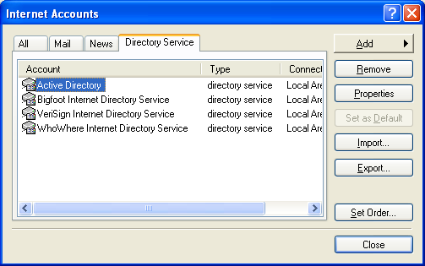
Directory service

Directory service accounts

A directory service is a repository of information about people and businesses.

When you don’t know someone’s e-mail address, you can try to find it by searching your directory services.

Creating a Mail Account

Tools, Accounts (unless the Wizard starts automatically)

Add, Mail

Your Name

Internet E-Mail Address

The address that will be added to recipients’ address books

The address Reply mail is sent to

E-Mail Server Names

Three protocols for inbound mail: POP3, IMAP, and HTTP

If your inbound server uses POP3 or IMAP, you’ll need to specify a separate SMTP address for outbound mail

Internet Mail Logon

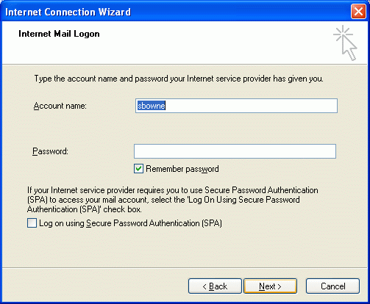
“Remember password” box could let other users of that computer read your mail

If you don’t use Secure Password Authentication, your password is sent unencrypted over the Net

The same is true for Outlook

Creating a News Account

Just like creating a mail account

Provide the address of an NNTP server instead of a POP3 and SMTP server

Creating a Directory Service Account

By default, Outlook Express provides access to your Active Directory and several public Lightweight Directory Access Protocol (LDAP) servers.

With these directory "accounts" established, you can look for people or businesses by pressing Ctrl+E

Or clicking the Find button on the toolbar and then choosing People from the Find menu

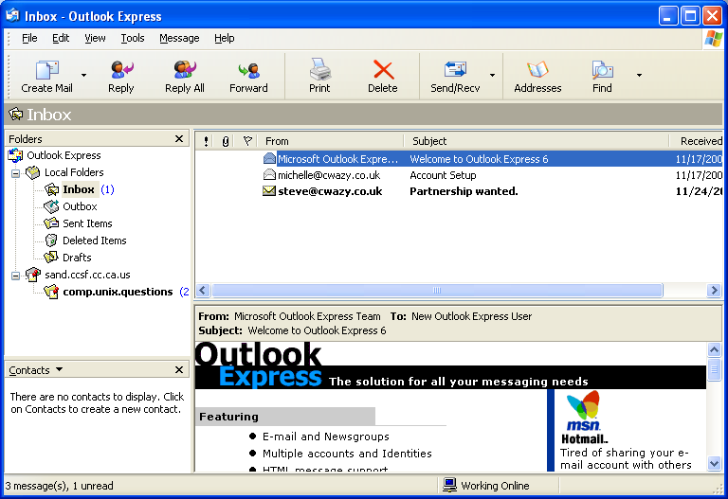
Editing Account Information

Tools, Accounts, select the name of the account, Properties

Previewing Messages

Convenient, but a security risk, especially if you show images in HTML-enabled e-mail.

Navigating the Folders List

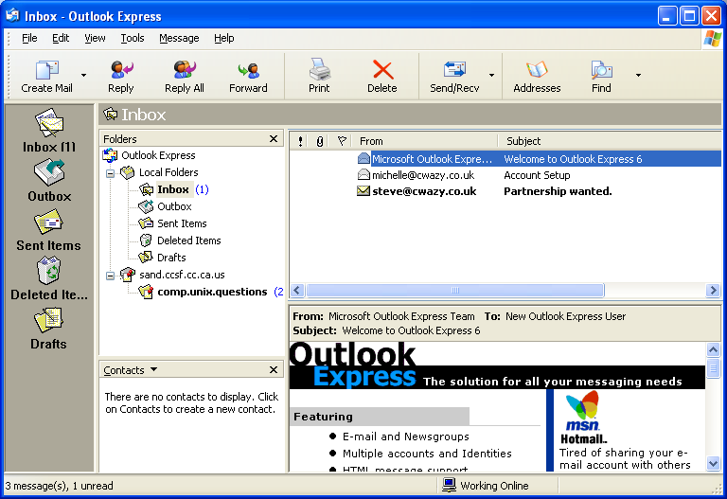
Local Folders are used for POP3 e-mail accounts

Outlook Express creates a separate set of folders for each HTTP, IMAP and News account

Outlook bar

Less useful than the Folders list or the Folders bar

Control it with View, Layout

Setting Basic Options

Tools, Options

Checking for Mail at Regular Intervals

Default is 30 minutes

Minimizing Connect Time with Dial-Up Accounts

If My Computer Is Not Connected At This Time

Hang Up After Sending and Receiving on Connection tab

Controlling the Format of Outbound Messages

Outlook Express formats outbound mail by default in HTML, leaving news posts in plain text

Making Outlook Express the Default Mail and News Handler

Options, General tab

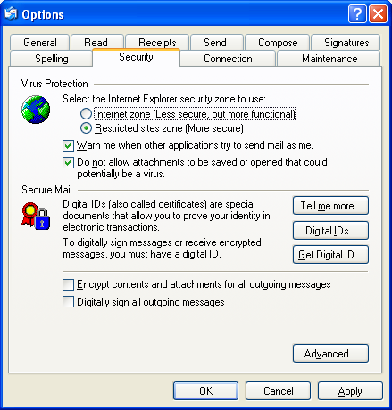
Setting Security Options

Tools, Options, Security tab; both these should be selected

Restricted Sites Zone (More Secure)

Uses IE settings

Warn Me When Other Applications Try To Send Mail As Me

Stops viruses from sending mail

Address Book

Outlook Express is tightly integrated with Address Book, a separate application designed to be shared by other programs that use contact information—fax clients, teleconferencing software, and the like

Open Windows Address Book from Outlook Express by clicking Addresses on the toolbar

Importing Address Book Data

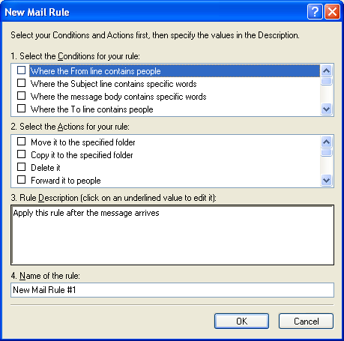
To import data from another Address Book (.wab) file, choose File, Import, Address Book in Outlook Express

To import information from another contact manager, choose File, Import, Other Address Book

If you specify a .csv file for import, make sure the first record has no empty fields

Exporting the Address Book

File, Export, Address Book (WAB) in Address Book.

File, Export, Other Address Book

Backing Up Your Address Book

Help, About Address Book to find the .wab file

Address Book makes a backup file in the same folder with the extension .wa~

If your .wab file becomes corrupt, your .wa~ file might still be good

Using Rules to Organize Messages

Tools, Message Rules, then specify either Mail or News

Blocking Obnoxious Mail

Select the message and choose Message, Block Sender

Tools, Message Rules, Blocked Senders List

Saving Messages Outside Outlook Express

Select the message and choose File, Save As

Your file will have the extension .eml

It’s not smart to entrust critical information exclusively to Outlook Express’s message store

If your message store becomes corrupted for any reason, or if you purge old messages periodically (something you should do), you could inadvertently lose or destroy some vital bit of correspondence

Maintaining Outlook Express

When you delete a message, Outlook Express marks the item as deleted but does not remove it from the disk file in which the folder is stored

Thus, over time, you can accumulate a significant amount of wasted disk space

Under these circumstances, Outlook Express’s performance will suffer, even though the apparent contents of your folders is relatively small.

Compact Messages

To reclaim the wasted disk space, you have to take a second step, called compacting

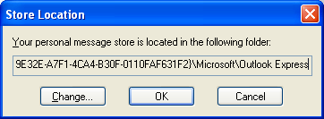
Tools, Options, Maintenance tab, Compact Messages In The Background, specify Percent Wasted Space

Relocating Your Message Store to Simplify Backup

To find your message store: Tools, Options, Maintenance tab Store Folder

To move your message store:

Tools, Options, Maintenance tab, Store Folder

In the Store Location box, click Change and select the new store folder

Outlook Express will move your messages the next time you start the program.

Archiving Old Messages

Outlook Express does not include a command for archiving old messages

You have to do it manually, with a complex procedure in the book

Outlook does archive manually

Moving Your Outlook Express Files to a New Computer

On the old machine:

Tools, Accounts, select the account name, Export to back up account

To back up your address book, open Address Book and choose File, Export, Address Book (WAB)

Determine the location of your message store

Tools, Options, Maintenance tab, and clicking Store Folder

On the new machine

Import account with Tools, Accounts, Import

Import address book -- open Address Book and choose File, Import, Address Book (WAB)

Determine the location of your message store

Close Outlook Express and copy all files from your old store folder to your new one

When you reopen Outlook Express, everything should be there.

Last modified 4-17-05

