Chapter 28 - Sending and Receiving Faxes

Sending and Receiving Faxes

Fax Services lets you send, receive, and manage faxes using your computer's fax modem

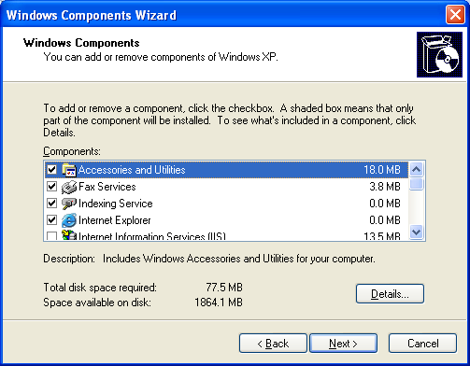
You can transmit documents directly from a word processor or e-mail client

At Home with Windows XP

Fax is the same in Home Edition and Win XP Pro

But because Windows XP Home Edition always uses Simple File Sharing, the Fax Security tab in the Fax Properties dialog box is not normally visible.

To see it, hold down the Ctrl key when opening the properties dialog box

Installing Fax

Log on with Administrative privileges

Add Or Remove Programs in Control Panel

Add/Remove Windows Components

Fax Services

Fax Appears on the Start Menu

Start, All Programs, Accessories, Communications, Fax

Installing Fax also adds the Fax service in Services

And creates a new printer named Fax

Configuring Fax

Log on with Administrative privileges

Run Fax Console to start the Fax Configuration Wizard

By default, Fax is set up to allow you to send but not to receive

Specifying Your Transmitting Station Identifier (TSID)

If you Enable Send, you can specify a TSID

TSID is a string of up to 20 characters that tells your fax recipients where your faxes are coming from

The receiving device usually prints your TSID at the top of each page

Usually you put your fax number in the TSID

If you Enable Receive, you can specify a CSID, like a TSID

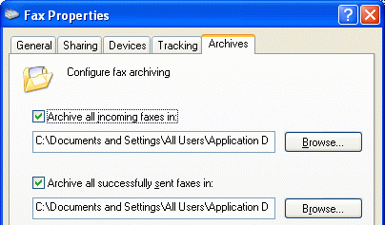
Routing Received Faxes to a Printer or Folder

By default, received faxes are stored as TIFF files

By default, the archive folder is %AllUsersProfile%\Application Data\Microsoft\Windows NT\MSFax\Inbox

Tools, Fax Printer Configuration in Fax Console, click the Archives tab

Retry Characteristics and Discount Hours

Retry -- how often and how frequently to keep trying to send a fax

Default: 3 attempts at 10-minute intervals

If you indicate "discount hours"

When you send a fax, you'll have the opportunity to schedule it to begin during the discount period.

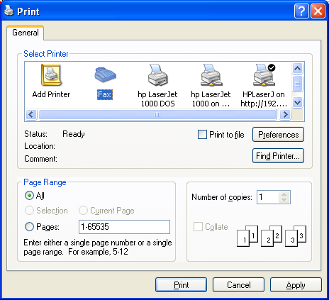
Faxing a Document

To fax a document, simply print it--using Fax as the "printer."

You can do this from your word processor or other application

Managing the Outbox Queue

Click Outbox in Fax Console's folder tree

Archiving Sent Faxes

When Fax has successfully sent a job, it moves it from the Outbox to the Sent Items folder

You can archive Sent items with Windows Explorer

Receiving Faxes

Received faxes appear in Fax Console's Inbox folder

and, if requested, a copy appears at your printer or in your routing folder

Reading Received Faxes

Faxes arrive in the Inbox folder as TIFF files

Double-click fax to open it in Microsoft Office Document Imaging (part of Microsoft Office)

That shows an optical character recognition (OCR) version

Last modified 4-17-05

