Ch 3 - Help and Support Options

Help And Support Center

Click Start, Help and Support

Tools, including

Disk Defragmenter

System Configuration Utility (Msconfig)

Network Diagnostics

Syntax and usage information for 175 command-line options

Windows Update

Dozens of troubleshooters (under Fixing a problem)

Computer Information

Easy access to

error logs

Group Policy settings

Links to external information sources, including the Microsoft Knowledge Base

Remote Assistance

Using the Help And Support Center

Searching for Help Topics

Results are in three groups

Suggested Topics

Full-Text Search Matches

Microsoft Knowledge Base

Using the Help Index

Connecting to Another PC with Remote Assistance

The novice sends a Remote Assistance invitation

Using Windows Messenger, e-mail, or a shared file

The expert accepts the invitation

The expert can view the desktop and exchange messages with the novice using text or voice chat.

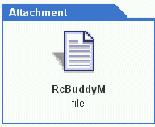
If the novice grants permission, the expert can work with objects on the remote PC

RA Ticket

At the heart of each Remote Assistance connection is a small text file called an RA ticket.

rcBuddy.MsRcIncident

Remote Assistance and IP Addresses

A Remote Assistance connection is easy when both parties have public IP addresses -- the computers connect directly, using TCP port 3389 (and port 80, if you use Messenger)

Remote Assistance connections are also easy on a private network – the computers connect without having to pass through any routers.

Remote Assistance and NAT

If one or both sides of the connection are using private IP addresses assigned through Network Address Translation (NAT), there can be trouble connecting

Internet Connection Sharing

Internet Connection Sharing (ICS) from Windows XP or Windows Me automatically lets Remote Assistance through

Older routers are harder to configure for Remote Assistance

Sending a Remote Assistance Invitation

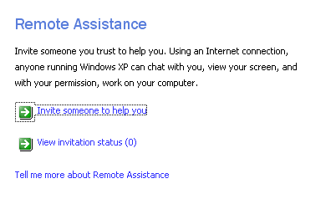
From Help and Support Center, click on

Invite a friend to connect to your computer with Remote Assistance

Maintaining Security

Set a short expiration time on Remote Assistance invitations sent via e-mail. A time of 1 hour should be sufficient for most requests.

Assign a strong password to Remote Assistance invitations.

Manually expire invitations when they’re no longer needed.

Disabling Remote Assistance

Open System in Control Panel

Click the Remote tab

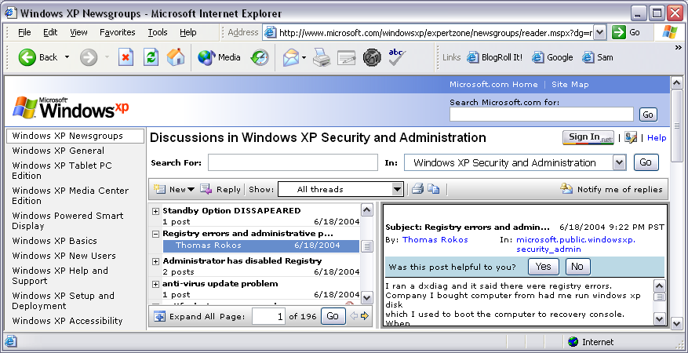
Clear the Allow Remote Assistance Invitations To Be Sent From This Computer check box.

Other Support Resources

In Help and Support Center, click the Support button for

Windows Newsgroups

Microsoft Support

Chapter 4 - Installing, Uninstalling, and Managing Programs

How User Rights Affect Program Setup Options

Administrator account

Can install any program without restrictions

Can also choose to remove, modify, or repair that program at any time

Therefore, spyware and viruses can be installed if you use the Internet while logged in as and Administrator

Limited user account

Blocked from installing most programs

Power Users

Power Users can install most programs, but not modify system files

The Power Users group is on the list of default groups in Windows XP Professional, but it has no members by default

It’s not much safer than using an administrative account

Run As

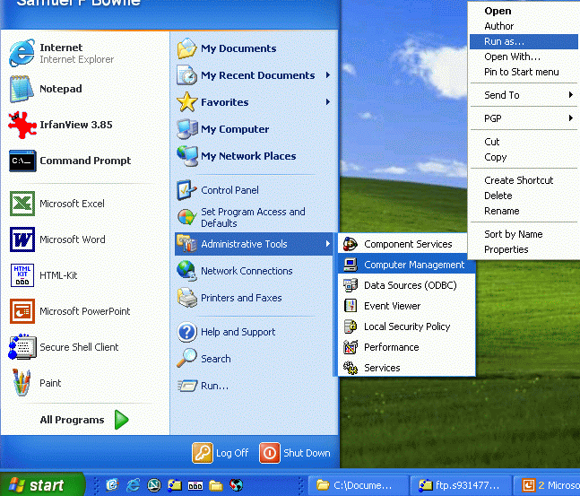
Temporarily elevates privileges

Right-click a file, sometimes Shift-Right-click

Much safer for security

Best practice is never to be logged in as an Administrator, if you can manage it

Installing a program for a user with a limited account

Windows 9x applications can stumble in Windows 2000 and Windows XP.

Is an upgrade available?

Is there a published workaround?

Can you adjust permissions in the registry?

Temporarily "promote" the user

Find a Windows XP–compatible program

Installing Programs

Before installing a new program, ask the following questions:

Is it compatible with Windows XP?

Are any patches available?

Are there known problems with the program?

Can it be uninstalled easily?

Set a restore point first

Start, Help, System Restore

Installing 32-Bit Windows Programs

Virtually all modern 32-bit Windows programs start the Setup process through a file called Setup.exe

Windows can track down the proper Setup file automatically when you use Add Or Remove Programs

Assigned and Published Applications

Windows Installer lets administrators configure a program so that it installs automatically from the server, in a domain

Three techniques

Assigned to a user

Appears on Start menu, installs on first use

Assigned to a computer

Installs on boot-up

Published

User can install from Add New Programs window.

Installing and Running 16-Bit Windows Programs

To run these older 16-bit programs (written for DOS or Windows 3.1) under a 32-bit operating system, Windows XP launches a subsystem—a virtual machine —that a 16-bit machine.

Glitches in 16-bit programs

Usually do not support long file names.

Do not run as fast

Require 16-bit device drivers, which are not supported in Windows XP

May have trouble with Dynamic link libraries (DLLs)

How to spot a 16-bit application

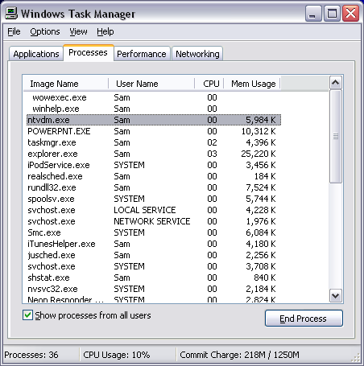
Right-click the program’s executable file and then choose Properties. If you see a Version tab, it’s a 32-bit program

Task Manager will show Ntvdm.exe, the virtual DOS machine, when 16-bit apps are running

Example -- C:\Windows\Winhelp

Multiple 16-bit Apps in a single virtual machine

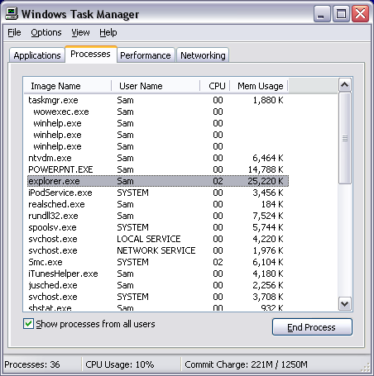
By default, Windows XP treats each running 16-bit application as a thread within a single virtual machine.

If you just launch Winhelp 3 times, you get these processes

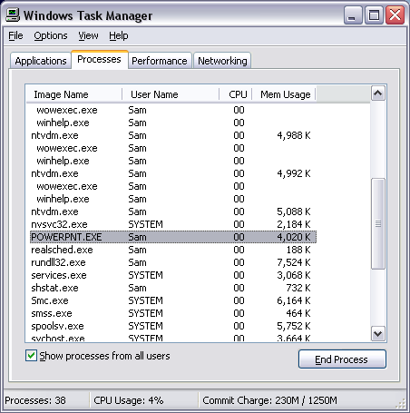
Multiple virtual machines

To make 16-bit apps more stable, do this:

Create a shortcut to the program, right-click the shortcut icon, and then choose Properties.

On the Shortcut tab, click the Advanced button.

Select the Run In Separate Memory Space check box.

This approach uses extra memory.

COMMAND vs. CMD

Command.com, the MS-DOS command processor, is a 16-bit application included with Windows XP

If you type command in the Run box, Windows starts a new MS-DOS virtual machine

Cmd.exe is the 32-bit Windows XP Command Prompt program.

For most command-line tasks, Cmd is preferred.

Making a Program Available to All Users

Most of the time, when you install a Windows program from an administrator’s account, its shortcuts are placed in the All Users profile

%AllUsersProfile%\Start Menu\Programs

Usually C:\Documents and Settings\All Users\Start Menu\Programs

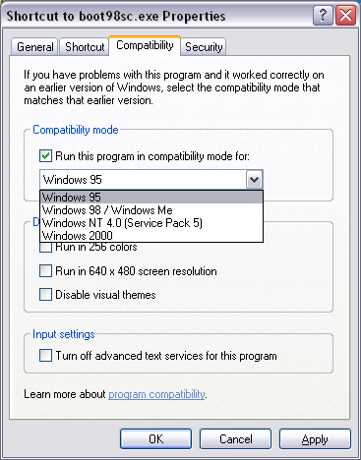
So that any user who wants to run that program can do so.

Making a Program Available to All Users

If Setup installs a program only for the currently logged-on user, you have two choices:

Log on using each user account and rerun Setup

For simple programs that don’t require per-user settings to be added to the registry before running, you might be able to simply add a shortcut to %AllUsersProfile%\Start Menu\Programs.

Forcing Older Programs to Run Properly

Make a program shortcut.

Right-click the shortcut icon and choose Properties, and then click the Compatibility tab

Managing Installed Programs

Control Panel, Add Or Remove Programs

Uninstalling Programs

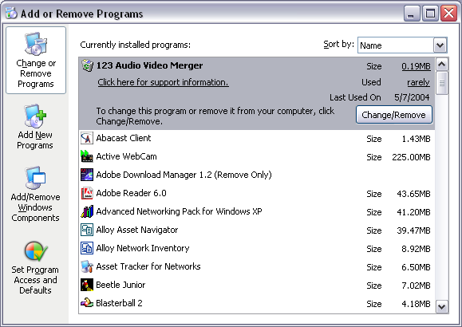
Add Or Remove Programs in Control Panel

Lists installed programs in alphabetical or by date last used

Most uninstall programs leave at least a few traces of the program behind

Running a Program as Another User

If you’re logged on using a limited account and the program you want to use requires administrative privileges, you have three options:

Fast User Switching (not available on a domain)

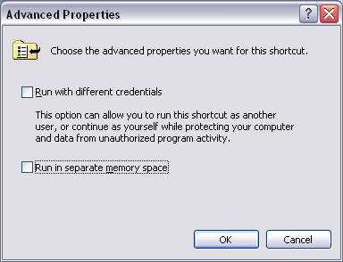
Right-click, Run As (sometimes Shift-right-click)

Runas command from a command window

runas /user:username cmd

Run With Different Credentials

To make it ask for credentials every time, right-click the shortcut icon and choose Properties.

On the Shortcut tab, click the Advanced button and select the Run With Different Credentials check box.
Chapter 5 - Setting Up and Troubleshooting Hardware

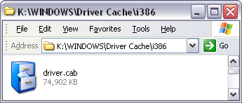
Device Drivers

Windows needs a driver for each device

Drivers are programs that hook directly into Windows, send your instructions to a hardware device, and relay data back to you.

Plug and Play Drivers

All the Plug and Play (PnP) drivers are in Driver.cab

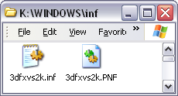
in %SystemRoot%\ Driver Cache\i386

Each PnP driver has a Setup Information file (with the extension .inf) in %SystemRoot%\Inf

Driver Signing

A digitally signed driver is best, because it shows

The driver was tested and approved by Microsoft

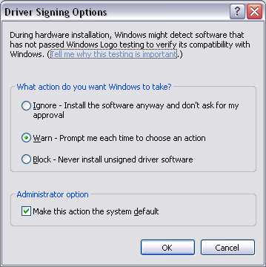
The driver was not modified (for example, by a trojan horse)

In its default settings, Windows XP warns you if you’re attempting to install a driver that isn’t digitally signed.

An unsigned, faulty driver can cause crashes, including blue-screen errors

Configuring Driver Signing

Control Panel, Performance and Maintenance, System, Hardware tab.

Click the Driver Signing button. There are three choices:

Ignore, Warn, Block

Will Drivers Written for Other Windows Versions Work with Windows XP?

Many (but not all) Windows 2000 drivers will work in Windows XP.

Windows Me drivers might also work under Windows XP, but only if the accompanying Setup Information (.inf) file includes specific instructions for Windows 2000/XP.

Drivers originally written for Windows 95/98 or Windows NT 4 or earlier are unlikely to work

Plug and Play Requirements

BIOS must support PnP (all ACPI BIOS’s do).

OS must support PnP (Win XP does).

Device must be PnP-compatible

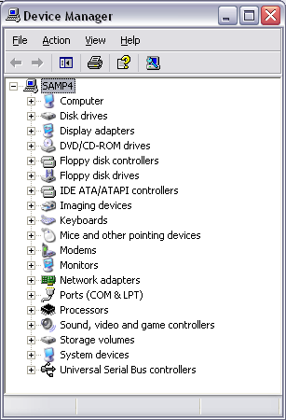
If it shows the Microsoft "Designed for Windows" logo, it is

The device driver must support PnP

Note: You must be logged on as a member of the Administrators group to install hardware drivers.

Configuring Non-Plug and Play Devices

Control Panel, double-click the System icon, click Add Hardware Wizard button on the Hardware tab.

You can choose a driver from a list, provide it as a file, or check Windows Update for it

Device Manager

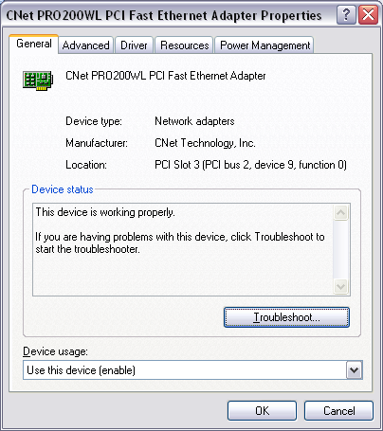
To Open Device Manager

Right-click My Computer and select Manage

From a command prompt, enter devmgmt.msc

From Control Panel, double-click the System icon and click the Device Manager button on the Hardware tab

To view information about a specific device, double-click it

General tab

Driver tab

Other tabs for some devices

View devices over the network

In Computer Management, select the Computer Management icon at the top of the left pane, and choose Action, Connect To Another Computer.

Troubleshooting Resource Conflicts

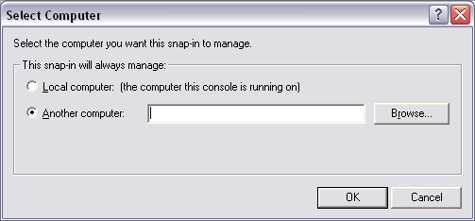
Resources are allocated automatically at startup, and cannot normally be changed in Device Manager

With PCI devices, try swapping cards, two at a time, between PCI slots.

Replace legacy (ISA) devices with a Plug and Play-compatible PCI devices

Use jumpers or a software utility to change settings on a legacy device so that it reserves a different set of resources

Check for an updated hardware driver (especially if the current driver is unsigned) and look for a BIOS update as well.

Managing Installed Drivers

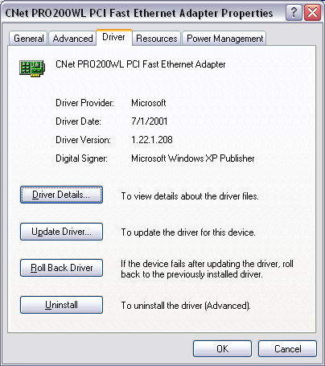
Your first stop should be Device Manager

Open the Properties for the device, Driver tab

Update Driver.

Roll Back Driver.

Uninstall

Driver Verifier

Will test your drivers the way they Microsoft Logo program does, and stop your machine at startup with specific information if a driver fails the tests

Not for everyday use; but may help when you have stability problems (see p. 154-155)

Enabling and Disabling Specific Devices

Device Manager, Properties for the device, General tab, Device Usage setting;

Use This Device (Enable)

Do Not Use This Device (Disable).

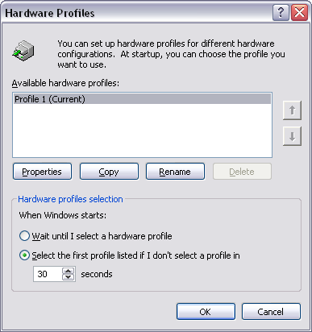
The drivers for a disabled device remain available, but Windows does not load them.

This is useful with hardware profiles, such as with notebook computers attached to docking stations

Hardware Profiles

To work with hardware profiles, open the System icon in Control Panel, click the Hardware tab, and then click Hardware Profiles.

Decoding Hardware Errors

When Windows encounters a problem with a device or its driver, it changes the icon in Device Manager and displays an error code on the General tab of the device's properties dialog box.

See chart p 158-162, or Microsoft Knowledge Base Article 310123

