Chapter 30 - Performing Routine Maintenance

Maintenance

Check your disks for errors.

Defragment your hard disks.

Make sure that you have enough space on your hard disk

Perform regular backups

Home Edition

Backup Utility is not installed by default on Home Edition, and even If you install it, Automatic System Recovery does not work
Checking Disks for Errors

Windows XP recovers automatically from many disk errors, especially on drives formatted with NTFS

Windows XP Check Disk utility, chkdsk.exe

Two versions of this utility

Graphical version that performs basic disk-checking functions

Command-line version that provides more options

To check for errors

Open My Computer

Right-click the drive

Properties

Tools tab

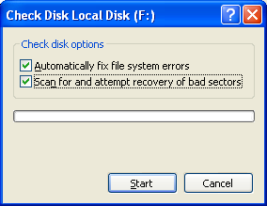
Check Now

Automatically Fix File System Errors

Equivalent to Chkdsk /F

Scan For And Attempt Recovery Of Bad Sectors

Automatically repairs file system errors too, even if other box is not checked

Equivalent to Chkdsk /R

If you simply want a report of file system errors without making changes, leave both boxes unchecked

Checking System Volumes

If you selected the Automatically Fix File System Errors

On a drive with open files

The disk check occurs during the character-mode startup phase of Windows

It Can Take a Long Time

Once started, the Check Disk operation cannot be stopped except by pressing your computer’s power switch

On very large drives (60 GB and larger), the full disk check can takes hours or even days to complete.

Windows 9x

Windows 95, Windows 98, or Windows Me ran ScanDisk automatically after an unexpected shutdown

Windows XP only runs Check Disk if the file system is "dirty"— data was not properly read or written

NTFS don’t get dirty as much as FAT32 ones

See Link Ch 30a

Command-line Check Disk

Chkdsk drive: runs Chkdsk in read-only mode, displaying drive status but not making any changes

Switches

/F fix any errors

/V verbose

/R Identifies bad sectors and recovers information from those sectors if possible

Chkdsk at the Recovery Console


Only two switches are available for Chkdsk in Recovery Console

/P Performs an exhaustive check of the current disk.

/R Repairs damage on the current disk.
Defragmenting Disks for Better Performance

On a freshly formatted hard disk, Windows writes a file in contiguous clusters (in order)


Reading and writing go faster with contiguous clusters

As you delete files and save new ones, the files get fragmented

Scattered them over the hard disk into many noncontiguous pieces

Disk Defragmenter rearranges files so that they’re stored in contiguous clusters

tip - Get a more powerful defragmenter

Executive Software’s Diskeeper

A full-featured version of the same utility bundled with Windows XP

Allows you to schedule continuous defragmentation in the background

Boot-time defragmentation of the page file

Others: Symantec’s Norton Utilities, Raxco’s PerfectDisk

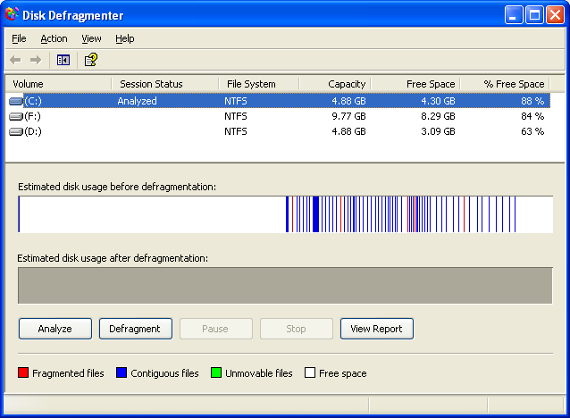
To Open Disk Defragmenter

Any of these:

All Programs, Accessories, System Tools, Disk Defragmenter, or

My Computer, right-click drive, Properties, Tools tab, Defragment Now

Dfrg.msc from a command prompt.

Computer Management, Storage, Disk Defragmenter

Analyze

To determine whether you need to defragment a drive, Analyze

Command-Line Version Defrag

defrag d:

where d is the drive letter

switches:

/A Analyzes

/V verbose

/F Forces defragmentation

Disk Defragmenter Limitations

Must have at least 15 percent free for complete defragmentation

You cannot defragment a volume that has errors

Run chkdsk d: /f first

The Disk Defragmenter does not defragment files in the Recycle Bin

Empty the Recycle Bin before defragmenting
Managing Disk Space

Clear out temporary files that you no longer need

Uninstall programs you don’t need

Uninstall Windows components you don’t need

Delete documents you don’t need

On NTFS volumes, use real-time file compression

Disk Cleanup

If you click a "low disk space" warning, this tool opens automatically

To start it manually

All Programs menu, Accessories, System Tools, Disk Cleanup

Cleanmgr at a command prompt

NTFS File Compression

Compression and ZIP files can be used to save space, as we already covered in an earlier chapter
Windows XP Backup Program

This utility is installed by default on Windows XP Professional

In Windows XP Home Edition, you need to install it from the Valueadd\Msft\Ntbackup folder on the Windows CD

Using this utility, you can back up all or part of the data on your computer’s local drives and on shared network folders.

tip - Back up to a CD

The Windows XP Backup Utility does not support backing up directly to CD recorders

Back up to a file first, and then copy that backup file to a CD-R or CD-RW disk

To start Backup Utility

Start, All Programs, Accessories, System Tools, Backup, or

Ntbackup.exe from a command prompt

Back Up File And Settings

What To Back Up

My Documents And Settings

Your entire user profile, including My Documents, Application Data, and desktop

Backup Types – Normal

Normal backup

Copies every file in the selected folders

Uses the most time and tape

Is easiest to restore: only one tape needed to restore file system to any day in the past

Backup Types – Differential

Differential backup

Copies only the files that have changed since the last Normal (or incremental) backup

Monday’s tape includes only Monday’s work

Tuesday’s tape includes both Monday’s and Tuesday’s work

Saves a lot of time and tape

Can require two tapes to restore files

Backup Types – Incremental

Incremental backup

Copies only the files that have changed since the last Normal or incremental backup

Monday’s tape includes only Monday’s work

Tuesday’s tape includes only Tuesday’s work

Saves the most time and tape

Can require several tapes to restore files

Advanced options

Copy backup

All files; but does not clear Archive attribute, so it does not interfere with the pattern of Normal, Incremental, Differential backups

Daily backup

All files that have changed on the current day

Restoring Data

Start the Backup Utility in Wizard Mode and choose the Restore Files And Settings option

At the conclusion of the wizard, click the Advanced button and Where To Restore:

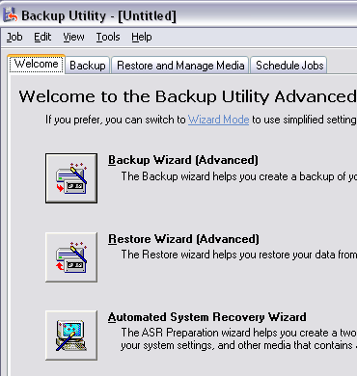
Original Location

Alternate Location

Single Folder

Automatic System Recovery Backup

Can restore your system partition in the event of a catastrophic failure

Not available on systems running Windows XP Home Edition. Backup Utility allows you to create an ASR backup, but you can’t Restore.

ASR saves the complete contents of your system drive

Also saves information about your current arrangement of disk partitions, system files, and detected hardware, on a floppy disk.

ASR can restore your system configuration

It does not back up or restore data on drives other than the system volume

Other Backup Software Options

Files And Settings Transfer Wizard

Compressed folders and other Zip utilities

Simple copies

Third-party file-syncing utilities

LapLink’s PCSync

FileWare’s FileSync

Create mirror images of important data folders

