Chapter 31 - Monitoring System Activities with Event Viewer

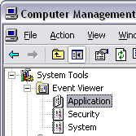
The Three Event Logs

Application

Security

System

All viewable in Event Viewer (in Computer Management)

Home Edition

Event Viewer is the same in Home Edition as in Windows XP Professional, but only certain predefined events are recorded in the Security log

Security Events

Security events are recorded in the Security log

Monitoring these events is called auditing and is not covered in this course

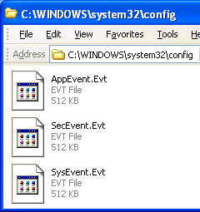
Application Events

Application events are generated by applications, including programs that you install, programs that come with Windows XP, and operating system services.

For example, events relating to Microsoft Office, the backup program that comes with Windows XP, and the Windows XP Fax service are all recorded in Appevent.evt

System Events

System events are generated by Windows XP itself and by installed components, such as device drivers.

If a driver fails to load when you start a Windows XP session, for example, that event is recorded in the System log.

Three types of events:

Errors

Possible loss of data or functionality

Examples: A malfunctioning device, or a service that failed to load

Warnings

Less significant or less immediate problems than errors

Examples: a nearly full disk or a timeout by the network redirector

Information

Other events

Examples: someone using a printer connected to your computer, or a successful dial-up connection to your ISP

To start Event Viewer

Right-click My Computer, Manage
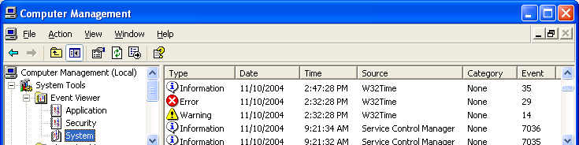

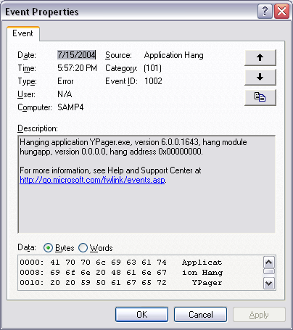
Event ID

All events are identified by a numerical value

Use eventid.net

Examining Event Details

Double-click the event.

Click the arrow buttons in the upper right corner of the properties dialog box to move to the previous or next event in the list.

Searching for an Event

The Find command on Event Viewer’s View menu allows you to locate particular items in the current log

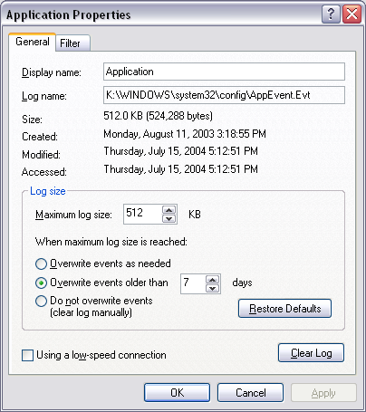

Setting Log File Size and Longevity

Select the log in question in the console tree of Event Viewer, then click Action, Properties

By default, each log file has a maximum size of 512 KB

Also by default, events in each log file have a minimum longevity of seven days

Help And Support Center

Click Start, Help And Support Center

Use Tools To View Your Computer Information And Diagnose Problems

Advanced System Information

View The Error Log

Merges the content from all three logs, but shows only errors

Last modified 4-20-05

