Chapter 32 - Recovering After a Computer Crash

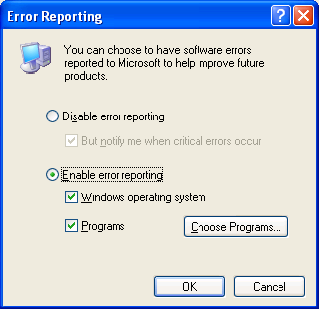
Home Edition

Home Edition has the same tools as Windows XP Professional, but you cannot customize error reporting and Recovery Console with Group Policy

Windows Error Reporting

When an application crashes, you will have a chance to send information back to Microsoft for use in preparing Knowledge Base articles, service packs, etc.

You can disable Windows Error Reporting in System Properties on the Advanced tab, but if you do, you will see Dr. Watson reports instead.

After a Computer Crash

Safe Mode

Last Known Good Configuration

System Restore

Recovery Console

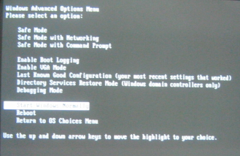
Reinstallation

Using Advanced Startup Options

Press F8 during text-mode startup

Using Safe Mode

In Safe Mode, Windows uses bare minimum services and drivers

Generic video driver at a resolution of 640x480

Support for your keyboard, mouse, monitor, local storage, and default system services

No audio devices or nonessential peripherals, including most USB devices

Ignores all startup programs

Safe Mode Tools

Device Manager

And Event Viewer

System Restore

Registry Editor

Backup

Help And Support Center

Except Group Policy in Advanced System Information

If Windows Works in Safe Mode

You can assume that there’s no problem with the basic services

Use Device Manager and Event Viewer to find the problem

Use Device Manager to uninstall or roll back a hardware driver

Add Or Remove Programs

Safe Mode With Networking

Lets you access network resources

But not on a portable computer with a PCMCIA (PC Card) network adapter, because PCMCIA peripherals are disabled in Safe Mode.

Safe Mode With Command Prompt

Same as Safe Mode, but uses the Windows XP command interpreter (Cmd.exe)

Last Known Good Configuration

When Windows starts

The operating system makes a record of all currently installed drivers and the contents of the registry key HKLM\SYSTEM\CurrentControlSet

But not if you start in Safe Mode

Last Known Good Configuration

Restores the previous, working registry key

System Restore is more reliable than Last Known Good Configuration, because it restores all Windows system files and the entire registry rather than just a single key

Caution

If you suspect that a driver change is causing system problems

Don’t log on in normal mode

Use Safe Mode

Because, as soon as you log on in normal mode

Windows resets the Last Known Good Configuration information, effectively removing your safety net

Other Startup Options

Enable Boot Logging

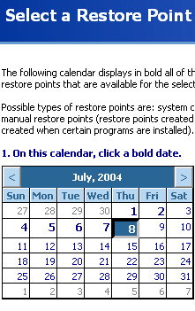
Creates a log file that lists the names and status of all drivers loaded into memory

%SystemRoot%/Ntbtlog.txt

Enable VGA Mode

Uses standard VGA mode using the current video driver

Not the plain-vanilla Vga.sys driver used in Safe Mode

Use this option to recover from video problems that are caused not by a faulty driver but by incorrect settings, such as an improper resolution or refresh rate

Directory Services Restore Mode

Only used with domain controllers running Windows 2000 Server or Windows .NET Server. Ignore it.

Debugging Mode

Kernel debug mode

Must connect the system to another computer using a serial connection on COM2; not much use for normal users

Undoing Configuration Mistakes with System Restore

System Restore takes a "snapshot" of your system’s registry at intervals

System Restore Wizard can roll back your system files and registry to those saved from a previous date

System Restore Can Save You When

You install a program that conflicts with other software or drivers on your system

You install one or more updated drivers that cause performance or stability problems

Your system developed performance or stability problems for no apparent reason

Viruses

System Restore cannot protect you from viruses, worms, Trojan horses, etc.

Your restore points might get infected

Use a reliable antivirus program, keep it up-to-date, and don’t open e-mail attachments unless you’re certain they’re safe

How System Restore Works

System Restore keeps a log of changes to file types defined in %SystemRoot%\System32\Restore\ Filelist.xml

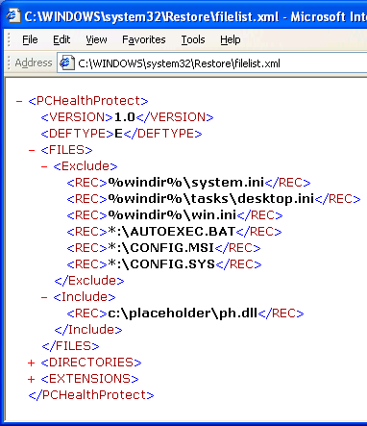
At regular intervals, the System Restore service copies system files to hidden archives for safekeeping.

It takes regular snapshots of the system state, including information about user accounts, hardware and software settings, and files required for startup

System Restore Does Not Monitor

The page file or hibernation file.

Any files in

My Documents, Favorites, Cookies, Recycle Bin, Temporary Internet Files, History, and Temp

Image and graphics files

E-mail

When Restore Points are Created

At installation

When you create a restore point manually

You install an unsigned device driver

You install an application

Using an installer that’s compatible with System Restore

You install a Windows update or patch

You use System Restore

You restore data from backup

Created with the Windows XP Backup program

Every 24 hours if you leave your computer on

Restoring a Previous System Configuration

Start, Help And Support, Undo Changes To Your Computer With System Restore

System Restore Do’s and Don’ts

Recently created user accounts may vanish

But if the new user created any data files, they’ll still be intact

System Restore does not uninstall programs, although it does remove executable files and DLLs

Changes made in Recovery Console are not monitored by System Restore

Upgrading OS erases Restore Points

You cannot create a new restore point in Safe Mode

Therefore you cannot undo a restore that you perform in Safe Mode

When you install a service pack, you can save or reset restore points

If you choose the reset option, all existing restore points are lost and System Restore uses the new configuration as the baseline for future restore points

Making Repairs from the Recovery Console

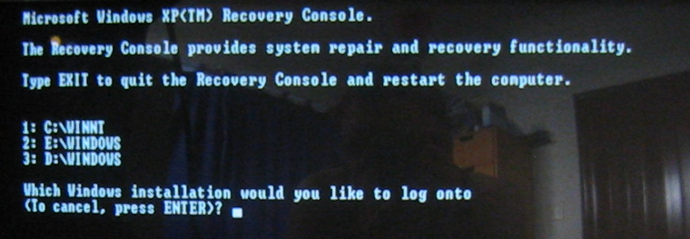
Recovery Console works even when your Windows system files are corrupted

Even when Safe Mode does not work

With Recovery Console, You Can

Use, copy, rename, or replace Windows system files and folders

Enable or disable services or devices

Repair the file system boot sector or the Master Boot Record (MBR)

Rebuild or repair the Windows boot menu

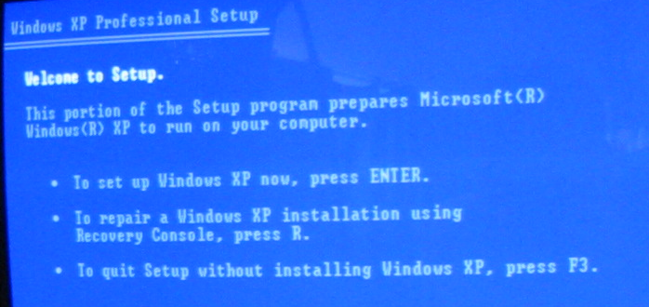
Create and format drives

To start the Recovery Console from the Windows CD

Insert the Windows CD and restart your computer.

At the Welcome To Setup screen, press R to start the Recovery Console.

Recovery Console Restrictions

Although Recovery looks like the Windows XP command interpreter (Cmd.exe)

It’s not the same

Recovery Console can only access files only in these locations:

The root directory of any volume.

%SystemRoot% (usually C:\Windows)

The Recovery Console Cmdcons folder and any subfolders

Files and folders on removable disks, including floppy disks, CDs, and Zip disks

For Security, Recovery Console imposes these limits

You cannot read from or write to

Program Files, Documents And Settings, and disks or folders containing other Windows installations

These restrictions apply on NTFS and FAT32 volumes alike.

Write access to removable disks is disabled

You cannot change the local Administrator account password from the Recovery Console

No text editing tools are available in the Recovery Console

Recovery Console Commands

Bootcfg -- Repairs Boot.ini

Fixboot -- Writes a new partition boot sector onto the partition you specify

Fixmbr -- Repairs the Master Boot Record of the specified disk, usually the system partition

Diskpart -- Manages the partitions on basic disk volumes

Disable -- Disables a service or driver

Enable -- Enables a service or driver

Repairing Damaged Boot Files With Recovery Console

The Boot.ini file is corrupt or missing

Use bootcfg

Critical system files are damaged or missing

You can restore Ntldr, Ntoskrnl.exe, Ntdetect.com, and driver files

Another operating system replaced the Windows XP boot sector code

Start Recovery Console from the Windows CD and use the Fixboot command to rewrite the boot sector code. Restart your computer.

Repairing and Reinstalling Windows

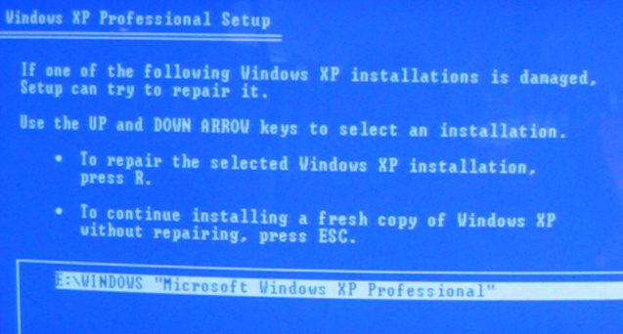
The repair option is quick and painless and typically does not adversely affect user settings

Start from the Windows CD

At the Welcome To Setup screen, do not choose the option to repair your installation using the Recovery Console

Instead, press Enter, which starts the Windows Setup program

When you reach the screen that lists your current Windows installation, select it from the list and press R to start the repair process

In cases of severe disk damage or registry corruption, a repair installation will not be effective; the only alternative is to reformat the disk and install a clean copy of Windows

