Chapter 33 - Troubleshooting Windows Errors

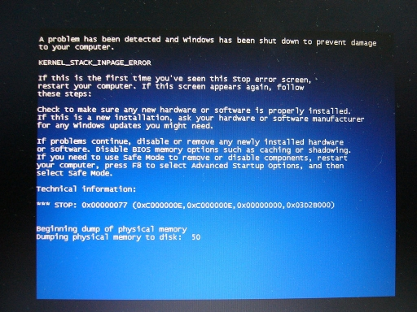
STOP Errors

When Microsoft Windows XP encounters a serious problem

And the operating system can't continue running

A STOP error appears -- the Blue Screen of Death (BSOD)

At Home with Windows XP

All of the advice in this chapter applies equally to Windows XP Home Edition and Professional.

If you use Recovery Console with Windows XP Home Edition, use a blank password for the Administrator account

STOP Errors During Windows Setup

Faulty device driver

Hardware is failing

Incompatible system BIOS

If your system that uses a high-speed disk controller whose drivers are not included with the Windows XP CD

Press F6 at the beginning of Setup and provide the correct drivers

STOP Errors at Startup

Incompatible service or device driver

Recently installed software or a new device is the most likely culprit

STOP Errors While Windows is running

Drivers, services, or defective hardware

Can be difficult to diagnose

The text of the STOP error usually provides important clues

Your computer hangs on startup.

Start with the Windows CD, and start Recovery Console

Add the /Noguiboot and /Sos switches to Boot.ini

Restarting your computer and you'll see a listing for each driver and service as it loads

The last one in the list is the most likely culprit

Then use Recovery Console's to disable a service or replace a file

How to Read a STOP Error -- Symbolic error name

The message that the error returned to the operating system

For example, DRIVER_IRQL_NOT_LESS_OR_EQUAL

How to Read a STOP Error -- Troubleshooting Recommendations

Generic advice, such as

Check available disk space

Uninstall a piece of hardware

Remove or update recently installed drivers or software

How to Read a STOP Error -- Error number and parameters

Developers call this section bugcheck information.

The text following the word STOP includes the error number

And up to four parameters

STOP Error Example

Error code: 0x000000D1

Indicates a driver that tried to use an improper memory address

Parameters

Memory address the driver tried to access

Interrupt request level

Whether the driver tried to read from or write to memory (the 0 means this was a read operation)

The memory address from which the illegal request originated

Driver information

Some STOP errors name the driver associated with the error

Check to see if the driver is digitally signed

Use Recovery Console or Safe Mode to remove or roll back the driver

BUT the accused driver may not be guilty

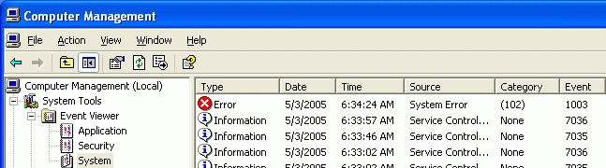
If the system restarts immediately after a STOP error

Look in the System event log

General Advice for Dealing with STOP Errors

Look for a driver name in the error details

Don't rule out hardware problems

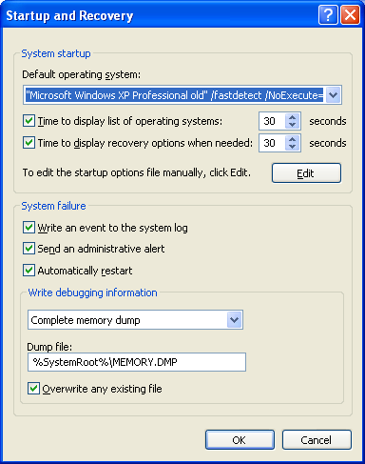
Ask yourself, "What's new?"

Search the Knowledge Base

Check your system BIOS carefully

Are you low on system resources?

Is a crucial system file damaged?

Customizing How Windows Handles STOP Errors

When Windows encounters a serious error, it

1: Displays a STOP message.

2: Writes debugging information to the page file

When the computer restarts, this information is saved as a crash dump file

3: Either pauses with the STOP message on the screen or restarts when the crash dump information has been saved.

Customizing How Windows Handles STOP Errors

Defining the size of the crash dump files

Specifying whether you want Windows to restart automatically after a STOP

By default, Windows XP automatically restarts after a STOP message

To Make Windows XP Halt at STOP Errors

System Properties, Advanced tab

Click Settings under Startup And Recovery

Clear the Automatically Restart check box

Adjusting Settings for Crash Dump Files

Small Memory Dump

Smallest file – 64 KB

Not enough to thoroughly debug an error

Kernel Memory Dump

Approximately one-third the size of installed physical RAM

Adjusting Settings for Crash Dump Files

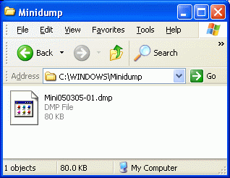
Complete Memory Dump

Equal in size to your installed RAM

Crash files are stored in

%SystemRoot%\Memory.dmp

Or

%SystemRoot%\Minidump

Online Crash Analysis

New in Windows XP

Sends debugging information to Microsoft Product Support Services

With your permission

If you use your Microsoft Passport to send an acknowledged upload

A support technician may contact you

Uploading Crash Reports Manually

Online Crash Analysis Web site

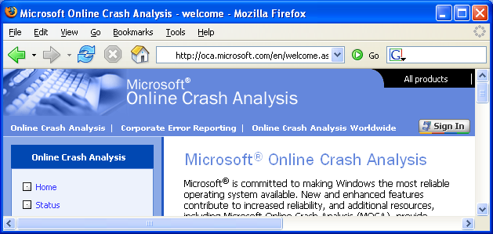
http://oca.microsoft.com

Last updated 5-3-05

