Chapter 34 - Editing the Registry

Editing the Registry is Dangerous

A bad manual change can crash your system

Normally you use Control Panel to update the registry to avoid such disasters

At Home with Windows XP

The basic structure of the registry is identical in Windows XP Home Edition and Professional

Regedit is the same

Group Policy to is not included in Home Edition

Understanding the Structure of the Registry

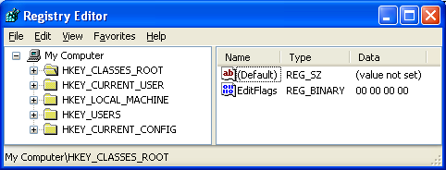
The registry consists of five root keys

HKey_Classes_Root

HKey_Current_User

HKey_Local_Machine

HKey_Users

HKey_Current_Config

Or HKCR, HKCU, HKLM, HKU, and HKCC

Subkeys

Root keys (sometimes called predefined keys), contain subkeys

Subkeys look like folders in Regedit

HKCU has these top-level subkeys: AppEvents, Console, Control Panel, Environment, …

A root key and its subkeys form a path

HKCU\Console

R.I.P. Regedt32

Windows 2000 included two registry editors: Regedit.exe and Regedt32.exe

Regedt32 is gone, and now that command just launches Regerdit.

There is no Read-Only Mode

Set a restore point before you begin registry edits

If you mess up the Registry, use System Restore to recover Editing the Registry

Values

Every Subkeys contains at least one value

The default value (often undefined)

Values have name, data type, and data

Hives

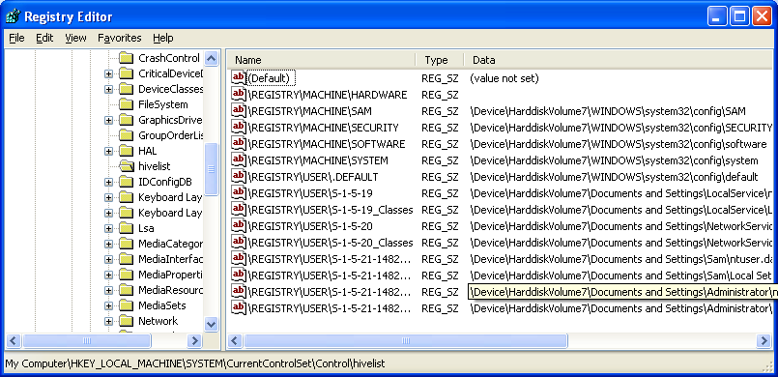
A key with all its subkeys and values is called a hive

The registry is stored on disk as several separate hive files

Hive files are read into memory when the operating system starts (or when a new user logs on)

HiveList

HKLM\System\
CurrentControlSet\
Control\HiveList

Hardware Hive

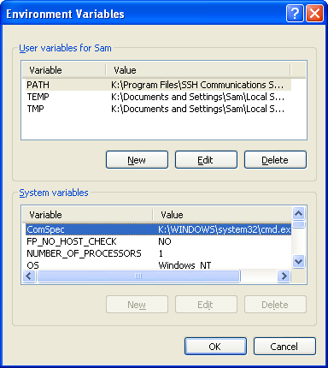
\Registry\Machine\Hardware has no associated disk file

Windows XP creates it fresh each time you turn your system on

LOG and ALT files

The folders containing your hive files contain hidden files:

.log – records changes made to the hive

.alt -- copy of the System hive file (not there on my Win XP)

Environment Variables

%allusersprofile% is usually C:\Documents and Settings\All Users

%UserProfile%\My Documents is the current user's My Documents folder

Only an administrator can change a system variable

Any user can add, edit, or remove user variables, which are exclusive to the user who created them and can be used in scripts and batch files

System Properties, Advanced tab, Environment Variables

Or SET at a command prompt

Avoiding Registry Mishaps

Registry Editor changes the registry immediately

No Undo command

No File, Save command

Backing Up Before You Edit

Registry Editor's File, Export

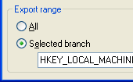
Registry Hive format is recommended

Include the selected key and all its subkeys and values

Although an All option will appear to be available in the Export Range section of the Export Registry File dialog box, you cannot save your entire registry as a hive file

.reg Files

You can export a registry key in Registration Files format

Creates a .reg file

Can be edited in notepad

A .reg file can be merged into a Windows XP or Windows 2000 registry
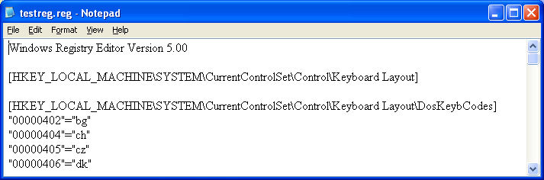

Using System Restore to Save the Registry's State

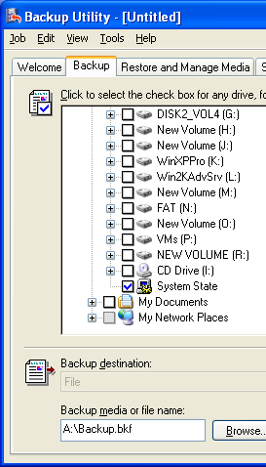
Most of the registry is included in the restore point

The keys that are not included are listed at

HKLM\System\ControlSet001\Control\
BackupRestore\KeysNotToRestore

Note error in textbook

On page 1168, the Control key is missing in the path

Backing Up and Restoring the System State

You must be Administrator

Backup Utility, Advanced Mode, Backup tab, System State box

When you do a System State backup, a copy of the registry is made in %SystemRoot%\Repair

Regedit: Find and Edit

Edit, Find or Ctrl+F

To change data, double-click a value

Adding or Deleting Keys and Values

To Add: Edit, New

To delete a key or value

Select it and press the Delete key

Working with a Remote Computer's Registry

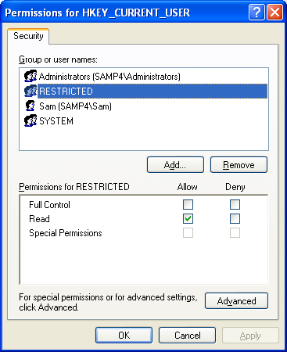
In Regedit, Choose File, Connect Network Registry

You must be logged on as an administrator or a member of the Administrators group on both your computer and the remote computer.

Changing Registry Key Permissions

Right-click a key, choose Permissions

RESTRICTED

The Restricted SID is limited to read for

HKEY_LOCAL_MACHINE

HKEY_CURRENT_USER

HKEY_USERS

Launch a suspicious program with Run As

Check Protect My Computer And Data From Unauthorized Program Activity

Runs the program using your credentials but adds the Restricted token

The program can't change the registry

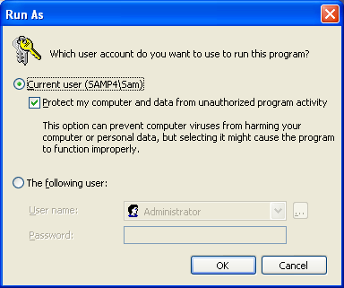
Most programs can't actually do useful work this way, but it can be used to test them

Prevent Users From Editing the Registry

Promote the user to administrator temporarily (if necessary)

Log in as them

Create

HKCU\Software\Microsoft\Windows\
CurrentVersion\Policies\System\
DisableRegistryTools

And set it to 1 (DWORD)

To undo it, see p. 1179 – a bit complicated

Editing the Registry from the Command Line

Reg.exe enables you to perform registry operations without using Registry Editor

Reg.exe commands can be used in batch files or scripts

reg /? At a command line

Last updated 5-6-05

