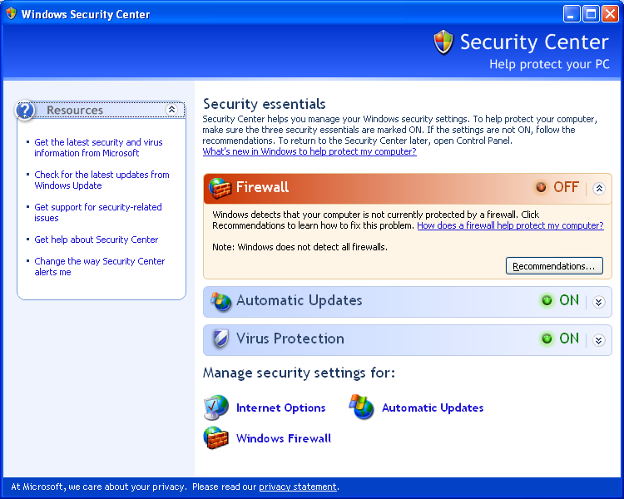
Ch 6: Security Essentials

Three Essential Security Steps

Firewall

Updates

Antivirus software (and anti-spyware software)

Windows Security Issues

A seemingly endless barrage of viruses and worms have attacked Windows-based computers

Sobig, Blaster, MyDoom, Netsky, Bagle, and Bugbear

Install Service Pack 2!

Security Threats

Virus -- code that replicates by attaching itself to another object

Virus payload -- the destructive portion of the code

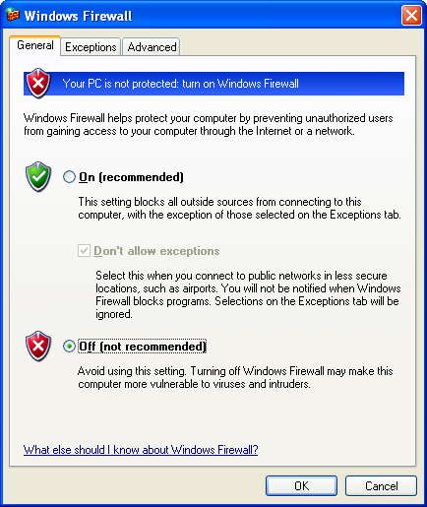
Worms -- independent programs that replicate by e-mail, TFTP, or other network protocols

Trojans -- acts as a stealth server that allows intruders to take control of a computer

Zombies -- Computers that have been taken over by Trojans

Social Engineering

Phishing – using an official-looking fake e-mail or website to get your account number, password, etc.

Spoofed return addresses

Attachments -- Don't open them unless you know what they are, and scan them for viruses first

Basic Prevention

Use an Internet firewall

Get computer updates

Use up-to-date antivirus software

Security Center

New in Service Pack 2

Windows Firewall

New in Service Pack 2

Replaced Internet Connection Firewall

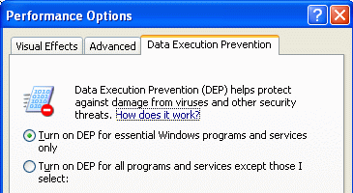
Protects your computer during startup

Automatic Updates

On by default in Service Pack 2

And also, unfortunately, in Windows Server 2003 Service Pack 1

Data execution prevention (DEP)

Protects against code in unexpected memory locations, such as buffer overrun attacks

Marks all memory locations used by a process as nonexecutable except those locations explicitly identified as having executable code

System Properties, Advanced tab, click Settings button in the Performance section

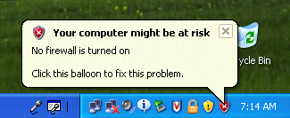
Monitoring Windows XP Security

Pop-up messages

They can be annoying, because many firewalls and antivirus software packages are not recognized by Security Center

To turn them off, click the Recommendations button in Security Center

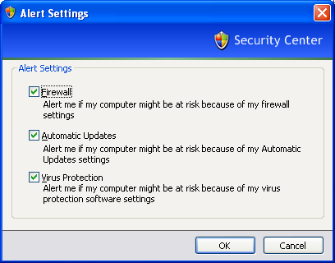
If your computer is joined to a domain, Security Center is turned off by default

To Disable Security Center alerts

In Security Center, click Change The Way Security Center Alerts Me

Blocking Intruders with Windows Firewall

You should run firewall software on each networked computer

Don't rely on corporate gateway firewalls

Part of Service Pack 2

Replaces the Internet Connection Firewall (ICF)

Packet Filtering

Blocks or allows transmissions depending on these attributes of the packet:

Source address

Destination address

Network protocol

Source and destination ports

Stateful Packet Filtering

Only allows incoming traffic that you requested, for example, by entering a URL in your browser's address bar

Link Ch 6m (Validation Requires)

Windows Firewall Improvements

Protects internal and external connections

Enabled by default for all connections

Global configuration options (like exceptions) apply to all connections

You're protected during startup

You can specify a IP address scope for each exception

You can create exceptions for programs

Windows Firewall figures out which port(s) and protocol(s) are used

Windows Firewall supports two profiles on domain-based computers

One used when connected to the domain and one when not connected to the domain

Internet Protocol version 6 (IPv6) is supported

Configuration can be done with command lines or using Group Policy

Enabling or Disabling Windows Firewall

Control Panel

Security Center

In the Network Connections folder, click Change Windows Firewall Settings

Network connection Properties, click the Advanced tab and then click Settings in the Windows Firewall box.

At a command prompt, type firewall.cpl

Don't Allow Exceptions

Rejects all unsolicited incoming traffic

Does not disconnect your computer from the Internet

Allowing Connections Through the Firewall

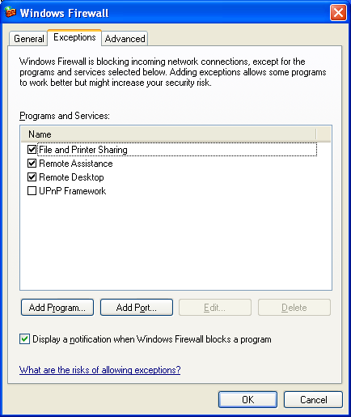
Check the desired program on the Exceptions tab

Enabling Ping and Other Diagnostic Commands

On the Advanced tab, click Settings in the ICMP box

Logging Firewall Activity

In Windows Firewall, on the Advanced tab, in the Security Logging box, click Settings

The default file is
%SystemRoot%\Pfirewall.log

Using the Netsh Command to Manage Windows Firewall

You can enable Windows Firewall with this command:

netsh firewall set opmode enable

Alternatives to Windows Firewall

Windows Firewall is concerned only with blocking unwanted inbound traffic

Other firewalls block both inbound and outbound traffic

A good independent source of information about firewalls is the ICSA Labs Web site

Link Ch 6a on my Web site

Keeping Your System Secure with Windows Update

Critical updates (also known as hotfixes)

Repair bugs that can hamper your system's performance, compromise its security, or cause system crashes

Periodically, Microsoft gathers these patches into collections called rollups

Keeping Your System Secure with Windows Update

Less frequently, Microsoft releases a service pack

A service pack includes many fixes

Each service pack includes the previous service pack

If you install Service Pack 2, you don’t need to install Service Pack 1

Reinstall A Service Pack If You

Reinstall Windows XP

Repair your Windows installation using Windows Setup

Use System Restore to revert to a restore point created before you installed the service pack

Upgrade from Windows XP Home Edition to Windows XP Professional

Using Windows Update Manually

Any of these techniques:

Help And Support Center

Start, All Programs, Windows Update

At a command prompt, type wupdmgr

In Internet Explorer, Tools, Windows Update

http://windowsupdate.microsoft.com

Express Install or Custom Install

Express Install

Only critical updates, security updates, service packs, and update rollups--known collectively as high priority updates

Custom Install

Noncritical software and hardware enhancements and updates in addition to the high priority updates

Automatic Updates

Open Security Center and click Automatic Updates

Retrieves only high priority updates

Downloading Update Files for Multiple Computers

Open Windows Update, click Administrator Options (in the left pane), and then click Windows Update Catalog

If there is a computer running Windows Server 2003 on your network, use Windows Update Services to automate updates of Windows, Microsoft Office, and other Microsoft products

Disabling Windows Update

Can be done with Group Policy (Windows XP Professional only, not available on Windows XP Home Edition)

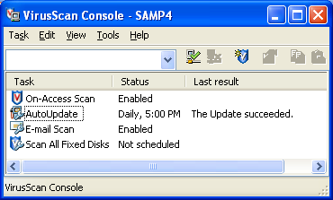
It takes several settings, as detailed on p. 196

Antivirus Programs

Windows XP does not include any anti-virus software

ICSA Labs tests antivirus programs (Link Ch 6a on my Web page samsclass.info)

After installing an antivirus package:

Update the virus definitions

Use automatic updates

Automatically scan each file that you access

Scan e-mail attachments

Disable System Restore if you have a virus

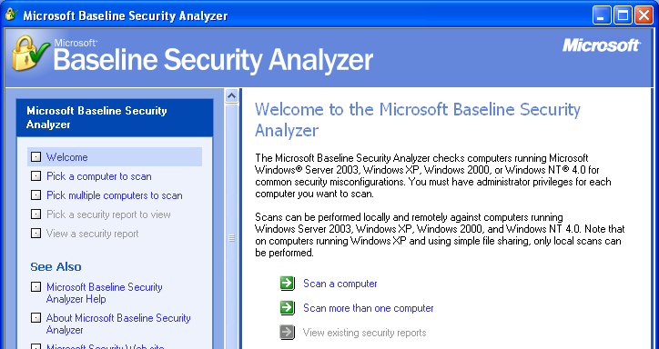
Turn off System Restore, which removes all saved restore points

Finish cleaning up your system

Then turn System Restore on again

Link Ch 6b

Microsoft Baseline Security Analyzer

A comprehensive test for security vulnerabilities

Link Ch 6c

Keeping Up with Security News

Microsoft's security home page (link Ch 6d)

Microsoft TechNet Security (link Ch 6e)

Microsoft Security Newsletter (link Ch 6f)

