Ch 7: Managing User Accounts, Passwords, and Logons

Windows XP Home Edition

Simple File Sharing is the only available file-sharing mode

You can't log on to the Administrator account except in Safe Mode

The Local Users And Groups snap-in (lusrmgr.msc) is not included in Windows XP Home Edition

With Windows XP, You Can:

Require each user to identify himself or herself when logging on

Control access to files and other resources that you own

Audit system events, such as logons and the use of files and other resources

Discretionary Security

Each securable system resource--each file or printer, for example--has an owner

The owner has discretion over who can and cannot access the resource (if it's on a NTFS Partition)

Usually, a resource is owned by the user who created it

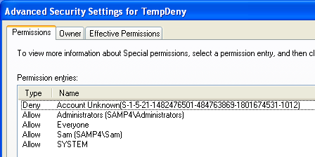
Administrators can take ownership of resources

Security ID (SID)

Windows assigns a SID to each user account

Each resource has an access control list (ACL)

A list of SIDs and the access privileges associated with each one

SID Demonstration

Create an account

Assign a permission to a folder for that account

Delete the account

The ACL will show the SID of the deleted account

Permissions and Rights

Permission

The ability to access a particular object in some defined manner

For example, to write to an NTFS file or to modify a printer queue

Right

The ability to perform a particular system-wide action

Such as logging on or resetting the clock

User Accounts

Each user account has a user name and (optionally) a password

Two special accounts:

Administrator -- full rights over the entire computer

Guest – minimal access

Simple File Sharing and the Guest Account

The Guest account is used to access shared network resources on your computer when Simple File Sharing is enabled

Local Accounts and Groups

A workgroup (or a standalone computer) uses only Local User Accounts

Stored on the Windows XP computer's hard disk

An account must be created on each computer a user logs on to

Local Groups contain Local User Accounts

Domain Accounts and Groups

Accounts are stored on the domain controller

The Domain Controller must use Windows Server 2003, Windows 2000 Server, or Windows NT Server

Each domain user can log on to any computer in the domain with the same account

Central Administration

Domain Accounts make it much easier to administer large networks

Local User Accounts still exist, and control the rights over a particular workstation

Domain Admins are Administrators over every computer in the domain.

Domain Groups contain Domain User Accounts

Group Membership and Permissions

Permissions and rights for group members are cumulative

If a user account belongs to more than one group, the user enjoys all of the privileges accorded to all those groups

Windows XP Account Types: Computer administrator

Create, change, and delete user accounts and groups

Install programs

Share folders

Set permissions

Access all files

Take ownership of files

Grant rights to other user accounts and to themselves

Install or remove hardware devices

Log on in Safe Mode

Windows XP Account Types: Limited

Limited -- Members of the Users group can:

Change the password, picture, and associated .NET Passport for their own user account

Use programs that have been installed on the computer

View permissions (if Simple File Sharing is disabled)

Create, change, and delete files in their document folders

View files in shared document folders

Windows XP Account Types: Guest

Guest -- Members of the Guests group are like limited accounts

A user logged on with the Guest account cannot create a password

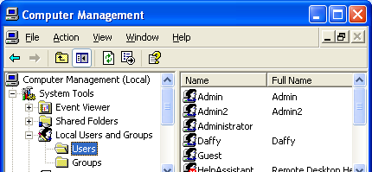
Windows XP Account Types: Unknown

Unknown -- not a member of the Administrators, Users, or Guests group

Manage such accounts with Local Users and Groups in Computer Management

Other Groups Created by Windows XP Professional

Backup Operators

HelpServicesGroup -- for Remote Assistance

Network Configuration Operators

Power Users

Remote Desktop Users

Replicator -- manage File Replication (see link Ch 7a)

User Profiles

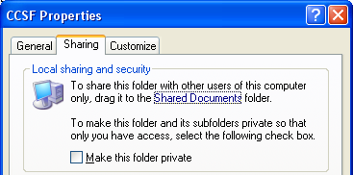
Personal registry settings for desktop features and program customizations like Word templates

Cookies

My Documents folder

Stored in %SystemDrive%\Documents And Settings

Simple File Sharing

Right-click a folder (or other object) and select Properties

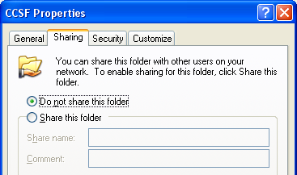
The simplified Sharing tab controls share permissions and NTFS file permissions

There is no Security tab

Network users are authenticated as Guest

Classic Sharing

You can specify various permissions for individual users and groups

Windows XP Home Edition always uses Simple File Sharing

How to Turn Simple File Sharing On or Off

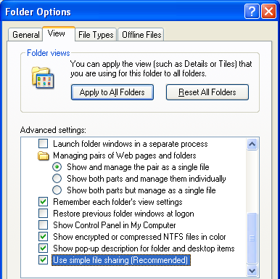
Open Folder Options in Control Panel

Click the View tab

Last item in the Advanced Settings box

Managing User Accounts

User Accounts in Control Panel is convenient

Local Users and Groups in Computer Management is more powerful

Access Local Users and Groups through Administrative Tools to get the Run As… option

Deleting an Account

When you delete an account, you see the message below

It is usually better to disable accounts than to delete them in a company environment, so you do not lose files

After deleting an account, that SID is gone and cannot be recreated.

A new account with the same name will not have the old account's permissions

Encrypted files created under the old account are lost, unless you have a Recovery Agent
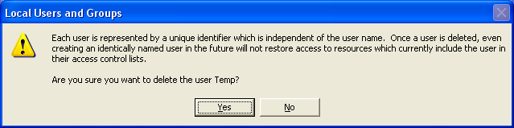

Controlling How Users Log On

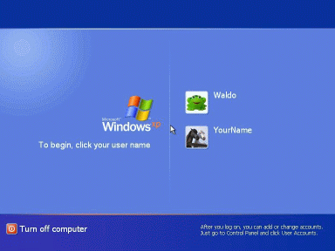
Welcome screen (not available in domains) shown to the right
Classic logon (available in workgroups and domains) shown below
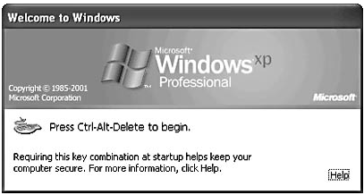

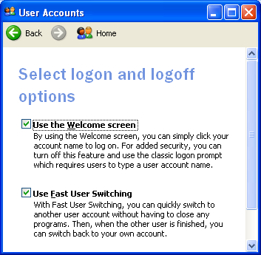

Hidden accounts

From the Welcome screen, press Ctrl+Alt+Delete twice

This is the only way to log on as Administrator from the Welcome screen

Activating the Welcome screen

Open User Accounts in Control Panel.

Click Change The Way Users Log On Or Off

Screen Saver and the Welcome Screen

Whenever you stop the screen saver, the Welcome screen appears

To control that behavior:

Right-click the desktop, Properties, Screen Saver tab

Ctrl+Alt+Delete

If you use the Welcome screen, pressing Ctrl+Alt+Delete after you're logged on displays Windows Task Manager

If you have disabled the Welcome screen, Ctrl+Alt+Delete displays Windows Security

Whether you use the Welcome screen or not, you can get to Task Manager with Ctrl+Shift+Esc.

Bypassing the Logon Screen

If your computer has only one account (aside from Administrator and Guest), and if that account doesn't have a password, Windows XP automatically logs on as that user during startup

To set up your workgroup computer to log on this way even if it has more than one user account

Type control userpasswords2 at a command prompt

Configuring Fast User Switching

The Welcome screen must be enabled

The computer must not be joined to a domain

Offline files must be disabled

To enable Fast User Switching

Open User Accounts in Control Panel.

Click Change The Way Users Log On Or Off

Securing the Administrator Account

Use a secure password

Change the name of the account

Open Local Security Policy in Administrative Tools

Open Local Policies\Security Options.

Double-click Accounts: Rename Administrator Account

Recovering from a Lost Password

Password hint -- clicking the question mark on the Welcome screen (only available with Welcome screen)

Password Reset Disk – Only available in workgroups

Make it with Control Panel, User Accounts, Prevent A Forgotten Password

