Chapter 8 - Securing Files and Folders

How Setup Decisions Dictate Your Security Options

Disk format

NTFS permissions are available only on NTFS-formatted drives

On drives formatted with FAT32, most local security options are unavailable. Any user can access any file without restriction.

Windows XP edition

Windows XP Home Edition and Windows XP Professional share a simplified security interface based on built-in group memberships

With Windows XP Professional, you can make your own groups

Windows XP Home Edition only allows Simple File Sharing – you cannot control the full NTFS permissions (although they are used behind the scenes, and can be accessed with cacls or Safe Mode)

User account settings

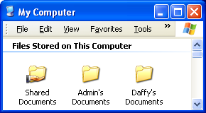
During setup, Windows XP creates a group of shared folders (only used in workgroups) In addition, each user with an account can designate certain folders as private

Simple File Sharing

Initially makes all the files in your user profile visible to all Administrators, but not available to other Limited accounts

Your user profile includes your My Documents folder, desktop, Start menu, and Favorites

The My Computer window displays a separate icon for the folder that holds each user’s personal documents, along with an icon for a Shared Documents folder

In Simple File Sharing, to make a folder private—all you do is right-click a folder, choose Sharing And Security, and select the Make This Folder Private check box

Simple File Sharing Limitations

The Make This Folder Private option is available only within your user profile – not for folders in any other location

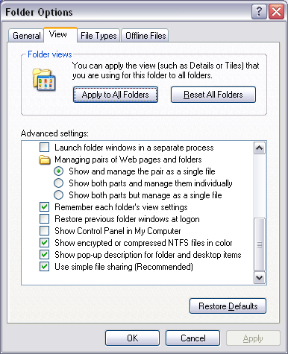
Protection applies to all files and subfolders within a folder where you select this option

You cannot protect an individual file, nor can you single out files or subfolders within a protected folder and make them available to others

The "private" setting is all-or-nothing -- you and only you can access files stored in that folder

When Simple File Sharing is enabled and you move or copy files or folders between a private folder and a shared location, the moved or copied objects always take on the security attributes of the destination folder

Disabling Simple File Sharing

Only in Windows XP Professional, and only on NTFS-formatted drives

Tools, Folder Options, View tab, scroll to the bottom of the list, and then clear the Use Simple File Sharing (Recommended) check box

You must be a member of the Administrators group to change file-sharing options

Note: sometimes this check box gives false information to non-Administrators

How Simple File Sharing Works

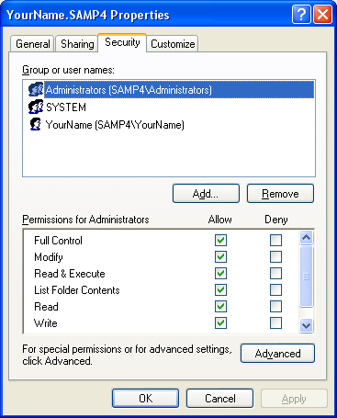
Default permissions for User Profile

Full Control for the user

Full Control for the Administrators group and the System account

The user is the Creator Owner of these folders

The owner has full control and can change the access controls on these files

Demonstration of Ownership

Create a folder, so you are the owner

Remove all permissions except yourself

Deny yourself all access

You cannot open the folder, but you can still change the permissions because you are the owner

Private folders

Selecting the Make This Folder Private option removes the Administrators group from the list of permitted users

If leaves only the user’s account and the built-in System account on the Permissions list

Shared folders

The Shared Documents folder is available to who can log in

Administrators have Full Control

Users have all rights

Except the ability to change permissions or take ownership of files in this folder

Limited accounts can read and open files

Keeping Your Own Files Private

Open %Systemdrive%\Documents and Settings

Right-click the icon labeled with your user name and choose Sharing And Security.

Under Local Sharing And Security, select the Make This Folder Private check box

Other users who log on to the same computer and open the My Computer window can no longer see the folder icon that represents your My Documents folder if you’ve made your user profile private

If The Make This Folder Private option can’t be selected.

Is the drive formatted using NTFS?

Is the folder in your user profile?

Is a parent folder already set as private?

Controlling Access with NTFS Permissions

Only available on Windows XP Professional with NTFS drives

You can:

Control access to any file or folder on any NTFS-formatted drive

In Simple File Sharing you can only protect files in your user profile

Allow different types of access for different users or groups of users

Fine-tune permissions on specific files or folders

Applying Advanced Security Settings

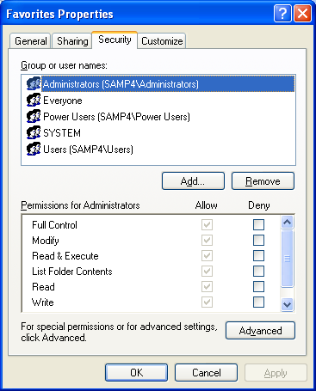
Right-click a file or folder, choose Properties, and then click the Security tab

Access control list (ACL) -- all the groups and users with permissions set for the selected object

The owner of a file or folder (typically the person who creates the file) has the right to allow or deny access to that resource

Members of the Administrators group and other authorized users can grant or deny permissions

Be careful with the Deny box

Deny overrides other permissions

Denying Everyone access to system files can destroy your machine

How Permissions Control File and Folder Access

Full Control

Modify (allows delete)

Read & Execute

List Folder Contents (folders only)

Read

Write (does not allow delete)

Special Permissions

Demonstration

Make a folder

Make sure the user has Write but not Modify permission

Try changing and deleting files in the folder

Note – this does not work with a single file because permissions of the containing folder can override the lack of Write permission

When adding or removing permissions, follow these basic principles:

Start from the top and work down

Organize shared data files into common locations

Use groups whenever possible

Steer clear of Special permissions

Grant only the level of access that users require

If you’re unable to set custom permissions

The Security tab is not visible

Simple File Sharing is on, or drive is FAT

Permission settings are unavailable

You are not logged on as an Administrator, or the selected object is inheriting its permissions from a parent folder

Built-in Users (Special Identities)

Everyone

Creator Owner

Authenticated User

Interactive

Anonymous Logon

Dialup

Network

Special Identities Examples

For shared data folders, assign the Read & Execute permission and the Write permission to the Users group, and the Full Control permission to the Creator Owner special identity

Every user who creates a file or folder becomes that object’s owner and has the ability to read, modify, and delete it

Other users can read and modify documents created by other users but can’t accidentally delete them.

If you have a second drive in your system and you want to prevent all access to files on that drive by anyone using the Guest account, change the default permissions on the root of the drive:

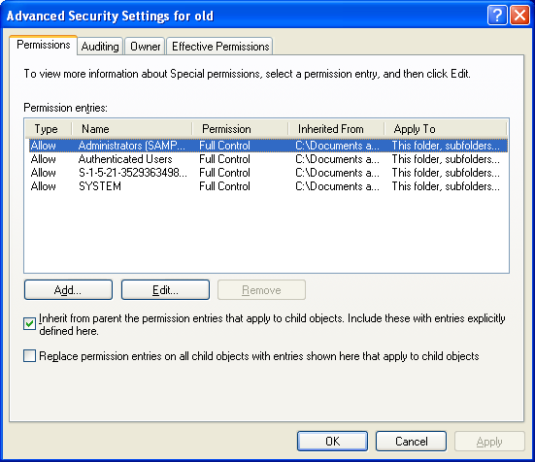
Add the Authenticated Users group and give it Full Control, and then remove the default Everyone group

Caution

Don't remove the Everyone group from the root of a drive—or worse, to select the Deny box next to Full Control for this group

Windows XP Professional warns you that you’re about to deny all access to all files on the drive by all users

Don’t change the default permissions on the drive that contains Windows system files

Applying Permissions to Subfolders Through Inheritance

Files and subfolders inherit permissions from a parent folder unless you block inheritance.

Right-click the folder icon, Properties, Security tab, Advanced button

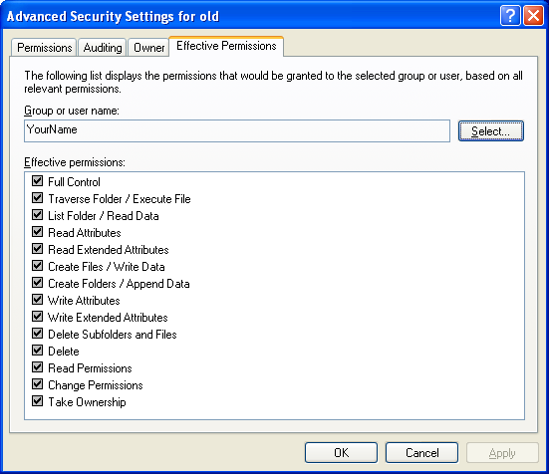
Uncheck Inherit From Parent The Permission Entries That Apply To Child Objects

Choose Copy or Remove

Testing the Effect of Permissions

File and folder permissions can come from a variety of settings

It’s difficult to figure out exactly what each user can and can’t do

Effective Permissions combine all the NTFS permissions assigned to an individual user account and to all of the groups to which that user belongs.

Effective Permissions

Thus, if Sue has Read & Execute permission

And is also a member of a group that has been assigned Write permissions

She has both Read & Execute and Write permissions for the folder

Effective Permissions is Not Perfect

The effective permissions calculation does not include

Anonymous Logon

Authenticated Users group

Settings granted because a user is the Creator Owner of an object

Does not consider whether you’re logging on interactively or over a network

Don’t trust it too far

Using Special Permissions

Don’t.

What are you, nuts?

Setting Permissions from a Command Prompt

Cacls.exe does it in both Windows XP Professional and Home Edition

Next to each user account name, Cacls displays a single letter for any of three standard permission settings: F for Full Control, C for Change, R for Read.

For more details, enter CACLS /?

K:\Documents and Settings\Sam>cacls .
K:\Documents and Settings\Sam SAMP4\Sam:F
NT AUTHORITY\SYSTEM:F
BUILTIN\Administrators:F
SAMP4\Sam:(OI)(CI)(IO)F
NT AUTHORITY\SYSTEM:(OI)(CI)(IO)F
BUILTIN\Administrators:(OI)(CI)(IO)F

Taking Ownership of Files and Folders

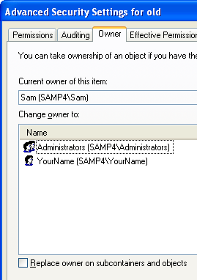
When you create a file or folder on an NTFS drive, you become the owner of that object

The owner can allow or deny permission for other users and groups to access the file or folder

Any member of the Administrators group can take ownership of any file or folder, although he or she cannot transfer ownership to other users

How to Take Ownership of Files and Folders

Right-click the file or folder icon and choose Properties.

On the Security tab, click the Advanced button to open the Advanced Security Settings dialog box for the file or folder.

Click the Owner tab.

Select the desired name from the Change Owner To list and click OK.

Troubleshooting Permission Problems

NTFS permissions are easy with Simple File Sharing

Users can’t manipulate file and folder access controls directly

When you drag a file out of your private My Documents folder and drop it in the Shared Documents folder, it becomes shared

Copying and Moving Files

But if you disable Simple File Sharing and work directly with NTFS permissions, weird things happen

Even when a user has been granted Full Control permissions for a given folder, he or she may encounter an "access denied" error message

Copying Files: Destination Folder Determines Permissions

When you copy a file or folder to an NTFS drive

The newly created folder or file takes on the permissions of the destination folder, and the original object retains its permissions.

This is true regardless of whether the destination is on the same NTFS drive as the original file or on a separate NTFS drive.

Moving Files

Moving Files to Another NTFS Drive: Destination Folder Determines Permissions

Moving Files to another folder on the same NTFS drive: The moved file retains its original permissions

This is because the file is not actually moved, only a pointer to it is changed

Going from NTFS to FAT

When you copy or move a file or folder from a FAT32 drive to an NTFS drive

The newly created folder or file picks up the permissions of the destination folder

When you copy or move a file or folder from an NTFS drive to a FAT32 drive

The moved or copied folder or file in the new destination loses all NTFS permissions

Because the FAT32 file system is incapable of storing these details.

Problems This Can Cause

When Simple File Sharing is disabled, you may discover, after dragging a file from your My Documents folder into the Shared Documents folder, that other users are unable to access that file.

This happens when:

The drive is formatted with NTFS

You've made your entire user profile private

You've disabled Simple File Sharing

Because both locations are on the same NTFS-formatted drive, dragging any file or folder from your user profile to the Shared Documents folder moves the selected object without making any changes to its access control list.

If you've disabled Simple File Sharing, never move a file from your personal profile to a shared location. Instead, get in the habit of copying the file.

Chapter 9 - Securing Your Internet Connection

What's New in Service Pack 2

Restrictions on automatic downloads in Internet Explorer

Improved handling of downloaded files, including e-mail attachments

Pop-up blocker

Tighter ActiveX security

An interface to control browser add-ons

New advanced security settings

Information Bar

Protecting Your System from Unsafe and Unwanted Software

Half the failures in Windows are caused by "deceptive software"

Clicking links on Web pages or in e-mail messages can lead to installing software that surreptitiously installs additional programs

Spyware? Adware? What's the Difference?

Spyware gathers information about you and your browsing activities

Adware displays advertisements including pop-up windows

Home-page hijackers change your default home page

Dialers configure a computer to make unsolicited (and usually expensive) dial-up connections

Trojan horses allow an intruder to take over a compromised computer

Downloading Executable Files

You must approve two separate Security Warnings to download and install a program in Internet Explorer

If a file is digitally signed, you might be comfortable trusting the publisher

If it isn't digitally signed, search for complaints about the program in Google Groups (http://groups.google.com)

Set a System Restore point before installing

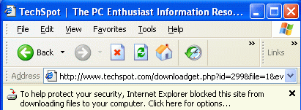
SP2 Blocks Automatic Downloads

The following message appears in the Information Bar

To help protect your security, Internet Explorer blocked this site from downloading files to your computer. Click here for options....

Controlling ActiveX Downloads

ActiveX controls are small programs that enhance the functionality of a Web site

They work only in IE, on Windows

Windows Update uses ActiveX

ActiveX controls are like executables that you run from the Start menu or a command line

They have full access to your computer's resources

You cannot download an ActiveX control, scan it for viruses, and install it separately

ActiveX controls must be installed on the fly

You're protected from known viruses if you've configured your antivirus software to perform real-time scanning for hostile code

ActiveX Security in Service Pack 2

When code on a Web page tries to install an UNSIGNED ActiveX control

This appears in the Information Bar:

"To help protect your security, Internet Explorer stopped this site from installing an ActiveX control on your computer. Click here for options...."

You cannot install unsigned ActiveX controls with the default security settings

When code on a Web page tries to install a SIGNED ActiveX control

"This site might require the following ActiveX control: `control_name' from `publisher_name'. Click here to install...."

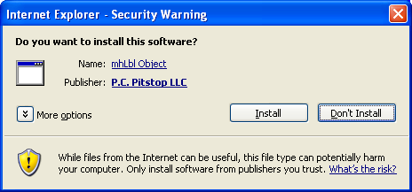
You can allow the download by clicking the Information Bar

Signed ActiveX Control Demonstration

Go to pcpitstop.com, click on "Check ActiveX”

Click in in the Information bar, then click “Install ActiveX Control…”

This “Security Warning” box is called the Authenticode box

Click "More Options" in the Authenticode box to see the "Always install…" and "Never install…" options
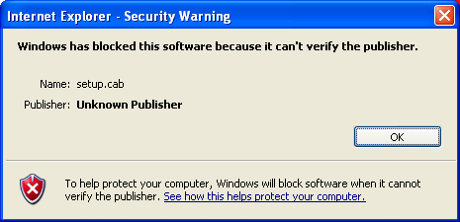

Unsigned ActiveX Control Demonstration

Go to mirra.com/downloads, click on version 1.1, download, install

Click in in the Information bar, then click “Install ActiveX Control…”

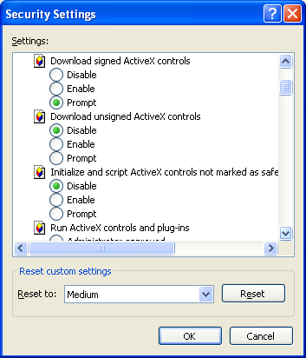

Adjusting ActiveX Security Levels

In IE, click Tools, Internet Options

On the Security tab, click Internet, Custom Level

See link Ch 9a for more details of ActiveX security

Controlling Scripts

Scripts are small programs written in a scripting language such as JavaScript or VBScript

Scripts run on the client computer

Hostile scripts can be embedded in Web pages or in HTML-formatted e-mail messages

You can disable scripts in Internet Options, the same way you control ActiveX control security

Authenticode

Authenticode is Microsoft's digital signing technology

Guarantees that an executable item comes from the publisher it says it comes from and that it has not been changed

Service Pack 2 blocks installation of any code that has an invalid signature

A digital signature doesn't promise that the signed item is healthy and benevolent, just that it's really from the company that signed it

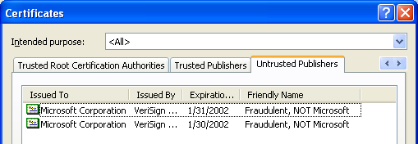
Trusted and Untrusted Publishers

In IE, Tools, Internet Options, Content tab, Publishers

Do not remove the two Microsoft Corporation entries from the Untrusted Publishers list

They are Microsoft certificates that VeriSign issued to a non-Microsoft employee in 2001 (see link Ch 9b)

Managing ActiveX and Java Controls

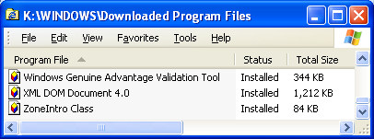
In IE, Tools, Internet Options, General tab, Settings, View Objects

Browser Add-ons

Add-ons can provide New toolbars, Explorer bars, menus, buttons, extended search capabilities, manage the process of filling in forms, save bookmarks, etc.

These add-ons take the form of browser extensions, browser helper objects (BHOs), toolbars, Java applets, and ActiveX controls, and more

Add-ons can also cause crashes, pop-ups, act as Spyware, etc.
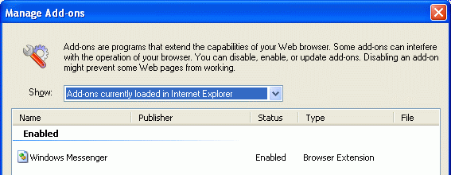

Managing Browser Add-ons

In IE, click Tools, Manage Add-Ons

This box does not provide an uninstallation option

Some malicious add-ons hide and do not appear here

Defining Security Zones for Web Sites

There are four security zones

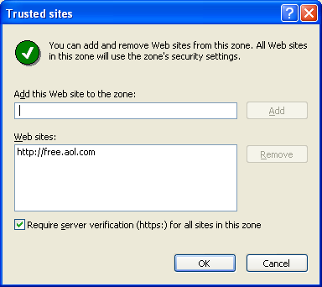
Internet -- all sites that not in any other category – "Medium" security by default

Local Intranet – "Medium-low" security by default

Trusted Sites – "Low" security by default

Restricted – "High" security by default

Demonstration: Adding Sites to the Trusted Zone

In IE, click Tools, Internet Options, Security tab, Trusted Sites, Sites

Note the https: restriction – you cannot be sure an http site is not spoofed

Blocking Objectionable Content

Content Advisor blocks sites that are rated outside your acceptable limits

It uses the Recreational Software Advisory Council's (RSAC) Internet rating system (known as RSACi)

Four categories: language, nudity, sex, and violence, and five levels, 0 through 4

The RSAC no longer exists, so if you intend to use Content Advisor, install the ICRA system (http://www.icra.org)

Unrated Sites

Not all Internet content is rated

By default, Content Advisor blocks pages that don't have a rating

To change the default behavior: Internet Options, Content tab, Settings, General tab, Users Can See Sites That Have No Rating

You can also allow or disallow sites yourself

Using E-Mail Safely

E-mail is the most common way users get viruses, worms, and Trojans

Executable E-mail attachments are the most dangerous

HTML E-mail messages can also include hostile scripts

Spam is another problem – unwanted commercial e-mail

Guarding Against Hazardous E-Mail Attachments

Don't open any attachment that's potentially executable

Save it instead, and scan it with your virus checker before running it

Understand that mail from your friends is as dangerous as mail from strangers, because viruses use address books, and also spoof From addresses

Outlook E-mail Protection

Outlook and Outlook Express have different versions of attachment filters in the various versions

Outlook 2003 blocked .mdb files on my home machine until I used a registry hack to allow them (link Ch 9c)

You Need Antivirus Software, Updates, and a Firewall

Not opening e-mail attachments is NOT enough security

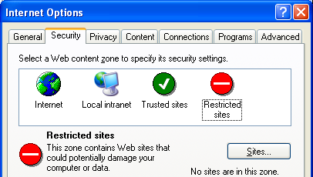
Klez and other auto-executing viruses can enter and infect your system without any action on your part

Guarding Against Rogue HTML Content

Outlook Express and Outlook use Internet Explorer's Restricted Sites security zone

Defending Yourself Against Spam

Spam is unsolicited commercial e-mail

Never reply to spam!

Don't click the "Unsubscribe" link

Block Sender is usually ineffective because spammers use fake e-mail addresses

Filtering messages containing particular words or phrases are similarly ineffective

Defending Yourself Against Spam

You can run e-mail filters at the client side, and your ISP can run filters at the server side

Use throwaway addresses to sign up for things, like yahoo or mailinator.com

Protecting Your Privacy

Cookies can reveal your e-mail address and other personal data to Web sites

Internet Explorer offers an elaborate set of features for filtering cookies

Windows XP provides a secure system for storing user names, passwords, and Web form data -- the Protected Storage service

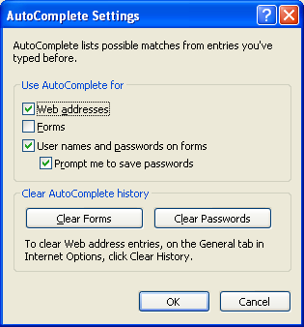
Password Storage

Windows 95 and 98 stored passwords in a weakly encrypted text file with the extension .pwl.

In Windows XP, this data is stored in a secure portion of the registry

It's encrypted using your logon credentials

Outlook Express passwords and Internet Explorer AutoComplete data is stored there

Turning Off AutoComplete

In IE, Tools, Internet Options, Content tab, AutoComplete

Clearing Your History

In IE, Tools, Internet Options, General tab, Clear History

