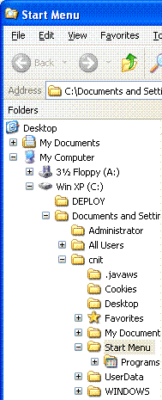
Selecting a Machine to Use
- Use one of these hard drives: L4, L6, L8, L10, L12, L14, L16, L18
Checking the Existing Partitions
- First you need to find out where the Windows XP is on this disk, so you can leave it intact when installing Vista. You also need to make sure there isn’t any data on the partition Vista is going onto.
- Start the computer and boot it up normally to Windows XP. Log in as cnit235 with no password.
- Right-click the Start button and select Explore. You should see a Start Menu window with an expanded tree in the left pane, as shown to the right on this page. Look at the root of this tree – it may be either the C drive or the E drive. Make a note of which partition it is – you want to make sure not to erase this partition! (It should be C: for L4, L6, L8, L10, L12, L14, L16, L18 and E: for L10 and L14.)
- Look to see if there are any other hard drive partitions available. There should either be no other partitions visible, or only an empty one. If you see a second partition with data on it, stop and talk to your instructor before continuing.
Booting from the Vista x86 DVD
- Insert the Vista DVD. Use the x86 DVD with the blue label, not the x64 DVD with the green label, because these machines have 32-bit processors.
- Restart your machine. When you see the message Press any key to boot from CD or DVD, press the Enter key.
- When you see the Install Windows box, accept the default language, time, and keyboard layout and click Next.
- In the next screen, click Install now.
- Type in the product key from the label inside the DVD case. Click Next.
- Accept the license and click Next.
- Click Custom.
Choosing the Installation Partition
- This is where you have a chance to ruin the Windows XP installation if you are not careful. There is one partition here with Windows XP on it – Drive C: is labeled Disk 0 Partition 1 and drive E: is labeled Disk 0 Partition 2. Make sure not to over-write that partition with Vista! Leave the Windows XP partition alone and delete all the other partitions, if there are any. Then select the Unallocated Space, which should be about 18.7 GB, and click Next.
- Now wait – it will take a while to copy the files.
- At the Country or Region screen, click Next.
- At the Choose a user name and picture page, enter Student and no password and click Next.
- At the next screen, click Next.
- Click Use recommended settings.
- At the time and date settings screen, click Next.
- At the you’re ready to start screen, click Start.
- When you see the Successfully connected to Network message, click This is my private network and click OK.
- When the User Account Control box appears, click Continue. You should see your Vista desktop, showing a lake and a mountain, and a clock dial.

Setting the Default Operating System to Windows XP
- Most users of these computers want to use Windows XP, not Vista. So the default operating system must be changed back to Windows XP for them.
- Click Start, right-click Computer, and click Properties. In the left pane, click Advanced System Settings. In the User Account Control box, click Continue.
- In the System Properties box, on the Advanced tab, in the Startup and Recovery section, click the Settings button.
- In the Startup and Recovery box, change the Default operating system to Earlier version of Windows. Click OK.
- In the System Properties box, click OK.

Activating Windows Vista
- In the Control Panel ► System and Maintenance ► System ►.box, at the bottom, you should see a Windows Activation section. Click the message that says 14 days left to activate. Click here to activate Windows now. In the User Account Control box, click Continue.
- In the Windows Activation box, click Activate Windows online now.
- In the Windows Activation box, you should see an Activation was successful message. Click the Close button. Notice that the Windows Activation section now shows your Product ID.

Rebooting into Windows XP
- Click the Start button (the Windows Logo button in the lower left corner). Point to the rightmost right-arrow, next to the padlock. In the pop-up menu, click Restart. Wait during restart to make sure that if you do nothing, it boots to Windows XP, not to Vista.
- Log in to the Windows XP system with a user name of cnit235 and a password of windowsxp

Exploring the Dual-boot Folder Tree
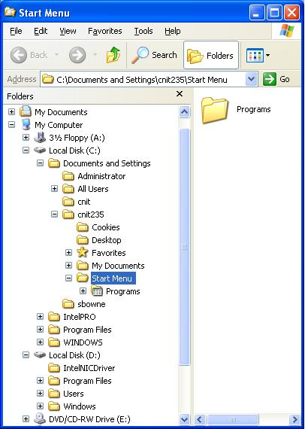
- Right-click the Start button and click Explore. The Windows XP system volume’s folder tree will expand automatically to show the Start Menu folder. There should now be a second drive letter in the folder tree, containing the Vista operating system. In my example, Vista is on drive D: as seen from Windows XP. Click the + sign to the left of the Vista drive letter to expand it, so that both the Windows XP and the Vista trees are visible, as shown to the right on this page. The Vista tree should show a Users folder, and the Windows XP tree should show a Documents and Settings folder. That’s a simple way to tell the difference.

Saving the Screen Image
- Click on the Start Menu window to make sure it is the active window.
- Hold down the Alt key and press the PrintScrn key in the upper-right portion of the keyboard. That will copy the active window to the clipboard.
- In the virtual machine, click Start, Programs, Accessories, Paint. In the untitled - Paint window, select Edit, Paste from the menu bar. The window image appears in the Paint window.
- In the untitled - Paint window, click File, Save. Save the document in the My Pictures folder (or any other place you wish, such as a floppy disk) with the filename Your Name Proj 1Va. Select a Save as type of JPEG.

Turning in your Project
- Open Internet Explorer, and use it to email the JPEG image to me as an email attachment. Send the message to: cnit.235@gmail.com with a subject line of CNIT 235 Proj 1V From Your Name, replacing Your Name with your own first and last name. Send a Cc to yourself.

Last Modified: 8-17-06

