Starting Your Computer
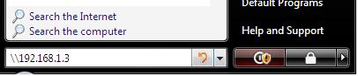
- Start your computer with the appropriate L removable hard drive in it. Boot it up to Vista. Log in as Student with no password.

Installing McAffee Antivirus
- Click the Start button (the Windows Logo button in the lower left corner). In the search box, type in \\192.168.1.3 as shown to the right on this page. Press the Enter key.
- In the Network ► 192.168.1.3 window, double-click cnit235.
- In the Network ► 192.168.1.3 ► cnit235 window, double-click _Software.
- Drag the Antivirus folder to the desktop. You will see a Copying 39 items box with a progress bar. Wait till the copy finishes.
- Close the Windows Explorer box (titled the Network ► 192.168.1.3 ► cnit235).
- Double-click the Antivirus folder to open it. Double-click the red Setup icon.
- In the User Account Control box, click Allow.
- Wait while a FEAD 2.3 Optomizer window shows progress, and another installer window opens and closes.
- When you see a McAffee VirusScan Enterprise Setup window, click Next.
- In the next window, click I accept the terms of the license agreement and click OK.
- In the Select Setup Type box, accept the default selection of Typical and click Next.
- In the Ready to Install box, click Install.
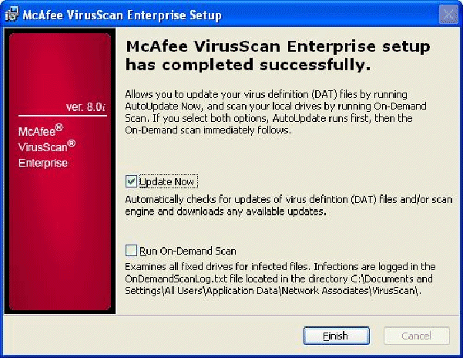
- When you see the McAffee VirusScan Enterprise setup has completed successfully screen shown to the right on this page, leave the Update now box checked, but uncheck the Run-On-Demand Scan box (because that will take a long time). Click Finish. McAffee will update itself.
- When you see a box saying The network driver is installed but you must restart the computer in order to load it, click OK.
- Restart the computer. Boot into Vista.
- A User Account Control box pops up requesting permission for the UpdaterUI.exe program. Click the Continue button.
- Click Start, Control Panel.

- In Control Panel, click Check this computer’s security status. You will see a Windows Security Center window showing that Malware Protection is Not found, as shown below on this page. However, the blue shield with a red V shows in the notification area (the lower right of the desktop), showing that Mcafee is actually running. Mcafee just does not report its status to Vista correctly, which is a problem that will presumably be fixed when Vista is finished. This is beta software, such little problems are to be expected.

Saving the Screen Image
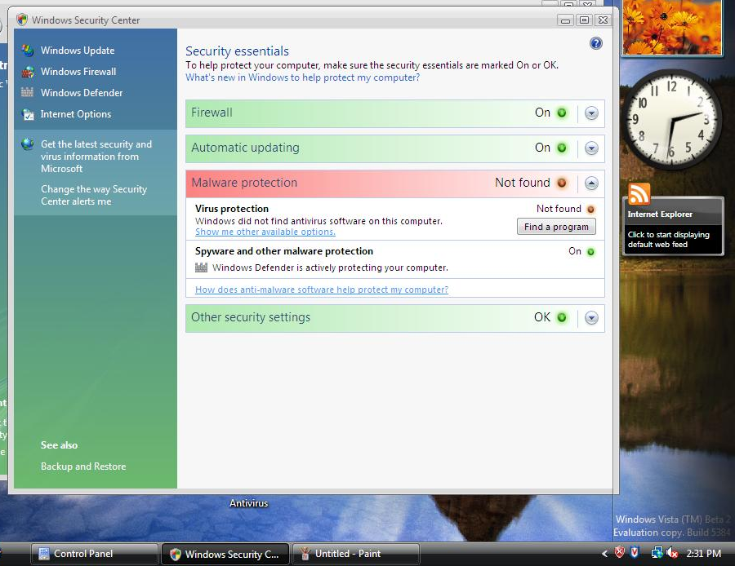
- Press the PrintScrn key in the upper-right portion of the keyboard. That will copy the whole desktop to the clipboard.

- Click Start and click in the Search box. Type in mspaint and press the Enter key to open Paint. In the untitled - Paint window, select Edit, Paste from the menu bar. The window image appears in the Paint window.
- In the untitled - Paint window, click File, Save. Save the document in the Student ► Pictures folder (or any other place you wish, such as a floppy disk) with the filename Your Name Proj 2Va. Select a Save as type of JPEG.

Updating Vista
- Click Start, All Programs, Windows Update.
- In the Control Panel ► System and Maintenance ► Windows Update ► box, click Install updates. In the User Account Control box, click Continue.
- When you see the message Restart your computer to finish installing important updates, click the Restart now button. Boot into the Vista operating system.
- Click Start, All Programs, Windows Update.
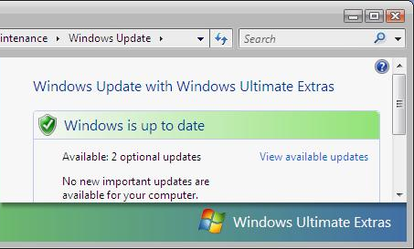
- You should see the message Windows is up to date as shown to the right on this page.

Saving the Screen Image
- Click on the Control Panel ► System and Maintenance ► Windows Update ► box to make sure it is the active window.
- Hold down the Alt key and press the PrintScrn key in the upper-right portion of the keyboard. That will copy the active window to the clipboard.
- Click Start and click in the Search box. Type in mspaint and press the Enter key to open Paint. In the untitled - Paint window, select Edit, Paste from the menu bar. The window image appears in the Paint window.
- In the untitled - Paint window, click File, Save. Save the document in the Student ► Pictures folder (or any other place you wish, such as a floppy disk) with the filename Your Name Proj 2Vb. Select a Save as type of JPEG.

Turning in your Project
- Open Internet Explorer in the virtual machine, and use it to email the JPEG images to me as attachments to one e-mail message. Send the message to: cnit.235@gmail.com with a subject line of CNIT 235 Proj 2V From Your Name, replacing Your Name with your own first and last name. Send a Cc to yourself.

Last Modified: 8-17-06

