Starting Your Computer
- Start your computer with the appropriate L removable hard drive in it. Boot it up to the Windows XP operating system. Start your virtual PC and log in with your own account. Do this entire project in the virtual PC.

Checking Internet Connectivity
- Click Start, Internet. Internet Explorer should open and display the msn.com web page. If you cannot open the Web page, call your instructor over to help you.

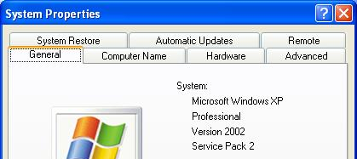
Checking Windows Version
- Click Start, right-click My Computer, and click Properties. Examine the System Properties window and compare it to the example to the right on this page. You should see that you have Windows XP Professional with Service Pack 2.

Updating Windows XP
- Although you have Service Pack 2 installed, there have been additional updates to Windows XP since then. It is very important to make sure you have all the updates because many of them are critical for security, so the next step is to make sure your Windows XP is fully updated, using the Microsoft Update Web site.
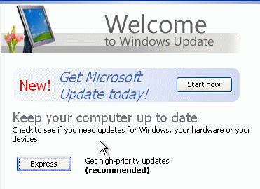
- Click Start, Help and Support. In the Pick a task section, click on Keep your computer up-to-date with Windows Update. If that doesn’t work, open Internet Explorer and click Tools, Windows Update.
- Windows Update should open, as shown to the right on this page
- Click Express. Wait while Windows Update scans your system. If an Internet Explorer box pops up saying When you send information to the Internet, it might be possible for others to see that information…, click Yes.
- If Windows Update finds any updates you need, follow the instructions on the screen to put in all recommended updates.
- Often you cannot install all the Windows Updates at once. Some of them require restarting your computer, or must be installed singly for other reasons. Keep running Windows Update as many times as necessary until you get all the updates. When I did it on June 14, 2006, I had to do these steps:
- Download and install Windows Update upgrade: Windows Genuine Advantage Validation Tool, then Continue.
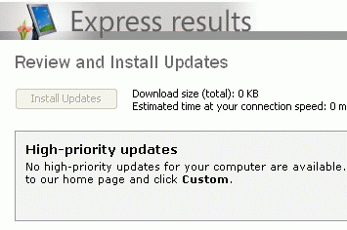
- Install 47 High-priority updates all at once, about 15 MB total. Agree to two End User License Agreements. After downloading and installation, restart and launch Windows Update again.

- When you see the message shown to the right on this page, saying No high-priority updates for your computer are available, or a similar message, you are done updating. Notice the hand icon pointing to this image: that indicates that you need to save this image to turn in for credit. Do the following steps to make a screen image of this window showing that you completed the update process.

Saving the Screen Image
- Click on the Windows Update window to make sure it is the active window.
- Hold down the Alt key and press the PrintScrn key in the upper-right portion of the keyboard. That will copy the active window to the clipboard.
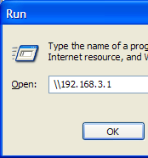
- In the virtual machine, click Start, Programs, Accessories, Paint. In the untitled - Paint window, select Edit, Paste from the menu bar. The window image appears in the Paint window.
- In the untitled - Paint window, click File, Save. Save the document in the My Pictures folder (or any other place you wish, such as a floppy disk) with the filename Your Name Proj 2a. Select a Save as type of JPEG.

Mapping the CNIT 235 Shared Folder to Drive Z
- In the virtual PC, click Start, Run. In the Run box, enter \\192.168.3.1 as shown to the right on this page. Press Enter.
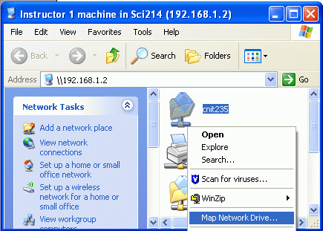
- An Instructor1 machine in Sci214 (192.168.3.1) window opens as shown to the right on this page (the IP address is incorrect in the figure). This is the shared drive on the server that we will use for many purposes in this class, so you will need to map it to a drive letter for convenient access. Right-click the CNIT235 folder and click Map Network Drive.
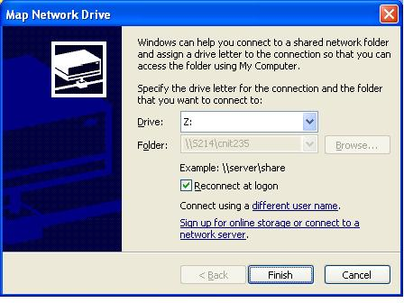
- In the Map Network Drive window, accept the default Drive letter of Z:, as shown to the right on this page, and click the Finish button.
- Close the Instructor1 machine in S214 window.

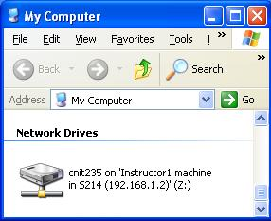
- Click Start, My Computer. Find the cnit235 on Instructor1 machine … icon, as shown to the right on this page, and make sure it is visible.

Saving the Screen Image
- Click on the My Computer window to make sure it is the active window.
- Hold down the Alt key and press the PrintScrn key in the upper-right portion of the keyboard. That will copy the active window to the clipboard.
- In the virtual machine, click Start, Programs, Accessories, Paint. In the untitled - Paint window, select Edit, Paste from the menu bar. The window image appears in the Paint window.
- In the untitled - Paint window, click File, Save. Save the document in the My Pictures folder (or any other place you wish, such as a floppy disk) with the filename Your Name Proj 2b. Select a Save as type of JPEG.

Installing McAffee Antivirus
- In the YourName WinXP window, click Start, My Computer. Double-click Z: to open the shared folder. Double-click _Software to open the folder. Resize the Software window so that you can see part of your desktop. Drag the Antivirus folder to your desktop. After the folder is done copying, close the Software window.
- Double-click the Antivirus folder to open it. Double-click the red Setup icon. Wait while a FEAD 2.3 Optomizer window shows progress, and another installer window opens and closes.
- When you see a McAffee VirusScan Enterprise Setup window, click Next.
- In the next window, click I accept the terms of the license agreement and click OK.
- In the Select Setup Type box, accept the default selection of Typical and click Next.
- In the Ready to Install box, click Install.

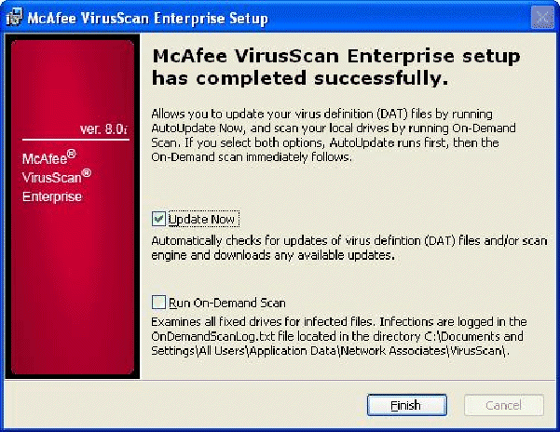
- When you see the McAffee VirusScan Enterprise setup has completed successfully screen shown to the right on this page, leave the Update now box checked, but uncheck the Run-On-Demand Scan box (because that will take a long time). Click Finish. McAffee will update itself.
- Click Start, Control Panel, Security Center. You will see a Windows Security Center window showing that the Virus Protection is ON, as shown to the lower right on this page.

Saving the Screen Image
- Click on the Windows Security Center window to make sure it is the active window.
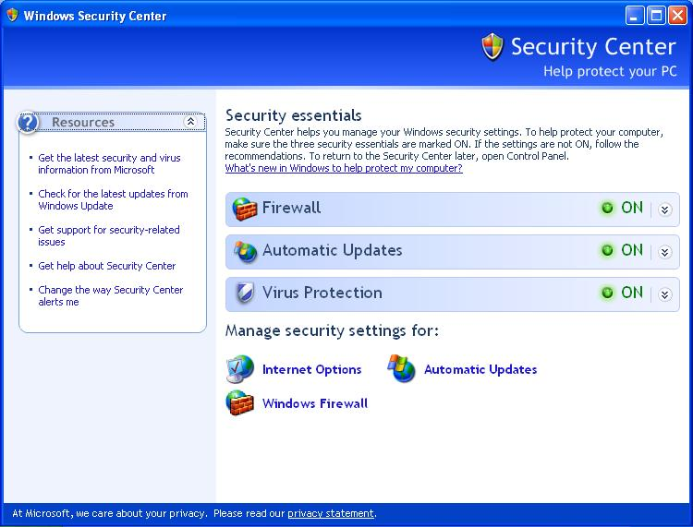
- Hold down the Alt key and press the PrintScrn key in the upper-right portion of the keyboard. That will copy the active window to the clipboard.

- In the virtual machine, click Start, Programs, Accessories, Paint. In the untitled - Paint window, select Edit, Paste from the menu bar. The window image appears in the Paint window.
- In the untitled - Paint window, click File, Save. Save the document in the My Pictures folder (or any other place you wish, such as a floppy disk) with the filename Your Name Proj 2c. Select a Save as type of JPEG.

Installing VMware Tools
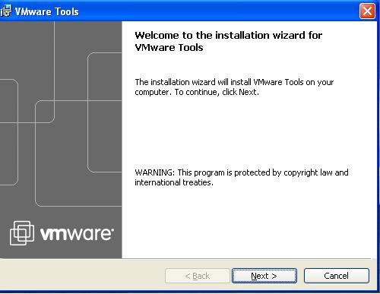
- VMWare Tools is a software product which makes VMWare run better. The most obvious thing it does is make it possible to move the mouse freely from the virtual PC to the host operating system, and also to drag-and-drop files from one machine to the other.
- Press Ctrl+Alt to release the mouse pointer from the virtual computer. From the VMWare Workstation window’s menu bar, click VM, Install VMWare Tools.
- When you see the Welcome to the installation wizard for VMWare Tools message shown to the right on this page, click Next.
- At the Setup Type screen, accept the default selection of Typical and click Next.
- At the Ready to install the program screen, click Install.
- At the Installation Wizard Complete screen, click Finish.
- A VMWare Tools box appears saying You must restart your system…. Click Yes. When the virtual machine restarts, log in as usual.

Turning in your Project
- Open Internet Explorer in the virtual machine, and use it to email the three JPEG images to me as three attachments to one e-mail message. Send the message to: cnit.235@gmail.com with a subject line of CNIT 235 Proj 2 From Your Name, replacing Your Name with your own first and last name. Send a Cc to yourself.

Last Modified: 6-16-06

