Using Help
- Click Start, Help and Support. Find the answers to the following questions in Help and write them down on the sheet below.
- Find System Restore and open it. How many Restore Points are there on your machine? Write down the dates and times below.

- How can you set your computer to open each folder in a separate part of memory? What are the advantages and disadvantages of doing that?

- How much RAM is there in your computer?

How many different ways can you find to see how much RAM you have? List them below:

Using Newsgroups
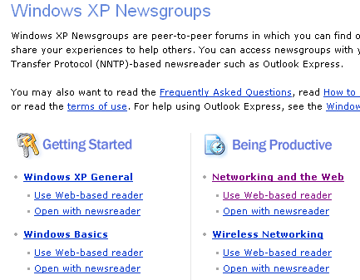
- Click the Home button to return to the main Help and Support page. Click Get support, or find information in Windows XP newsgroups. Click Go to a Windows Web site forum. Click Go to Windows Newsgroups.
- You should see the Windows XP Newsgroups as shown to the right on this page. Look through the topics and click one of the Use Web-based reader links in a topic that interests you. Read through the messages until you find two threads you find interesting, in which a person asked for help and got an answer. Then summarize them in a few sentences below: what was the problem, and what was the solution?

1.

2.

Knowledge Base

- Click Start, and then click Run.
- Type http://support.microsoft.com and then click OK. You can search the Knowledge Base here by typing keywords in to the box in the upper left, or by clicking the Search the Knowledge Base link for a more advanced search screen. Use this procedure to solve the following problems – find a Knowledge Base article that explains what to do, and write down the KB number of that article.

- Scenario: A network administrator calls and states what while upgrading the operating system of a networked computer from Windows 2000 Professional to Windows XP Professional, he received the following error message:

Error Reading CD-ROM in Drive D:

Please Insert CD-ROM WXHFPP_EN
With Serial Number 6A84-0E41 in Drive D:

If the CD-ROM is still in the drive, it may require cleaning.

Press ENTER for OK or ESC to Cancel: OK

The administrator has cleaned the disk and repeated the procedure but still gets the same error message. What do you recommend?

KB Article #: _______________________________________

- Scenario: A customer calls and says “I’m installing Windows XP, but the installation just stopped. There is a message on the screen that says “Error loading operating system.” What should I do?”

KB Article #: _______________________________________

- Scenario: A customer calls and says “I’m upgrading Windows 98 to Windows XP, but the installation just stopped. There is a message on the screen that says “INF File Textsetup.sif is corrupt or missing Status 14 SETUP CANNOT CONTINUE” What should I do?”

KB Article #: _______________________________________

Revised 1-27-05

