If you are replacing your computer with a new one, or erasing a hard disk completely and installing Windows XP on it, you will need to use either FAST (File and Settings Transfer) or USMT (User State Migration Tool) to transfer user files and desktop settings from one machine to another. File and Settings Transfer Wizard (FAST) uses a graphical interface and can be run on any computer using Windows 95 or later. The more advanced tool is User State Migration Tool (USMT) which can be used in command-line mode, but only with machines that are in a domain.

We will use FAST to save the user state on a network share.

Starting Your Computer
- Start your computer with the appropriate L removable hard drive in it. Start your virtual PC and log in with your own account.

Customizing Your Profile
- Password: Click Start, Control Panel, User Accounts, User Accounts. In the User Accounts box, click the icon next to your name. In the What do you want to change about your account? screen, click Create a password. Enter a password of your choice in both password boxes and click Create Password. . In the Do you want to make your files and folders private? screen, click No.
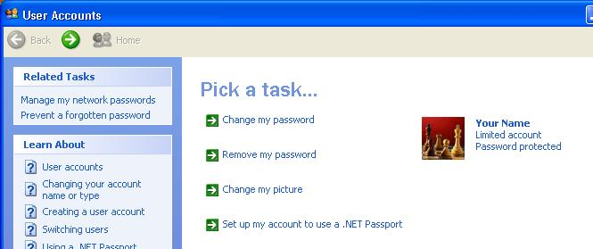
- Picture: In User Accounts, click Change my picture. Click on a picture you like and click the Change Picture button. Close all windows.
- Desktop Settings: Right-click the desktop and click Properties. Click the Desktop tab. Select a background you like and click OK.
- Internet Explorer Favorites: Click Start, Internet. Go to my Web page samsclass.info and click Favorites, Add to Favorites, OK. Go to a few more pages you like and add them to your Favorites. Close Internet Explorer.
- Drive Mapping: Click Start, My Computer. Verify that the Z: drive is mapped to a network share.

Saving Your Settings with the File and Settings Transfer (FAST) Wizard
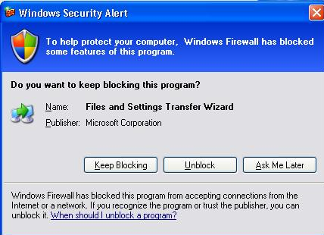
- Click Start, All Programs, Accessories, System Tools, File and Settings Transfer Wizard.
- The File and Settings Transfer Wizard opens. Read the information and click Next.
- In the Which computer is this? screen, click Old computer and click Next.
- A Windows Security Alert box opens, as shown to the right on this page – Service Pack 2 has blocked this action. Click the Unblock button.

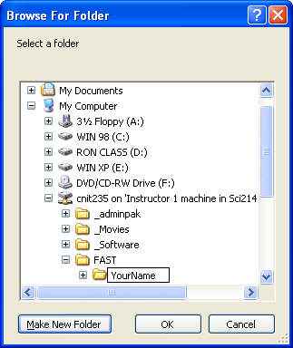
- In the Select a transfer method screen, click Other. Then click the Browse button. Expand My Computer, expand cnit235 on ‘Instructor 1 machine…, and click on FAST. Click the Make New Folder button and name the folder with your first and last name. In the Browse for Folder window, click OK. In the File and Settings Transfer Wizard window, click Next.
- In the What do you want to transfer? screen, click Settings only. Click Next.
- In the Completing the Collection Phase screen, click Finish.
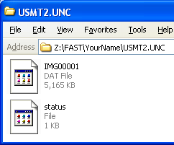
- Click Start, My Computer and open drive Z (labeled cnit235 on 'Instructor 1 machine in Sci214 (192.168.3.1)'). Open the FAST folder and the folder with your name on it. You should see a folder named Usmt2.unc. Open that folder. You should see two files: IMG00001.dat and status, as shown to the right on this page. Your files may have different sizes.

Saving the Screen Image
- Click on the USMT2.UNC window to make sure it is the active window.
- Hold down the Alt key and press the PrintScrn key in the upper-right portion of the keyboard. That will copy the active window to the clipboard.
- In the virtual machine, click Start, Programs, Accessories, Paint. In the untitled - Paint window, select Edit, Paste from the menu bar. The window image appears in the Paint window.
- In the untitled - Paint window, click File, Save. Save the document in the My Pictures folder (or any other place you wish, such as a floppy disk) with the filename Your Name Proj 4a. Select a Save as type of JPEG.
- Close Windows Explorer.

Restoring Your Settings to Another Machine with the FAST Wizard

Picking a Partner
- Pick another student to be your partner and make sure your partner has reached this same step. If no partner is available, you can create a second account for yourself on the same machine and move your settings to that account.

Creating an Account for Your Partner
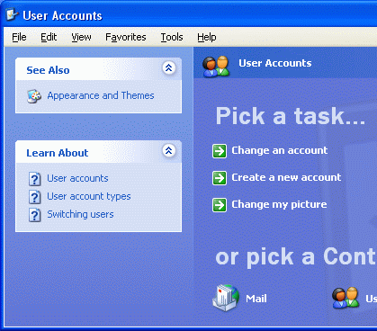
- In your virtual PC, click Start, Control Panel, User Accounts.
  - In the Pick a task… section, click on Create a new account.
  - In the Name the new account screen, enter your partner’s name and click Next.
  - In the Pick an account type screen, select Limited. Click Create Account.
  - Close all windows.
- Click Start, Log Off. In the Log Off Windows window, click Log Off.

Copying Your Personal Settings to Your Partner’s Computer
- Switch machines with your partner. You should see a Windows Welcome screen with several choices, including one with your name. Click on your name. Notice that you do not need any password, because no password has been assigned to the account on this computer.
- Click Start, All Programs, Accessories, System Tools, File and Settings Transfer Wizard.
- The File and Settings Transfer Wizard opens. Click Next.
- In the Which computer is this? screen, click New computer and click Next.
- In the Do you have a Windows XP CD? screen, click I don’t need the Wizard Disk. I have already collected my files and settings from my old computer and click Next.
- In the Where are the files and settings? screen, click Other. Then type in this path:

\\192.168.3.1\cnit235\FAST\Your Name

- Click Next. Wait for the transfer to finish.

Saving the Screen Image
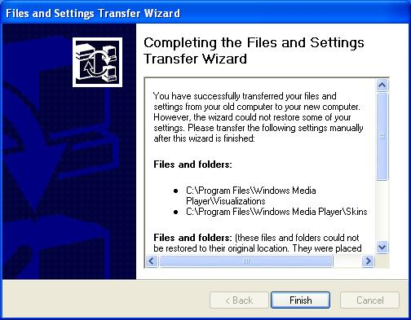
- A File and Settings Transfer Wizard window opens as shown to the right on this page, with the message “You have successfully transferred your files and settings…”.

- Click on the File and Settings Transfer Wizard window to make sure it is the active window.
- Hold down the Alt key and press the PrintScrn key in the upper-right portion of the keyboard. That will copy the active window to the clipboard.
- In the virtual machine, click Start, Programs, Accessories, Paint. In the untitled - Paint window, select Edit, Paste from the menu bar. The window image appears in the Paint window.
In the untitled - Paint window, click File, Save. Save the document in the My Pictures folder (or any other place you wish, such as a floppy disk) with the filename Your Name Proj 4b.
- In the Completing the File and Settings Transfer Wizard screen, click Finish.
- In the File and Settings Transfer Wizard box, click Yes to log off.
- Click your name to log on. Examine your profile and answer the questions below.

- Did your password transfer to the new computer? ______________
- Did your Login Picture (shown on the Windows Welcome page)
transfer to the new computer? ______________
- Did your desktop background transfer to the new computer? ______________
- Did your Internet Explorer Favorites transfer to the new computer? ______________
- Did your Drive Mapping for the Z: drive transfer to the new computer? ______________

Turning In your Project
- There are two images you need, and they are now stored on different virtual machines. Transfer the Your Name Proj 4b from your partner’s machine to yours, using any method that suits you: email it to yourself, save it in the shared folder with your desktop settings, or copy it to a floppy disk.
- After you have put them both on the same machine, email the JPEG images to me as attachments to a single email message. Answer the questions above in the body of the email message. Send it to: cnit.235@gmail.com with a subject line of CNIT 235 Proj 4 From Your Name, replacing Your Name with your own first and last name. Send a Cc to yourself.

Last Modified: 6-25-06

