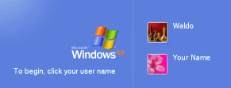
Starting Your Computer
- Start your computer with the appropriate L removable hard drive in it. Boot it up to the Windows XP operating system. Start your virtual PC, but don’t log in yet. Your screen should look like the image to the right on this page.

Checking the Administrator Password
- In order to use the Recovery Console, you must use the Administrator account. The password for this account was set to P@ssw0rd during Windows installation in project 1, if you followed the instructions.
- The Administrator account is not one of the options at the Windows Welcome screen shown above on this page. To log in as Administrator, press Ctrl+Alt+Insert twice. That will open a Windows 2000 style login box. Enter a login ID of Administrator and a password of P@ssw0rd
- If you can successfully log in to the Administrator account, everything is OK. Log out, log back in with your normal account, and proceed with this project.
- If you cannot log in as Administrator, log in with your own account Use Local Users and Groups in Computer Management to reset the Administrator password before proceeding. If you don’t know how to do that, ask for help from your instructor. Do not proceed with this project without the Administrator password, or you will break your machine and be unable to repair it!

Observing the boot.ini file
The boot.ini file is needed to start your machine. We’ll look at it, damage it, and fix the damage using the Recovery Console. That’s why we are using the Virtual PC, so the damage will not break the host operating system.
- Click Start, right-click My Computer, and click Properties. In System Properties, click the Advanced tab.
- In the Startup and Recovery section, click Settings button. In the System startup section, click the Edit button.
- The boot.ini file will open in Notepad. The file should look like the example below.
[boot loader]
timeout=30
default=multi(0)disk(0)rdisk(0)partition(1)\WINDOWS
[operating systems]
multi(0)disk(0)rdisk(0)partition(1)\WINDOWS="Microsoft Windows XP Professional" /noexecute=optin /fastdetect

Breaking boot.ini
- If the boot.ini file is damaged, your machine cannot start up. Let’s break it in a fairly simple way. Add an x after the WINDOWS in the line beginning default and in the line containing Windows XP Professional, so your file looks like the example below. Be careful to make both changes! Many students add only one x and that does not break the file! The added characters have been shaded for emphasis. This change will prevent the boot loader from finding the operating system.
[boot loader]
timeout=30
default=multi(0)disk(0)rdisk(0)partition(1)\WINDOWSx
[operating systems]
multi(0)disk(0)rdisk(0)partition(1)\WINDOWSx="Microsoft Windows XP Professional" /noexecute=optin /fastdetect

- In the boot – Notepad window, click File, Save. Close Notepad. Close all windows.

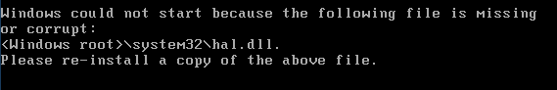
- Click Start, Turn Off Computer, Restart to restart the virtual PC. It won’t start up, and gives you an error message saying hal.dll is missing or corrupt, as shown below.

Booting the Virtual PC from the Windows XP Installation CD ISO File
- Press Ctrl+Alt to release the cursor from the virtual PC. From the Menu bar, select VM, Settings.
- In the Virtual Machine Settings box, click CD-ROM in the left pane. In the right pane, click Use ISO Image. Click the Browse button, navigate to the C:\ISO Image folder, and select the ISO image file.
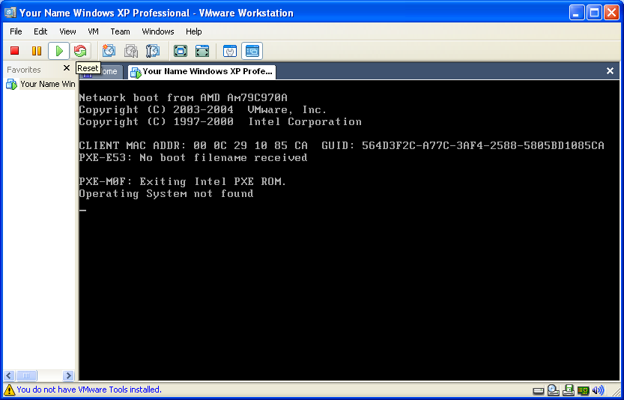
- Click OK to close the Virtual Machine Settings box
- Click the Reset button as shown to the right on this page. If a VMWare Workstation box opens asking Are you sure that you want to restart the guest operating system? click OK. In the next box, click OK.
- The virtual machine still does not boot from the CD, but that’s not because of the broken boot.ini file – it’s because the BIOS boot order is incorrect.

Adjusting the Boot Device Order in the BIOS
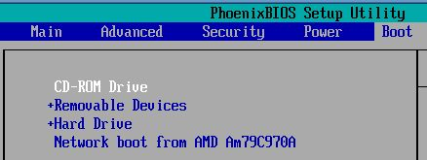
- Press Ctrl+Alt+Insert to restart the virtual PC again, and press F2 to open the BIOS Setup Utility.
- Press the B key to open the Boot menu, and use the down-arrow key to highlight CD-ROM Drive. Then press the + key twice to move it up in the boot order, until your screen looks like the example to the right on this page.
- Press the F10 key to save BIOS changes. When the Setup Confirmation box appears, press the Enter key to save changes.

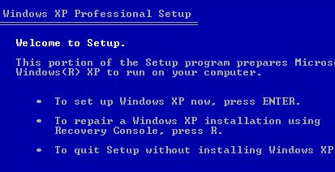
Fixing boot.ini with Recovery Console
- The virtual PC restarts again. When you see the message Press any key to start from CD, press any key.
- When you see the Welcome to Setup screen shown to the right on this page, press R to repair a Windows XP installation using Recovery Console.

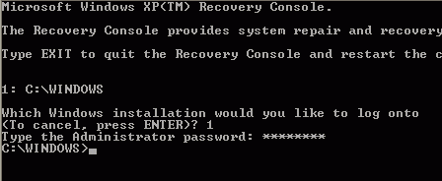
- You will see a text screen titled Microsoft Windows XP(TM) Recovery Console, as shown to the right on this page. This is the Recovery Console – it is not friendly or easy to use, and it is intended only for experts.
- At the Which windows installation would you like to log on to question, type 1 Enter.
- When it asks for the Administrator password, enter P@ssw0rd Enter.
- You will see a C:\WINDOWS> prompt. Enter the HELP command, followed by the Enter key. Each command must be terminated with the Enter key, so I will stop mentioning it explicitly from now on.
- Help lists the available commands. Notice that one of the commands is BOOTCFG. Press the space bar to finish the help message and give you a C:\WINDOWS> prompt.
- Enter BOOTCFG /? to learn about the BOOTCFG command. Read the information: this is a new feature in the Windows XP recovery console and it is very handy.
- Enter BOOTCFG /REBUILD. Recovery console scans your disk to find Windows installations.
- After it locates Windows, it asks you
Add installation to boot list? (Yes/No/All)
- Type Y and press the Enter key.
- When it asks Enter load identifier type in Windows XP Fixed.
- When it asks Enter OS load options type in /noexecute=optin /fastdetect.

Saving the Screen Image
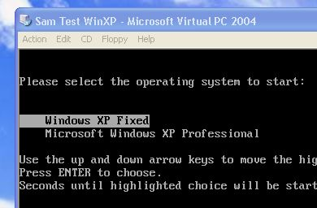
- When the command prompt C:\WINDOWS returns, type in EXIT to leave Recovery Console. Your virtual PC restarts. While it is restarting, press Ctrl+Alt to move the mouse outside the Virtual PC window and click on the host system’s desktop to make the virtual PC stop being the active window.
- When you see the choice of two operating systems, as shown to the right on this page, press the PrintScrn key.
- In the host operating system (not the virtual PC), click Start, Programs, Accessories, Paint. In the untitled - Paint window, select Edit, Paste from the menu bar. The image appears in the Paint window.
- In the untitled - Paint window, click File, Save. Save the document in the My Pictures folder (or any other place you wish, such as a floppy disk) with the filename Your Name Proj 6a. Select a Save as type of JPEG. Close Paint.

Cleaning up boot.ini
- Click in the virtual PC window to make it active. If you still see a choice of operating systems, select Windows XP Fixed. When you see the Windows Welcome screen, log in with your usual account.
- Now we’ll remove the useless extra line from the BOOT.INI file.
- In the virtual PC window, click Start, right-click My Computer, and click Properties. In System Properties, click the Advanced tab.
- In the Startup and Recovery section, click Settings button. In the System startup section, click the Edit button.
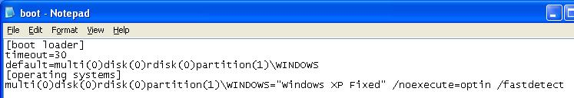
- The boot.ini file will open in Notepad. Edit the file to remove the last line, so that your boot.ini file looks like the example below.

Saving the Screen Image
- Click in the title bar of the boot – Notepad window to make sure it is the active window.
- Press Alt + PrintScrn to capture an image of the active window.
- Click Start, Programs, Accessories, Paint. In the untitled - Paint window, select Edit, Paste from the menu bar. The image appears in the Paint window.
- In the untitled - Paint window, click File, Save. Save the document in the My Pictures folder (or any other place you wish, such as a floppy disk) with the filename Your Name Proj 6b. Select a Save as type of JPEG. Close Paint.

Saving the Boot.ini File and Testing it
- Close Notepad. Save your changes.
- In the virtual PC window, close all windows. Click Start, Turn Off Computer, Restart to restart the virtual PC. Verify that your virtual PC starts normally. Log in with your usual account.

Turning In your Project
- The first image you saved is in the host operating system, not the virtual PC. To copy it to the virtual PC, just drag it and drop it onto the virtual desktop. If that doesn’t work, you could also email it to yourself, or use a network share, or a floppy disk, to transfer it.
- Once both images are together on the same machine, email the JPEG images to me as attachments to a single email message. Send it to: cnit.235@gmail.com with a subject line of CNIT 235 Proj 6 From Your Name. Send a Cc to yourself.

Last modified 4-16-06

