Starting Your Computer
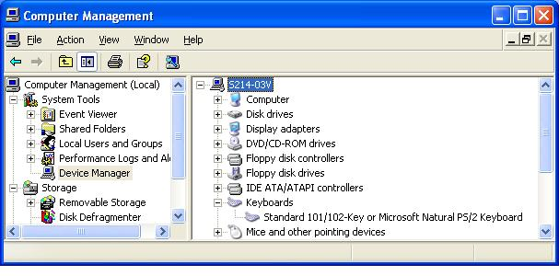
- Start your computer with the appropriate L removable hard drive in it. Start your virtual PC and log in with your own account.

Viewing the Keyboard Driver
- In the YourName Win XP window, click Start, right-click My Computer, and click Manage.
- In Computer Management, in the left pane, click Device Manager. In the right pane, expand Keyboards. You should see Standard 101/102-Key or Microsoft Natural PS/2 Keyboard as shown to the right on this page.

Installing the Wrong Keyboard Driver
- In the Computer Management window, in the Keyboards section, double-click Standard 101/102-Key or Microsoft Natural PS/2 Keyboard.
- In the Standard 101/102-Key or Microsoft Natural PS/2 Keyboard Properties window, click the Driver tab. Click the Update Driver button.
- In the Hardware Update Wizard, the first screen asks Can Windows connect to Windows Update to search for software? Click No, not at this time and click the Next button.
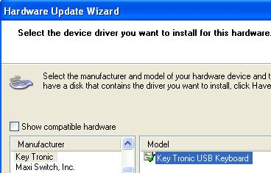
- In the next screen, click Install from a list or a specific location (Advanced) and click the Next button.
- In the next screen, click Don’t search. I will choose the driver to install and click the Next button.
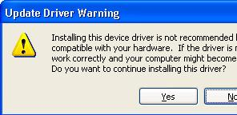
- The next screen shows only one possible device driver. Clear the Show compatible hardware box to see more options. In the Manufacturers list, click Key Tronic, and in the Model list, select Key Tronic USB Keyboard as shown to the right on this page. Click the Next button.
- An Update Driver Warning appears as shown to the right on this page. A sensible person might stop here, but the point of this exercise is to break the virtual PC and then fix it, so click Yes.

- After the driver installs, click Finish to close the Hardware Update Wizard. Close the Key Tronic USB Keyboard Properties window. When a System Settings Change box opens asking if you want to restart your computer, click Yes.

Attempting to Log On
- After the Virtual machine restarts, try to click on your name to log in as usual. The mouse no longer works properly, because you are using the wrong keyboard driver, so you cannot log in.
- Press Ctrl+Alt to release the mouse from the virtual machine, and close the virtual machine by clicking on the little white X to the right of the VMWare tabs. A VMWare Workstation box opens asking Are you sure you want to power off and close this virtual machine? Click Yes. The virtual machine shuts off without going through the normal Windows shutdown procedure.

Opening the Windows Advanced Options Menu
- In the VMWare Workstation window, on the Home tab, click Open Existing VM or Team link. Find your virtual machine in the My Documents folder and double-click it.
- Start the virtual machine again, and click inside the virtual machine’s window as soon as it begins booting up. Then press the F8 key on the keyboard every few seconds. If you see the message “Press any key to boot from CD”, wait till it vanishes, then press F8 immediately.
- You should see the Windows Advanced Options Menu as shown below.
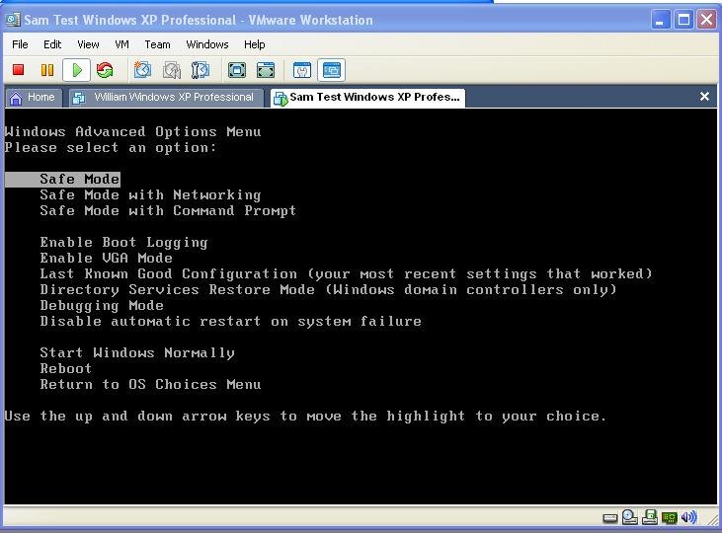

Saving the Screen Image
- Move the mouse pointer out of the YourName WinXP window. Click an empty portion of the Windows XP desktop outside the YourName WinXP window, so that the YourName WinXP title bar is dimmed.
- Press the PrintScrn key in the upper-right portion of the keyboard. That will copy the whole desktop to the clipboard.
- Click Start, Programs, Accessories, Paint. In the untitled - Paint window, select Edit, Paste from the menu bar. The desktop appears in the Paint window, with only a corner of it visible.
- In the untitled - Paint window, click File, Save. Save the document in the My Pictures folder (or any other place you wish, such as a floppy disk) with the filename Your Name Proj 7a. Select a Save as type of JPEG.

Restarting in Safe Mode
- In the Windows Advanced Options Menu, use the arrow keys on the keyboard to highlight Safe Mode and press the Enter key on the keyboard.
- Although you are using Safe mode, the mouse still doesn’t work and you cannot log in. Safe mode uses only a minimum set of drivers, but it can’t fix this driver problem.

Using Last Known Good Configuration
- Press Ctrl+Alt to release the mouse from the virtual machine, and close the virtual machine by clicking on the little white X to the right of the VMWare tabs.
- Start the virtual machine again, and click inside the virtual machine’s window as soon as it begins booting up. Then press the F8 key on the keyboard every few seconds to open the Windows Advanced Options Menu again.
- In the Windows Advanced Options Menu, use the arrow keys on the keyboard to highlight Last Known Good Configuration (your most recent settings that worked) and press the Enter key on the keyboard.
- When the virtual machine starts up, log on normally. The mouse works now.

Using Device Manager to View Your Keyboard Driver
- In the YourName Win XP window, click Start, right-click My Computer, and click Manage.
- In Computer Management, in the left pane, click Device Manager. In the right pane, expand Keyboards. You should see Standard 101/102-Key or Microsoft Natural PS/2 Keyboard as shown to the right on this page.

Saving the Screen Image
- In the virtual machine, press Alt+PrintScrn keys to copy the active window to the clipboard.
- In the virtual machine, Click Start, Programs, Accessories, Paint. In the untitled - Paint window, select Edit, Paste from the menu bar. The window appears in the Paint window.
- In the untitled - Paint window, click File, Save. Save the document in the My Pictures folder with the filename Your Name Proj 7b. Select a Save as type of JPEG.

Checking the Network Adapter’s Function
- Click Start, Internet. A Web page should open. That shows that the network adapter is currently working.

Installing the Wrong Network Adapter Driver
- In the YourName Win XP window, click Start, right-click My Computer, and click Manage.
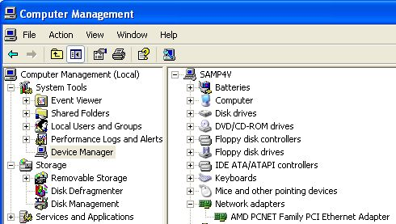
- In Computer Management, in the left pane, click Device Manager. In the right pane, expand Network Adapters. You should see an AMD PCNET Family PCI Ethernet Adapter as shown to the right on this page.
- In the Computer Management window, in the Network Adapters section, double-click AMD PCNET Family PCI Ethernet Adapter.
- In the AMD PCNET Family PCI Ethernet Adapter Properties window, click the Driver tab. Click the Update Driver button.
- In the Hardware Update Wizard, the first screen asks Can Windows connect to Windows Update to search for software? Click No, not at this time and click the Next button.
- In the next screen, click Install from a list or a specific location (Advanced) and click the Next button.
- In the next screen, click Don’t search. I will choose the driver to install and click the Next button.

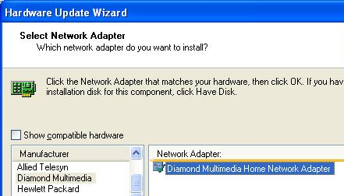
- The next screen shows only one possible device driver. Clear the Show compatible hardware box to see more options. In the Manufacturers list, click Diamond Multimedia, and in the right pane, select Diamond Multimedia Home Network Adapter as shown to the right on this page. Click the Next button.
- An Update Driver Warning appears. Click Yes.
- After the driver installs, the Hardware Update Wizard shows this message: Cannot Start the Hardware. Click Finish to close. Close the Diamond Multimedia Home Network Adapter Properties window.

Attempting to Connect to the Internet
- Click Start, Internet. You should no longer be able to reach the Internet, because the Network Adapter can’t operate with the wrong driver.

Viewing the Network Adapter in Device Manager
- Click Start, right-click My Computer, and click Manage.
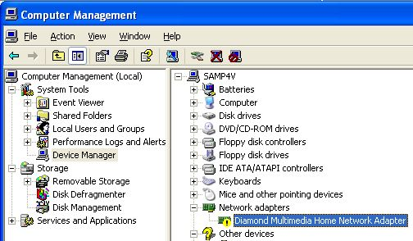
- In Computer Management, in the left pane, click Device Manager. In the right pane, expand Network Adapters, if necessary. You should see Diamond Multimedia Home Network Adapter with a yellow ! to indicate that there is a problem with this device, as shown below on this page.

Saving the Screen Image
- Click the Computer Management window to make it active.
- Press Alt+PrintScrn keys to copy the active window to the clipboard.
- In the virtual machine, Click Start, Programs, Accessories, Paint. In the untitled - Paint window, select Edit, Paste from the menu bar. The window appears in the Paint window.
- In the untitled - Paint window, click File, Save. Save the document in the My Pictures folder with the filename Your Name Proj 7c. Select a Save as type of JPEG.

Using Driver Rollback to Restore the Previous Network Adapter Driver
- In the Computer Management window, double click Diamond Multimedia Home Network Adapter.
- In the Diamond Multimedia Home Network Adapter Properties box, click the Driver tab, and click the Roll Back Driver button.
- A box appears saying Are you sure you would like to roll back to the previous driver? Click Yes.
- After a few seconds, the title of the properties sheet changes to AMD PCNET Family PCI Ethernet Adapter Properties. Click the Close button.
- In Computer Management, in the right pane, in the Network Adapters section, you should see an AMD PCNET Family PCI Ethernet Adapter without a yellow !.

Attempting to Connect to the Internet
- Click Start, Internet. A Web page should open. That shows that the network adapter is working again.

Turning in your Project
- The first image you saved is in the host operating system, not the virtual PC. To copy it to the virtual PC, just drag it and drop it onto the virtual desktop. If that doesn’t work, you could also email it to yourself, or use a network share, or a floppy disk, to transfer it.
- Once all the images are together on the same machine, email the JPEG images to me as attachments to a single email message. Send the message to: cnit.235@gmail.com with a subject line of CNIT 235 Proj 7 From Your Name, replacing Your Name with your own first and last name. Send a Cc to yourself.

Revised 6-16-06

