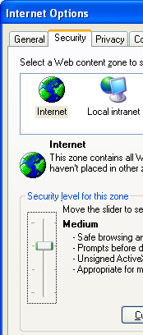
This project can be done on any Windows XP machine with Service Pack 2. You can use either Internet Explorer version 6 (IE 6a) or version 7 (IE 7).
- Start your computer with the appropriate L removable hard drive. Start your virtual machine and log in with your own account. .
Ensuring That Internet Explorer Security is at its Default Settings
- Click Start, Internet. Click Tools, Internet Options. Click the Security tab. Click the globe labeled Internet to select the Internet security zone. Click the Default Level button. The Security Level changes to Medium. Once the security is set to Medium, the Default Level button is grayed out. Click OK to close Internet Options.
Installing Windows Defender
- Windows Defender is Microsoft’s antispyware tool, and it is widely considered to be a good product.
- If you are in Science 214, use the procedure below to get Windows Defender from the server in that room. If you are working at home, you can download it from tinyurl.com/c9p2f
- Click Start, Run. Enter \\192.168.1.3 and click OK.
- An Instructor1 Machine in Sci214 window opens. Double-click the CNIT 30 folder. Drag the Windows Defender installer file to your desktop.
- Double-click the Windows Defender icon on your desktop. Run the installer. Accept the agreement. Use the recommended or default settings. When you see the message Windows Defender Installation Complete, leave the Check for updated definitions and run a quick scan now box checked and click Finish. Wait until the scan finishes.
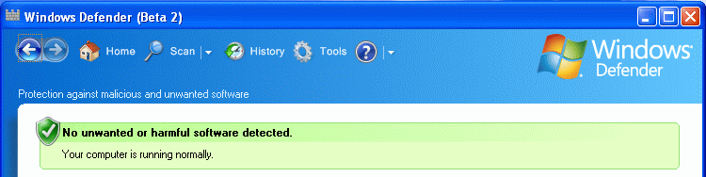
Saving a Screen Image
- When you see the Windows Defender window shown below, press the PrintScrn key.

- Click Start, Programs, Accessories, Paint. In the untitled - Paint window, select Edit, Paste from the menu bar. The window appears in the Paint window.
- In the untitled - Paint window, click File, Save. Save the document in the Shared Documents folder with the filename Your Name Proj 10a. Select a Save as type of JPEG.
- If no Spyware was found, close the Windows Defender window. If Spyware was found, follow the on-screen prompts to learn what it is. You should probably remove it, unless it is a program you deliberately installed and want.

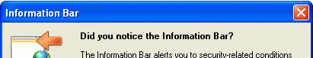
Using PC Pitstop's Check ActiveX
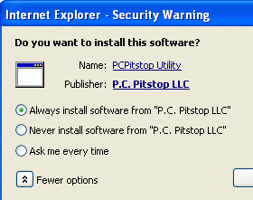
- Open Internet Explorer and go to pcpitstop.com. In the left column of the PC Pitstop page, under Tests and Scans, click Check ActiveX. An Information Bar box opens, as shown to the right on this page. Click the Close button.
- Click the yellow Information bar near the top of the Internet Explorer window, and click Install ActiveX Control.
- In the Internet Explorer – Security Warning box, click the button to the left of the More Options label. Click the Always install software from "P.C. Pitstop LLC" radio button, as shown to the right on this page. Click the Install button.
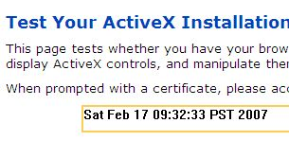
- Wait while the software downloads (just a few seconds). When the ActiveX control is loaded, the date and time will appear in the yellow box, as shown to the right on this page.
Observing the Trusted Publishers
- In Internet Explorer, click Tools, Internet Options. Click the Content tab. Click the Publishers button. Click the Trusted Publishers tab. You should see P.C. Pitstop LLC, as shown to the right on this page.
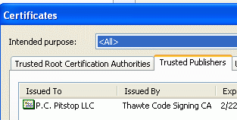
Saving a Screen Image
- Click the Certificates title bar to make sure it is the active window.
- Hold down the Alt key and press the PrintScrn key in the upper-right portion of the keyboard. That will copy the window to the clipboard.
- Click Start, Programs, Accessories, Paint. In the untitled - Paint window, select Edit, Paste from the menu bar. The window appears in the Paint window.
- In the untitled - Paint window, click File, Save. Save the document in the Shared Documents folder with the filename Your Name Proj 10c. Select a Save as type of JPEG. Close Paint.
- In the Certificates window, click Close.
- In the Internet Options window, click OK.
Running Check ActiveX Again
- Close Internet Explorer. Open Internet Explorer and go to pcpitstop.com.
- In the left column of the PC Pitstop page, under Tests and Scans, click Check ActiveX.
- The date and time will appear in the yellow box. It did not ask you for permission to install the ActiveX control, but that’s not because it trusts PC Pitstop – it’s because the ActiveX control is already installed. ActiveX controls stay on your computer for a long time, unless you delete them. This has strange effects – often a corrupt ActiveX control causes problems in Internet Explorer.
Managing Installed ActiveX Controls
- This next step is different for different browser versions.
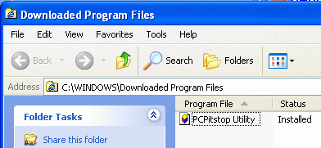
  - If you are using IE 6, click Tools, Internet Options. In the Internet Options window, on the General tab, in the Temporary Internet Files section, click the Settings button. In the Settings box, click the View objects button.
  - If you are using IE 7. click Tools, Internet Options. In the Internet Options window, on the General tab, in the Browsing History section, click the Settings button. In the Temporary Internet Files and History Settings box, click the View objects button.
- You should see a Downloaded Program Files box containing an item named mhLabel Class, as shown above and to the right .
Attempting to Remove the Installed ActiveX Control
- In the Downloaded Program Files window, right-click the mhLabelClass item and click Remove. In the Remove Program File box, click Yes. A Share Violation box opens telling you that this file is in use.
- Close all windows. Open Internet Explorer. This unlocks the ActiveX control.
- In the Internet Explorer window, click Tools, Internet Options.
- This next step is different for different browser versions.
  - If you are using IE 6, click Tools, Internet Options. In the Internet Options window, on the General tab, in the Temporary Internet Files section, click the Settings button. In the Settings box, click the View objects button.
  - If you are using IE 7. click Tools, Internet Options. In the Internet Options window, on the General tab, in the Browsing History section, click the Settings button. In the Temporary Internet Files and History Settings box, click the View objects button.
- In the Downloaded Program Files window, right-click the mhLabelClass item and click Remove. In the Remove Program File box, click Yes. The ActiveX control vanishes.
- Close all windows.

Running Check ActiveX Again
- Close Internet Explorer. Open Internet Explorer and go to pcpitstop.com.
- In the left column of the PC Pitstop page, under Tests and Scans, click Check ActiveX.
- The date and time will appear in the yellow box. It did not ask you for permission to install the ActiveX control, and this time that was because you told it to trust PC Pitstop as a publisher.

Turning in your Project
- Email the JPEG images to me as attachments to one e-mail message. Send the message to: cnit.235@gmail.com with a subject line of Proj 10 From Your Name, replacing Your Name with your own first and last name. Send a Cc to yourself.

Revised 2-17-07

