You can do this project on any Windows XP computer for which you have Administrative privileges.
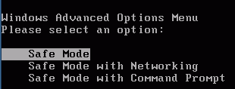
Use Safe Mode
- Start your computer with the appropriate L removable hard drive.
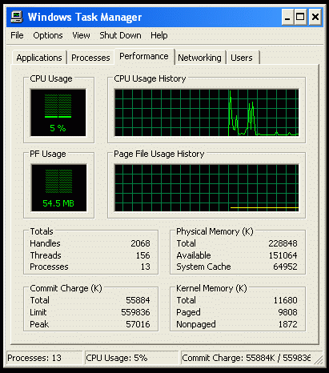
- Start your virtual machine and click in its window. Wait until you see the message Press any key to boot from CD…. Immediately after that message vanishes, press the F8 key. When you see the Windows Advanced Options Menu as shown above on this page, verify that Safe Mode is highlighted and press the Enter key. Log in with your usual account.
- Task Manager is a useful tool in normal mode. The only reason we are using Safe Mode is to stop extra processes such as the virus scanner, to make the results easier to interpret.
Memory Use by Windows
- Right-click the taskbar (at the bottom of the screen) and select Task Manager. Click the Performance tab, as shown in the figure to the right on this page. Your numbers may be different from the example.
- In the Physical Memory section, find the Total and Available numbers. Write them in the box to the right on this page. Because Windows has processes running, the Available values keeps changing. Just estimate the average value.

Total Physical Memory: ___________________________

Available Physical Memory: ___________________________

PF Usage: ___________________________

Processes: ___________________________

Commit Charge: ___________________________
- In the center left portion of the Task Manager window, you will see a green bar labeled PF Usage with a green number under the bar. Find that value and write it in the box above on this page. This measures the amount of hard disk space that has been reserved for virtual memory.

- In the Totals section, find the Processes number. Write it in the box on the previous page.
- In the lower right of the Task Manager window, find the Commit Charge. It is a fraction, like 133732K / 478060 K. You may have to resize the Windows Task Manager box too see it. What matters here is the first number. Write it in the box on the previous page.
Performance With All Available Memory
- If you have a clock or watch with a second hand available, use it to time how long your computer takes to perform the next step. If no clock is handy, just count the seconds by reciting them out loud.
- Click Start, Internet to open an Internet Explorer window. Measure how many seconds it takes to show its error page –no Internet connection is available in Safe Mode.. Wait a few seconds until the numbers in Task Manager stop changing (this should happen when the CPU falls to 10% or below and stays there), and write them down on the first line of the table below.
- Repeat this process twice more, writing down the time, available memory, PF usage, and Total Commit Charge each time.
- Now open 7 more Internet Explorer windows, so you have 10 of them open at once. Wait till they are all open and the Task Manager values become reasonably steady.
- Click Start, Internet Explorer to open an Internet Explorer window. Measure how many seconds it takes to show your home page. Wait a few seconds until the numbers in Task Manager stop changing, and write them down on the line numbered 11 in the table below.

IE Windows | Time to  Open (sec) | Avl. Phys.  Mem (K) | PF Usage (MB) | Processes | Total Commit Charge
1 | _________ | _________ | ____________ | _______ | _________________________
2 | _________ | _________ | ____________ | _______ | _________________________
3 | _________ | _________ | ____________ | _______ | _________________________
. . .
11 | _________ | _________ | ____________ | _______ | _________________________

- Examine the values in the table above and answer the questions in the box below.

Did it take longer to open the 11th window than the first one? _______________
Does opening more windows lower the Available Physical Memory? _______________
Does opening more windows increase PF Usage? _______________
Does opening more windows increase the number of Processes? _______________
Does opening more windows increase Commit Charge? _______________

Starting With Less Memory
Note:
The 96 MB value was chosen to make the performance change reasonable for the S214 lab machines. If you find that you get the same performance with 96 MB, lower the RAM to 64 MB instead. If the performance is intolerably slow with 96 MB, try 128 MB.
- Close all windows.
- Click Start, right-click My Computer, and select Properties. On the Advanced tab, in the Startup and Recovery section, click the Settings button. In the System Startup section of the Startup and Recovery window, click the Edit button.
- The boot.ini file opens in Notepad. Find the last line, the one starts Windows XP. Carefully copy it and paste it below the original line. Then add this switch to the end of the new line:
/MAXMEM=96
- Add 96 MB to the end of the description line in the new line. This will start Windows XP with only 96 MB of RAM, which is only 32 MB more than the minimum amount that Microsoft regards as acceptable.
- Your boot.ini file should now resemble the example shown below.

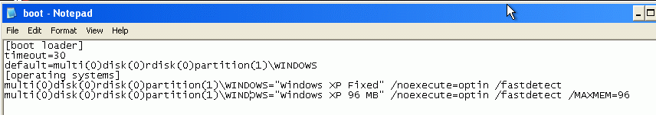
- Close Notepad and save changes.
- Restart your computer. When you see a screen offering you a choice of operating systems, press F8 and start in Safe Mode. Select the 96MB operating system. Log in with your usual account.

Total Physical Memory: ___________________________

Available Physical Memory: ___________________________

PF Usage: ___________________________
- Open Task Manager, find the Total Physical Memory, Available Physical Memory, and PF Usage, and write them in the box to the right on this page.
- Repeat the process you used before to fill in the values in the chart below on this page, with various numbers of Internet Explorer windows open. Notice how slow the response is when you open the 11th window – that’s what computers are like when they are low on RAM.

Performance With 96 MB Memory

IE Windows | Time to  Open (sec) | Available  Physical  Memory (K) | PF Usage (MB) | Processes | Commit Charge
1 | _________ | _________ | ____________ | _______ | _________________________
2 | _________ | _________ | ____________ | _______ | _________________________
3 | _________ | _________ | ____________ | _______ | _________________________
. . .
11 | _________ | _________ | ____________ | _______ | _________________________

Did it take longer to open the 11th window than the first one? _______________
Does opening more windows lower the Available Physical Memory? _______________
Does opening more windows increase PF Usage? _______________
Does opening more windows increase the number of Processes? _______________
Does opening more windows increase Commit Charge? _______________

- After you have filled in the charts, turn in this handout with your name on it, or e-mail the answers to:
cnit.235@gmail.com

Last modified 4-24-06

