This project can be done on any Windows XP Pro machine for which you have Administrative privileges.
- In S214, start your virtual machine and log in with your usual account.
Downloading MARCH.BAT
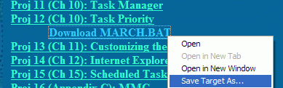
- Open Internet Explorer and go to my Web page samsclass.info. Click the CNIT 235: Windows Desktop Support Technician link. Click the Projects link (or scroll down to the Projects section).
- Under the Proj 12 line, right-click Download MARCH.BAT and select Save Target As…, as shown to the right on this page. Save the file on the root of C:\.
- Close Internet Explorer.
Measuring CPU Use
- Click Start, Run to open a Run box. In the Run box, type in CMD and press the Enter key.
- A Command Prompt window opens. Enter CD \ and press the Enter key. This changes the working directory to the root of the C: drive.
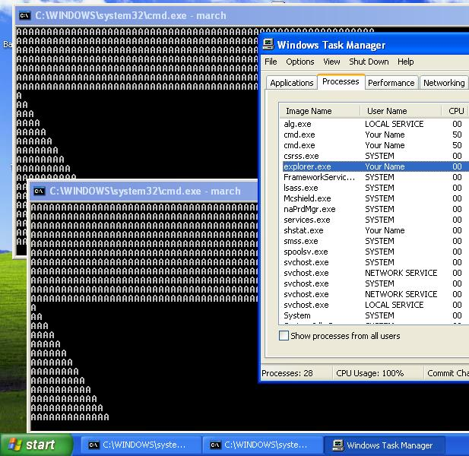
- In the Command Prompt window, enter MARCH and press the Enter key. This runs a batch file that prints some As on the screen, slowly marching to the right.
- Click Start, Run again to open a Run box. In the Run box, type in CMD and press the Enter key.
- A second Command Prompt window opens. Enter CD \ and press the Enter key. Enter MARCH and press the Enter key. This makes a second window with As on the screen, slowly marching to the right.
- Do not resize the Command Prompt windows, but drag them so you can see them both at once.
- Right-click the taskbar and select Task Manager. Click the Processes tab, and click the Image Name header to sort the processes alphabetically, as shown to the right on this page.
Observing Priority Boost
- Notice that the two cmd.exe processes have the same CPU value, approximately 50%. That’s because neither of them is the Active window – the window with the title bar bright blue. Right now, Task Manager is the Active Window. By default, Windows XP is set to give the Active Window a priority boost – it gets a lot more CPU cycles than processes taking place in the other windows.
- Click on one of the Command Prompt window title bars to make it the Active Window. The Task Manager title bar will become dim. Now you should see the CPU for one of the cmd.exe processes become much larger than the other one, and you should be able to visibly see the As march faster in the active window. In VMWare, one process gets approximately 75% of the CPU and the other gets approximately 25%, as shown below on this page.
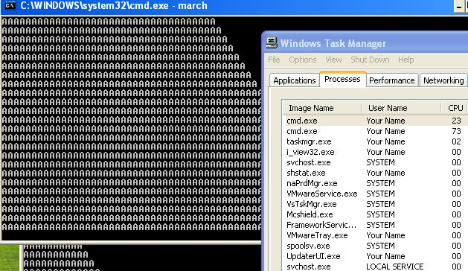

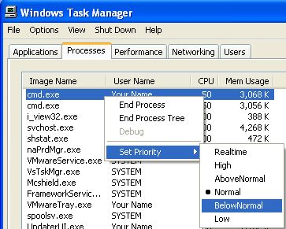
- Press PrtScn to copy the whole desktop to the clipboard.
- On the Start menu, click Run. Enter the command mspaint and press the Enter key. Paint opens.
- Press Ctrl+V on the keyboard to paste the image into the Paint window. Save the document in the Shared Documents folder with the filename Your Name Proj 12a. Select a Save as type of JPEG. Close Paint.
Adjustng Priority in Task Manager
- Right-click one of the cmd.exe in Task Manager, point to Set Priority, and click BelowNormal as shown to the right on this page.

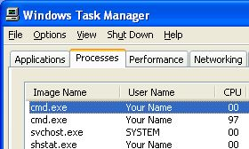
- A Task Manager Warning box opens, warning you that this may have undesired results. Click Yes.
- Now one cmd.exe process gets almost all the CPU – 99% or so, and the other one gets almost none at all – 0% or so, as shown to the right on this page.
- Press Alt+PrtScn to copy the Task Manager window to the clipboard.
- On the Start menu, click Run. Enter the command mspaint and press the Enter key. Paint opens.
- Press Ctrl+V on the keyboard to paste the image into the Paint window. Save the document in the Shared Documents folder with the filename Your Name Proj 12b. Select a Save as type of JPEG. Close Paint.
- Right-click one the cmd.exe that is getting the least CPU in Task Manager, point to Set Priority, and click Normal. In the Task Manager Warning box, click Yes. Now the two cmd.exe processes should be back to about 50% of the CPU.
Adjusting Performance Options
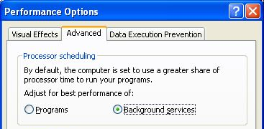
- Click Start, right-click My Computer, and click Properties. In the System Properties window, click the Advanced tab. In the performance section, click the Settings button.
- In the Performance Options box, click the Advanced tab. The default selection for processor Scheduling is Programs, which gives a greater share of processor time to the foreground process. Click the Background services radio button, as shown to the right on this page.
- In the Performance Options box, click the OK button. In the System Properties box, click the OK button.
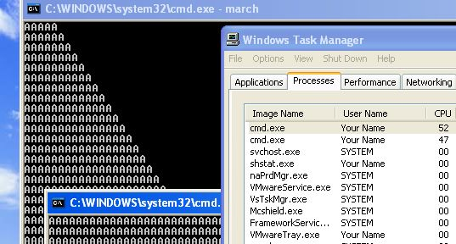
- Click one of the Command Prompt title bars to make it the active window. Even though it is the active window, it still gets the same CPU as the other process, both about 50%, as shown to the right on this page.

- Press PrtScn to copy the whole desktop to the clipboard.
- On the Start menu, click Run. Enter the command mspaint and press the Enter key. Paint opens.
- Press Ctrl+V on the keyboard to paste the image into the Paint window. Save the document in the Shared Documents folder with the filename Your Name Proj 12c. Select a Save as type of JPEG. Close Paint.
Returning Performance Options to its Default Condition
- Click Start, right-click My Computer, and click Properties. In the System Properties window, click the Advanced tab. In the performance section, click the Settings button.
- In the Performance Options box, click the Advanced tab. In the Processor Scheduling section, click Programs.
- In the Performance Options box, click the OK button. In the System Properties box, click the OK button.
- Close all windows.
Turning in your Project
- Email the JPEG images to me as attachments to one e-mail message. Send the message to: cnit.235@gmail.com with a subject line of CNIT 235 Proj 12 From Your Name, replacing Your Name with your own first and last name. Send a Cc to yourself.

Last modified 6-25-06

