This project can be done on any Win XP Pro machine for which you have administrative privileges.
Opening Microsoft Management Console (MMC)
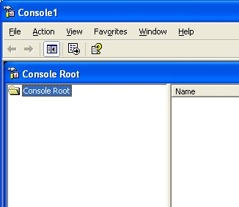
- Use your virtual PC. Log in with your own account, which has Administrative privileges.
- Click Start, Run. In the Run box, enter mmc and press the Enter key.
- A Console1 window opens, with a second window inside it titles Console Root, as shown to the right on this page. This is the MMC console. At the moment it is an empty shell, and does not do anything.
Adding the Device Manager Snap-in
- In the Console1 window, click the File menu item. On the submenu, click Add/Remove Snap-in….
- In the Add/Remove Snap-in window, click the Add button.
- In the Add Standalone Snap-in window, click Device Manager. Click the Add button.
- In the Device Manager window, you can select which computer's devices to manage. Accept the default selection of Local Computer and click the Finish button.
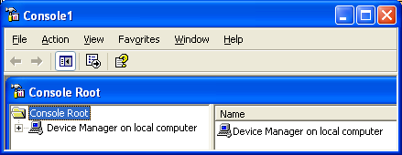
- In the Add Standalone Snap-in window, click the Close button.
- In the Add/Remove Snap-in window, click the OK button.
- Your Console1 window should now show a Device Manager on local computer item, as shown to the right on this page.
Adding the Certificates Snap-in
- In the Console1 window, click the File menu item. On the submenu, click Add/Remove Snap-in….
- In the Add/Remove Snap-in window, click the Add button.
- In the Add Standalone Snap-in window, click Certificates. Click the Add button.
- In the Certificates snap-in window, you can select which user account's certificates to manage. Accept the default selection of My user account and click the Finish button. These Certificates are used for encrypting your files, and for encrypting Web page data (if your machine is being used as a Web server).
- In the Add Standalone Snap-in window, click the Close button.
- In the Add/Remove Snap-in window, click the OK button.

Adding the Services Snap-in
- In the Console1 window, click the File menu item. On the submenu, click Add/Remove Snap-in….
- In the Add/Remove Snap-in window, click the Add button.
- In the Add Standalone Snap-in window, find and select Services. Click the Add button.
- In the Services window, you can select which computer's services to manage. Accept the default selection of Local computer and click the Finish button.
- In the Add Standalone Snap-in window, click the Close button.
- In the Add/Remove Snap-in window, click the OK button.
Saving a Screen Image of the Console
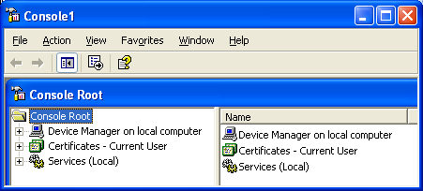
- Your Console1 window should now show the three items shown to the right on this page: Device Manager, Certificates, and Services. Press Alt+PrtScn to copy this window to the clipboard.
- On the Start menu, click Run. Enter the command mspaint and press the Enter key. Paint opens.
- Press Ctrl+V on the keyboard to paste the image into the Paint window. Save the document in the Shared Documents folder with the filename Your Name Proj 16a. Select a Save as type of JPEG. Close Paint.
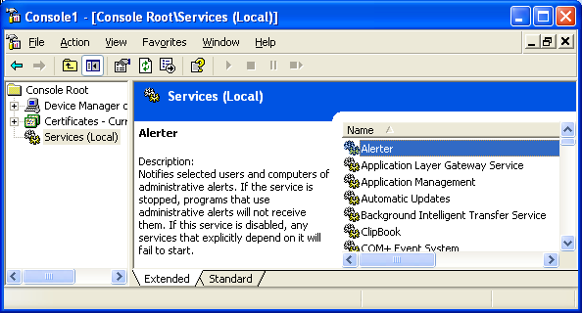
Exploring Services
- In the left pane of the Console1 window, select Services (Local). In the right pane, you should see an alphabetical list of the services available on your system, with a paragraph in the upper left explaining the currently selected service, as shown to the right on this page.
- Scroll through the services and read the explanations to answer the questions in the box on the next page.

Saving Your Console
A: What happens if you stop the Workstation service?

B: What happens if you stop the Plug and Play service?

C: What happens if you stop the Event Log service?

- In the Console1 window, click File, Save As….
- In the Save As dialog box, click the Save in: box to display the default location for saved MMC consoles, as shown to the right on this page. Note that the default location is:
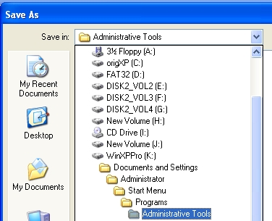
C:\Documents and Settings\Administrator\Start Menu\Programs\Administrative Tools. (Your system drive will probably be C:, not K: as shown in the figure, and your account name will appear instead of Administrator.)
- Usually, saving consoles in your personal start menu is the correct thing to do – that way the consoles appear on your start menu and no one else’s. But it did not work correctly on VMWare when I tried it, and I don’t know why. So instead, we will save the console in the All Users profile, so that every user can see it by clicking the Start button.

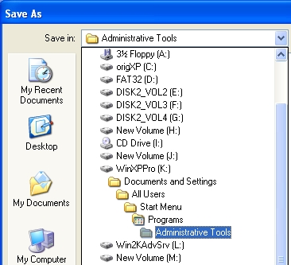
- Click the drop-down arrow at the right of the Save in: box, and in the drop-down folder list, click Documents and Settings.
- Double-click All Users, double-click Start Menu, double-click Programs, and double-click Administrative Tools. The correct folder selection is shown to the right on this page.
- In the Save As dialog box, in the File name: box, enter a file name of YourNameConsole. Replace YourName with your own name. Click the Save button.
- Close the YourNameConsole1 window.

Making Sure Administrative Tools is Available on the Start Menu
- Click Start, and look for the Administrative Tools item. If Administrative Tools is not shown in your start menu, do the lettered steps below to display it:
  - Right-click the start button and select Properties.
  - In the Taskbar and Start Menu Properties window, on the Start Menu tab, select the Start Menu radio button and click the upper Customize button.
  - In the Customize Start Menu window, on the Advanced tab, scroll down to the System Administrative Tools section. Click the Display on the All Programs Menu and the Start Menu radio button.
  - Click OK to close the Customize Start Menu window.
  - Click OK to close the Taskbar and Start Menu Properties window.
Saving a Screen Image of the Administrative Tools Menu
- Click Start, Administrative Tools. You should see a YourNameConsole.msc item, as shown in the figure below on this page. Press PrintScrn (without the Alt key) to copy the whole desktop to the clipboard.
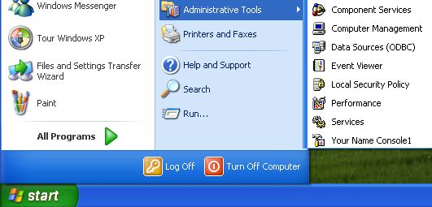

- On the Start menu, click Run. Enter the command mspaint and press the Enter key. Paint opens.
- Press Ctrl+V on the keyboard to paste the image into the Paint window. Save the document in the Shared Documents folder with the filename Your Name Proj 16b. Select a Save as type of JPEG. Close Paint.

Turning in your Project
- Email the JPEG images to me as attachments to one e-mail message. Answer the questions in the box in the body of the e-mail message. Send the message to: cnit.235@gmail.com with a subject line of CNIT 235 Proj 16 From Your Name, replacing Your Name with your own first and last name. Send a Cc to yourself.

Last modified 6-25-06

