This project can be done on any Windows XP machine for which you have administrative rights.
Log in With an Account that has Administrative Privileges
- In S214, use your virtual machine and your usual account.
Ensuring that File Extensions are not Hidden
- Click Start, My Computer. Click Tools, Folder Options. In the Folder Options box, click the View tab. Scroll down to find the Hide extensions for known file types box and make sure it is not checked. Click OK to close the Folder Options box. Resize My Computer and move it to the side of the desktop.
Creating a New File Type: .xyz
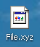
- Right-click the desktop and select New, Text Document. A new document appears with the name New Text Document.txt highlighted so you can change it. Type in the new name File.xyz and press Enter. A Rename box pops up warning you If you change a file name extension, the file may become unusable. Click Yes.
- Notice that the File.xyz icon is the generic icon, as shown to the right on this page. That's because Windows does not know what application should be used to open this file – the extension .xyz has no association with any installed program.
Associating the .xyz Extension With Notepad
- Right-click File.xyz and select Open.
- A Windows box opens saying Windows cannot open this file. Click Select the program from a list and click OK.
- In the Open With box, click Notepad. Verify that the Always use the selected program to open this kind of file box is checked and click the OK button.
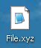
- The file opens in Notepad. Type in some text, press Ctrl+S to save the file, and close Notepad.
- Notice that the File.xyz icon now has a little Notepad on it, as shown to the right on this page. That's because the extension .xyz is now associated with Notepad.
- Double-click File.xyz. It opens in Notepad immediately. Close Notepad.
- Right-click File.xyz. Notice that Open is bold – that in dicates that Open is the default action for this file. Double-clicking a file executes the default action. Click in a blank area of the desktop to clear the context menu.
Changing the Default Action for .xyz Files
- In the My Computer window, click Tools, Folder Options.
- In the Folder Options box, click the File Types tab. Wait while the list populates – Windows is reading the entire list of file associations from the Registry.
- When the file extensions appear, scroll down to the XYZ extension and select it.
- In the Details for 'XYZ' extension section, click the Advanced button.
- In the Edit File Type box, click the edit action to select it (not the Edit… button) and click the Set Default button. edit turns bold.
- Click OK to close the Edit File Type box. Click Close to close the Folder Options box. Resize the Close the My Computer window.
- Right-click File.xyz and observe that the first item on the list is now Edit, and that it is bold.
- Double-click File.xyz. It opens in Notepad immediately, because the Edit action is set to open it in Notepad (the same thing the Open action does). Close Notepad.
Changing the Edit Action for .xyz Files
- In the My Computer window, click Tools, Folder Options.
- In the Folder Options box, click the File Types tab.
- When the file extensions appear, scroll down to the XYZ extension and select it.
- In the Details for 'XYZ' extension section, click the Advanced button. (You may see a Restore button instead of an Advanced button. If you do, click it to make the Advanced button appear.)
- In the Edit File Type box, click the edit action and click the Edit… button. An Editing action for type: box opens. The Application used to perform action: box shows the following command-line (your drive letter may be different.):
C:\WINDOWS\system32\NOTEPAD.EXE %1
Change the command line to
"C:\Program Files\Windows NT\Accessories\wordpad.exe" "%1"
If your drive letter is not C:, replace C: with your actual system drive letter. Don't forget the quotation marks.
- Click OK to close the Editing action for type: box.
- Click OK to close the Edit File Type box.
- Click Close to close the Folder Options box.
- Right-click File.xyz and select Edit. The file opens in WordPad. To verify that this is really WordPad, click the Format menu item and note that Bullet style is one of the options. Close WordPad.
- Right-click File.xyz and select Open. The file opens in Notepad. To verify that this is really Notepad click the Format menu item and note that the Bullet style is not available. Close Notepad.
Adding a New Action for .xyz Files
- In the My Computer window, click Tools, Folder Options.
- In the Folder Options box, click the File Types tab.
- When the file extensions appear, scroll down to the XYZ extension and select it.
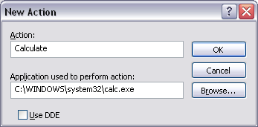
- In the Details for 'XYZ' extension section, click the Advanced button.
- In the Edit File Type box, click the New button.
- In the New Action box, enter an Action of Calculate and an Application used to perform action: of
C:\WINDOWS\system32\calc.exe
As shown in the figure to the right on this page. If your drive letter is not C:, replace C: with your actual system drive letter.
- Click OK to close the New Action box.
- Click OK to close the Edit File Type box.
- Click Close to close the Folder Options box.
- Right-click File.xyz and observe that there is now a Calculate option. Click Calculate option. Calculator opens. Close Calculator.
Saving a Screen Image of the Edit File Type Box
- In the My Computer window, click Tools, Folder Options.
- In the Folder Options box, click the File Types tab.
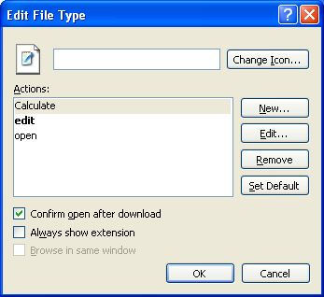
- When the file extensions appear, scroll down to the XYZ extension and select it.
- In the Details for 'XYZ' extension section, click the Advanced button.
- An Edit File Type box opens with three Actions: Edit, Calculate, and open, as shown to the right on this page. Press Alt+PrntScn to copy this window to the Clipboard.
- On the Start menu, click Run. Enter the command mspaint and press the Enter key. Paint opens.
- Press Ctrl+V on the keyboard to paste the image into the Paint window. Save the document in the Shared Documents folder with the filename Your Name Proj 17a. Select a Save as type of JPEG. Close Paint
Turning in your Project
- Email the JPEG image to me as an attachment to an e-mail message. Send the message to: cnit.235@gmail.com with a subject line of CNIT 235 Proj 17 From Your Name, replacing Your Name with your own first and last name. Send a Cc to yourself.

Revised 6-25-06

