cThis project can be done on any Windows XP Pro machine, but if WinZip is installed you should uninstall it before doing this project..
Downloading BigFile.txt
- Open Internet Explorer and go to my Web page samsclass.info. Click the CNIT 235: Windows Desktop Support Technician link. Click the Projects link.
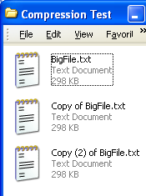
- Under the Proj 18 line, right-click Download BigFile.txt and select Save Target As…. Save the file on your desktop. Close Internet Explorer.
- Right-click the desktop and select New, Folder. Name the new folder Compression Test. Double-click the Comp Compression Test folder to open it, and resize it so you can see the BigFile.txt file on your desktop.
- Drag the BigFile.txt file into the Compression Test folder.
- The BigTile.txt file should be highlighted. If it is not, click it once to highlight it.
- Press Ctrl+C on the keyboard to copy the file, and Ctrl+V to paste it. Press Ctrl+V to paste it again. You should now see three files in the Compression Test folder as shown to the right on this page.
- Right-click the BigFile.txt icon and select Properties from the context menu. There are two values shown: Size: is the actual number of bytes of data in the file, and Size on disk: is the amount of disk space required to store the file. The size on disk is usually larger than the Size because of cluster overhang – wasted space on the disk. Write down both sizes in the box to the right on this page.

BigFile.txt

Size: ______________________________

Size on disk: ______________________________
- Close the BigFile.txt Properties box.
Using NTFS Compression
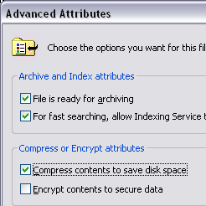
- Right-click the Copy of BigFile.txt icon and select Rename. Rename the file Compressed BigFile.txt
- Right-click the Compressed BigFile.txt file and select Properties.
- In the Compressed BigFile.txt Properties box, on the General tab, click the Advanced button.
- In the Advanced Attributes box, click the Compress contents to save disk space box, as shown to the right on this page. Click OK.
- Click OK to close the Compressed BigFile.txt Properties box.
- Notice that the filename has turned blue. That’s how Windows XP indicates that a file is compressed with NTFS compression.

- Right-click the Compressed BigFile.txt icon and select Properties. Record the Size: and the Size on disk: values in the box to the right on this page.

Compressed BigFile.txt

Size: ______________________________

Size on disk: ______________________________
- Click OK to close the Compressed BigFile.txt Properties window.
- Double-click the BigFile.txt icon. The file opens in Notepad. Close Notepad.
- Double-click the Compressed BigFile.txt icon. The file opens. Your machine has to uncompress it to make it readable by Notepad, but the time that takes is not noticeable. Close Notepad.
Using Zip Compression
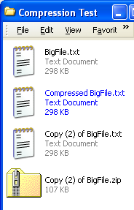
- In the Compression Test window, right-click the Copy (2) of BigFile.txt file and select Send to, Compressed (zipped) Folder. A zipped folder appears, as shown to the left on this page.
- Right-click the Copy (2) of BigFile.zip folder and select Properties. Record the Size: and the Size on disk: values in the box to the right on this page.

Zipped Folder

Size: ______________________________

Size on disk: ______________________________

- Close the Copy (2) of BigFile.zip Properties box.
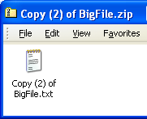
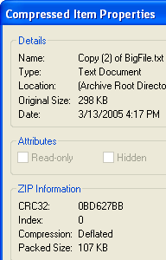
- Double-click the Copy (2) of BigFile.zip folder. The file does not open in Notepad– it opens like a folder. Inside the folder is Copy (2) of BigFile.txt file, as shown to the right on this page. Note the tiny folder icon with a zipper in the upper-left corner of the window – this is your only indication that you are looking inside a zipped file, not in a normal folder.
- In the Copy (2) of BigFile.zip window, right-click the Copy (2) of BigFile.txt icon and select Properties. A Compressed Item Properties window opens, as shown to the left on this page. Find the Original Size and the Packed size and write them in the box below.
- Click OK to close the Compressed Item Properties window.

Compressed Item

Original Size: ______________________________

Packed size: ______________________________

- There are two ways to open the zipped file. One way is to drag it out of the folder, and the other way is to open it in place.
- Point to the Copy (2) of BigFile.txt file in the Copy (2) of BigFile.zip window. Drag the file to the desktop and drop it there.
- Double-click the Copy (2) of BigFile.txt icon on the desktop. It opens in Notepad, because this file is no longer compressed. Close Notepad.
- Right-click the Copy (2) of BigFile.txt icon on the desktop, and select Properties. It has the same size as the original BigFile.txt – the numbers you wrote in the first box on the first page of this project. That’s because this is not a compressed file.
- Close Copy (2) of BigFile.txt Properties.
- In the Copy (2) of BigFile.zip window, double-click the Copy (2) of BigFile.txt. It opens in Notepad. How is this possible? Notepad cannot open a zipped file correctly. Instead, there is a temporary unzipped file in a hidden folder in your profile. To see the hidden file, leave Notepad open.
- Right-click the Start button and select Explore. Windows Explorer opens to the Start Menu folder in your profile. About six items above the highlighted Start Menu item, there is a folder called Local Settings. Click the + sign to the left of that folder to expand it.
- Inside the Local Settings folder there is a Temp folder. Click it to reveal the files inside.
- You should see a faded, hidden folder named Temporary Directory 1 for Copy (2) of BigFile.zip. If you do not see it, click Tools, Folder Options and on the View tab, check Show hidden files and folders.
- Open the Temporary Directory 1 for Copy (2) of BigFile.zip folder. You should see the Copy (2) of BigFile.txt file inside it, as shown below on this page.
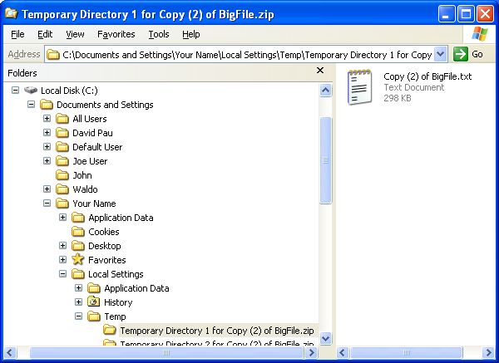
- Press Alt+PrtScn to copy this window to the clipboard.
- On the Start menu, click Run. Enter the command mspaint and press the Enter key. Paint opens.

- Press Ctrl+V on the keyboard to paste the image into the Paint window. Save the document in the Shared Documents folder with the filename Your Name Proj 18a. Select a Save as type of JPEG. Close Paint.

- Opening zipped files in this manner can cause problems – if the application used to open them crashes, it can leave them behind, wasting disk space. Those files may also represent a security hazard, leaving hidden copies of documents behind when you imagine that the documents have been erased.
- Close Windows Explorer. Close Notepad.
Password-Protected Zip Compression
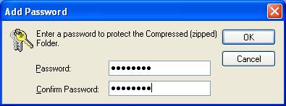
- In the Copy (2) of BigFile.zip folder, click the Copy (2) of BigFile.txt icon to select it. From the menu bar, select File, Add a Password.
- In the Add Password box, enter Password in both boxes, as shown in the figure to the right on this page. Click OK.
- Close the Copy (2) of BigFile.zip window.
- Double-click the Compression Test folder to open it.
- Double-click the Copy (2) of BigFile.zip compressed folder to open it. Note that you can open it and see then name of the compressed file without using the password – this is a potential security hazard. Be careful not to give confidential documents file names that reveal secrets, because the file names are not protected.
- Double-click the Copy (2) of BigFile.txt icon. It does not open in Notepad, but it asks for a Password first. In the Password needed box, enter an incorrect password like 123 and click the OK button.
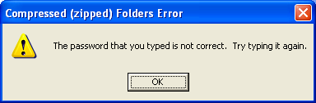
- A Compressed (zipped) Folders Error window opens as shown to the right on this page, showing that you entered an incorrect Password. Press Alt+PrtScn to copy this window to the clipboard.
- On the Start menu, click Run. Enter the command mspaint and press the Enter key. Paint opens.
- Press Ctrl+V on the keyboard to paste the image into the Paint window. Save the document in the Shared Documents folder with the filename Your Name Proj 18b. Select a Save as type of JPEG. Close Paint.
- Click OK to close the Compressed (zipped) Folders Error window. Then give it the correct Password. Observe that the file opens correctly.
- Close all windows.
Turning in your Project
- Email the JPEG images to me as attachments to one e-mail message. Answer the questions in the boxes in the body of the e-mail message. Send the message to: cnit.235@gmail.com with a subject line of CNIT 235 Proj 18 From Your Name, replacing Your Name with your own first and last name. Send a Cc to yourself.
Last modified 6-15-06

