Changing Network Adapters Settings
- Start VMware Workstation
- Select your virtual machine, but do not start it.
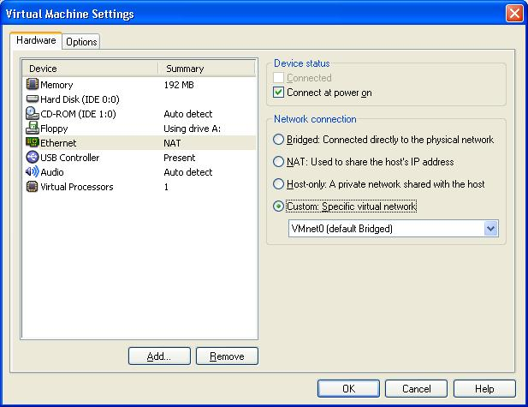
- Click the blue Edit Virtual Machine Settings link on the left side.
- Select Ethernet in the left pane and in the right pane click the Custom radio button, and select VMnet0 from the drop-down list, as shown below on this page. Click OK.
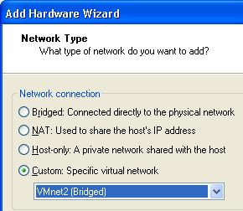
- Click the blue Edit Virtual Machine Settings link on the left side.
- In the Virtual Machine Settings box, click the Add button.
- The Hardware Wizard starts. Click Next.
- On the next screen select Ethernet Adapter and click Next.
- On the Network Type screen select Custom and select VMnet2 from the drop-down list as shown to the right on this page. Click Finish.
- In the Virtual Machine Settings window, click OK. This machine now has two virtual Ethernet adapters which map to its two physical NICs.
Last modified 10-26-06

