This project requires at least two Windows XP (Professional or Home Edition) computers, a hub and some network cables. Unless you have that equipment, you will have to do it in S214.

Choosing Machines for your LAN
- Select three or four adjacent machines in the room. They have to be near one another so that we won’t need long cables to connect them together. Up to four students may work together on this project. You only need send one e-mail message for whole group, with all the group member's names in the subject line. Pick one of your machines to be your Server.

Testing the Machines
- Start all the virtual machines, including the Server, and log in with your usual accounts, so that you have Administrative privileges. On each machine, open Internet Explorer and verify that they can connect to the Internet. If any of them cannot, call the instructor over to fix the problem before proceeding any further.

Turning on Simple File Sharing
- Do this on each virtual machine:
  - Click Start, My Computer.
  - Click Tools, Folder Options
  - On the View tab, scroll to the bottom of the list and make sure Use simple file sharing (Recommended) is checked.
  - Click OK to close Folder Options.

Wiring the LAN (Local Area Network)
- Put a hub on the table in the middle of your machines. Plug the power into the hub and make sure its front panel lights light up.
- Look at the back panel of one of your machines. There are two Network Interface Cards, but we are only using the built-in Intel one. Make sure you remember which port we are using.
- Remove the Ethernet cable from the back of your machine and plug in one of the additional cables your instructor has provided. Replace the cable on each machine with one that goes to a numbered port on the hub. It does not matter which port on the hub you use – they are all the same, except the Uplink port. If there is an Uplink port, don’t use it – just leave it empty. Your final network should look like the diagram to the right on this page. Each box marked W is a computer (Workstation).
Hub
4 3 2 1
W
W
W
W

Using the Network Setup Wizard to Make a Workgroup
- On each one of your machines, click Start, My Computer, My Network Places to open the My Network Places window.
- In the left pane of the My Network Places window, in the Network Tasks section, click the Set up a home or small office network link.
- At the Welcome to the Network Setup Wizard screen, click Next.
- At the Before you continue… screen, click Next.
- At the Select a connection method screen, select Other and click Next.
- At the Other Internet connection methods screen, select This computer belongs to a network that does not have an Internet connection and click Next.
- At the Give this computer a description and a name screen, leave the description unchanged and verify that the Computer name is the same as the label on the front of your system unit with a V at the end (for example, S214-01V), and click Next.
- At the Name your network screen, enter a name of WORKGROUP and click Next.
- If a File and printer sharing screen appears, select Turn on file and printer sharing and click Next.
- At the Ready to apply network settings screen, read the settings, and if they look correct, click Next.
- At the Please wait screen, wait for the animation to end. It might take a minute or longer.
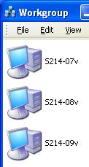
- At the You’re almost done screen, click Just finish the wizard. I don’t need to run the wizard on other computers and click Next.
- At the Completing the Network Setup Wizard screen, click Finish.
- If you are prompted to, restart your machine.

Viewing Your Workgroup in My Network Places
- On each of your virtual machines, click Start, My Computer, My Network Places to open the My Network Places window.
- In the left pane, in the Network Tasks section, click View workgroup computers. All the computers in your workgroup should appear, as shown to the right on this page. If they don’t, try pressing the F5 key to refresh the Workgroup window, and then try restarting all the virtual machines.
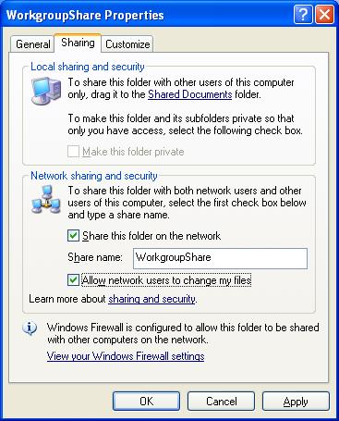
- On the Server, make sure all the computers in your workgroup appear in the Workgroup window. Press Alt+PrtScn to copy the Workgroup window to the clipboard.
- On the Start menu, click Run. Enter the command mspaint and press the Enter key. Paint opens.
- Press Ctrl+V on the keyboard to paste the image into the Paint window. Save the document in the Shared Documents folder with the filename Your Name Proj 20a. Select a Save as type of JPEG. Close Paint.

Creating a Shared Folder on the Server
- On the Server, click Start, My Computer and open drive C:. Right-click an empty portion of the window and select New, Folder. Name the folder WorkgroupShare. Right-click the WorkgroupShare folder and select Sharing and Security.
- In the Workgroupshare Properties box, on the Sharing tab, select Share this folder on the network, as shown to the right on this page. Check the Allow network users to change my files box. Click OK.
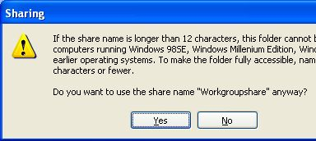
- A Sharing box opens as shown to the right on this page. Click Yes.
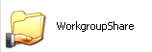
- A hand should now appear under the folder icon indicating that it is shared, as shown to the right on this page.
- Go to another machine in your workgroup. Click Start, My Computer, My Network Places to open the My Network Places window.
- In the left pane, in the Network Tasks section, click View workgroup computers. All the computers in your workgroup should appear. Find the Server computer and double-click it.
- When a window opens named \\computername, where computername is the name of the Server, you should see the WorkgroupShare folder. Double-click the WorkgroupShare folder to open it. That shows that the network is working: you can share files with other members of the workgroup. Close all windows on both machines.
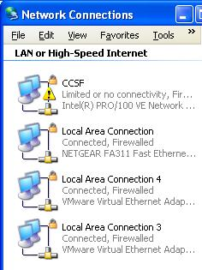
Internet Connection Sharing: Connecting the Host System to the Internet
- You will now convert your Server into Internet Gateway. On the Server, open Internet Explorer and try to open a Web page – you can’t do it, because the machine is not connected to the Internet now.
- Take the blue network cable that leads to the CCSF network (and therefore to the Internet) and plug it into the second network adapter card in the back of your Server computer.
- On the host operating system of your Server computer (NOT the virtual machine), click Start, right-click My Network Places, and click Properties. You should see several network connections as shown to the right on this page – look at the third line of the information, which shows the manufacturer of the NIC in gray letters. There should be one Intel ® connection, one NETGEAR connection, and two VMware Virtual Ethernet connections. If you do not see three lines of information about each connection, click View, Tiles from the Network Connections menu bar.
- The Intel ® connection is built into the motherboard. The NETGEAR connection is on an expansion card, and the port used to plug a cable into it is below the Intel ® port on the back panel of the computer. Right now the Intel ® port is connected to your hub, so it shows the yellow ! warning symbol and the message Limited or no connectivity. The NETGEAR connection should show the message Connected, Firewalled as shown in the figure.
- Open Internet Explorer on the host operating system on your Server machine and verify that you can open a Web page -- the host system can now reach the Internet.

Using the Network Setup Wizard to Create an Internet Gateway
- On your Server virtual machine, click Start, My Computer, My Network Places to open the My Network Places window.
- In the left pane of the My Network Places window, in the Network Tasks section, click the Set up a home or small office network link.
- At the Welcome to the Network Setup Wizard screen, click Next.
- At the Before you continue… screen, click Next.
- At the Select a connection method screen, select This computer connects directly to the Internet. The other computers on my network connect to the Internet through this computer and click Next.
- At the Select your Internet connection screen, accept the default selection and click Next.
- At the Give this computer a description and a name screen, leave the description unchanged and verify that the Computer name is the same as the label on the front of your system unit with a V at the end (for example, S214-01V), and click Next.
- At the Name your network screen, enter a name of WORKGROUP and click Next.
- If a File and printer sharing screen appears, select Turn on file and printer sharing and click Next.
- At the Ready to apply network settings screen, read the settings, and if they look correct, click Next.
- At the Please wait screen, wait for the animation to end. It might take a minute or longer.
- At the You’re almost done screen, click Just finish the wizard. I don’t need to run the wizard on other computers and click Next.
- At the Completing the Network Setup Wizard screen, click Finish.

Testing the Internet Gateway’s Internet Connection
- Open Internet Explorer on the Server virtual machine and try to open a Web page. You should succeed, demonstrating that this machine is now connected to the Internet.

Using the Network Setup Wizard to Connect the Your Other Workgroup Members to the Internet
- Do this Network Wizard process on each virtual machine in your workgroup, except the Server virtual machine. Click Start, My Computer, My Network Places to open the My Network Places window.
- In the left pane of the My Network Places window, in the Network Tasks section, click the Set up a home or small office network link.
- At the Welcome to the Network Setup Wizard screen, click Next.
- At the Before you continue… screen, click Next.
- There are two possibilities for the next screen:
  - If you see a Select a connection method screen, select This computer connects to the Internet through a residential gateway or through another computer on my network and click Next.
  - If you see a Do you want to use the shared connection? screen, select Yes, use the existing shared connection… and click Next.
- At the Give this computer a description and a name screen, leave the description unchanged and verify that the Computer name is the same as the label on the front of your system unit with a V at the end (for example, S214-01V), and click Next.
- At the Name your network screen, enter a name of WORKGROUP and click Next.
- If a File and printer sharing screen appears, select Turn on file and printer sharing and click Next.
- At the Ready to apply network settings screen, read the settings, and if they look correct, click Next.
- At the Please wait screen, wait for the animation to end. It might take a minute or longer.
- At the You’re almost done screen, click Just finish the wizard. I don’t need to run the wizard on other computers and click Next.
- At the Completing the Network Setup Wizard screen, click Finish.

Testing the Workgroup Member’s Internet Connection
- On each machine in your workgroup except the Internet Gateway computer, open Internet Explorer and verify that they are connected to the Internet.

Shutting Down the Internet Gateway Machine
- Shut down the Server virtual machine. Then try to refresh the Web page on the other machines in the workgroup. All of them are unable to contact the Internet, of course, because their only path to the Internet goes through the Internet Gateway machine.

Restarting the Internet Gateway Machine
- Start the Server virtual machine. Then try to refresh the Web page on the other machines in the workgroup. They are again connected to the Internet.

Stopping the Internet Connection Sharing Service
- On the Server virtual machine, click Start, Administrative Tools, Services. (If Administrative Tools is not on the Start menu, you can find it in Control Panel.) In the right pane, select Windows Firewall/Internet Connection Sharing as shown in the figure below on this page. Press Alt+PrtScn to copy this window to the clipboard.
- On the Start menu, click Run. Enter the command mspaint and press the Enter key. Paint opens.
- Press Ctrl+V on the keyboard to paste the image into the Paint window. Save the document in the Shared Documents folder with the filename Your Name Proj 20b. Select a Save as type of JPEG. Close Paint.
- Near the center of the window, there is a blue Stop the service link. Click the word Stop.
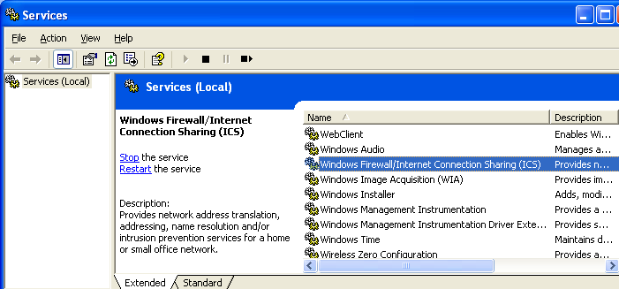

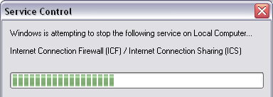
- A Service Control window opens as shown to the right on this page. After it finishes, the service is stopped.
- On the Server virtual machine, open Internet Explorer and try to open a Web page. You should succeed – this machine is still connected to the Internet.
- Go to a machine in your workgroup, open Internet Explorer and try to open a Web page. Your workgroup machines cannot connect to the Internet without the aid of the Windows Firewall/Internet Connection Sharing service on the Internet Gateway machine.

Restarting the Internet Connection Sharing Service
- On the Server virtual machine, in the Services window, verify that Internet Connection Firewall/Internet Connection Sharing is still selected. Click the blue Start link near the middle of the window.
- Go to a machine in your workgroup, open Internet Explorer and try to open a Web page. It should succeed now. Close all windows on both machines.

Renaming Network Connections on the Internet Gateway
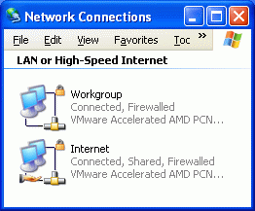
- On the Server virtual machine, click Start, My Computer, My Network Places. In the left pane, in the Network Tasks section, click View network connections. You should see two connections, named Local Area Connection and Local Area Connection 2. Those are not very useful names.
- The connection marked Connected, Shared, Firewalled is the connection to the CCSF network and also to the Internet. Right-click that connection, select Rename, and rename it Internet.
- Right-click the other connection, select Rename, and rename it Workgroup. Now your Network Connections window should look like the example shown to the right on this page.
- Notice the extra symbols on the Internet connection. The hand below it indicates that it is shared, and the padlock indicates that it is protected by the Internet Connection Firewall.

Examining IP Addresses
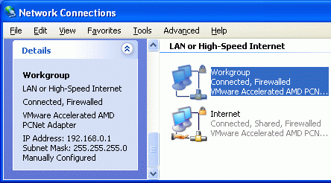
- On your Server virtual machine, in the Network Connections window, click the Workgroup connection to select it. Scroll down in the left pane to see the Details section, as shown in the figure to the right on this page. Note the IP address: it should be 192.168.0.1. Internet connection sharing always assigns this value to the Internet Gateway machine. This is a Private IP Address – the 192.168 series is not used on the public Internet.
- Press Alt+PrtScn to copy this window to the clipboard.

- On the Start menu, click Run. Enter the command mspaint and press the Enter key. Paint opens.
- Press Ctrl+V on the keyboard to paste the image into the Paint window. Save the document in the Shared Documents folder with the filename Your Name Proj 20c. Select a Save as type of JPEG. Close Paint.
- In the Network Connections window, click the Internet connection to select it. Scroll down in the left pane to see the Details section. Note the IP address: is it public or private? Does this machine really connect directly to the Internet, or does it pass through another stage of Network Address Translation before it reaches the Internet? If you are not sure of the answers, call your instructor over to talk about it.
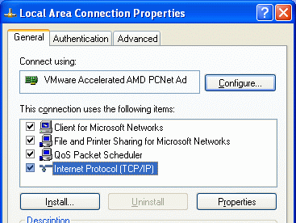
- Go to the other machines in your workgroup, open the Network Connections window, and find out what their IP addresses are. All the IP addresses in your workgroup should all start with 192.168.0.

Assigning Manual IP Addresses
- The purpose of this exercise is to show you how to manually assign IP addresses, and demonstrate an IP address conflict. In modern LANs, most people use automatic addressing to avoid these problems.
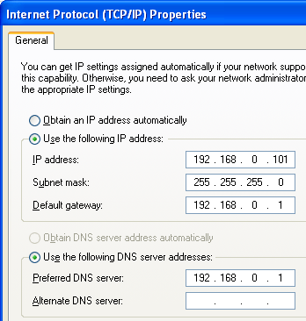
- Go to one of the machines on your workgroup (not the Server virtual machine). Click Start, My Computer, My Network Places. In the left pane, in the Network Tasks section, click View network connections. Right-click the Local Area Connection and select Properties. You should see a Properties sheet like the one shown to the right on this page. Click Internet Protocol (TCP/IP) to highlight it, and click the Properties button.
- In the Internet Protocol (TCP/IP) Properties window, click the Use the following IP address button. Enter an IP address of 192.168.0.101 as shown to the right on this page. You will find it clumsy to enter the address, because the Tab key does not move between the fields in the normal way. The insertion point moves to the next pane automatically if you enter a three-digit number in a pane, but if you enter a shorter number, use the . key to go to the next pane. After entering the last number in the IP address, press the Tab key once and the Subnet mask will automatically fill in for you.
- Enter 192.168.0.1 into the Default gateway and the Preferred DNS Server fields as shown to the right on this page and click OK.
- In the Local Area Connection 2 Properties window, click the Close button. Note this step – a large number of students close this window with the red X instead, and if you do that your changes are cancelled.
- Repeat the Assigning Manual IP Addresses process on the previous page for each virtual machine in your workgroup (but not the Server virtual machine), assigning each one a different IP address, so you end up with a network like the one shown below. You do not need to assign an IP address to the Server virtual machine, because the Network Setup Wizard has already assigned the IP address 192.168.0.1 to it.
Hub
To the Internet

192.168.0.101
192.168.0.102
192.168.0.103

Gateway
192.168.0.1

- Open Internet Explorer on each of the machines and verify that they are all connecting to the Internet properly.

Creating an IP Address Conflict
- Go to the machine with the IP address 192.168.0.101 and shut it down.
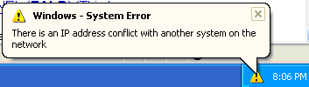
- Then go to the machine with the IP address 192.168.0.102 and repeat change its IP address to 192.168.0.101. Open Internet Explorer and verify that its connection is working.
- Restart the virtual machine originally assigned the IP address 192.168.0.101. When it starts, a System Error message will appear on the other station using that number, as shown to the right on this page. Press PrtScn to copy this window to the clipboard.
- On the Start menu, click Run. Enter the command mspaint and press the Enter key. Paint opens.
- Press Ctrl+V on the keyboard to paste the image into the Paint window. Save the document in the Shared Documents folder with the filename Your Name Proj 20d. Select a Save as type of JPEG. Close Paint.

- The virtual machine that just restarted may show a similar message – if it does, click OK to close the message and log in using an account with local administrative rights. Open Internet Explorer and try to open a Web page. You can’t – this machine is not connected to the workgroup at all. This is one of the main problems of manually assigned IP addresses: anyone in the workgroup who changes an IP address can create a conflict with a random other machine, which may be in a different room, creating confusing error messages and intermittent problems. It is far better to leave all the machines set for automatic IP address assignment and let the server assign the addresses so that there are never such conflicts.
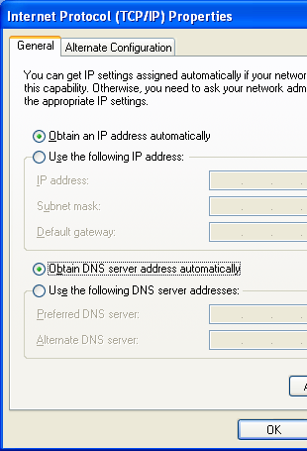
- On the virtual machine that just restarted, click Start, My Computer, My Network Places, and click View Network Connections. Select Local Area Connection and look at the IP Address in the lower portion of the left pane. The address is 0.0.0.0 – that indicates that this adapter is not able to use TCP/IP at all.

Using Automatic IP Addressing
- Right-click Local Area Connection and select Properties. In the Local Area Connection Properties window, highlight TCP/IP (Internet Protocol) and click the Properties button.
- In the Internet Protocol (TCP/IP) Properties window, click the Obtain an IP address automatically and Obtain DNS server address automatically items, as shown to the right on this page. Click OK. In the Local Area Connection Properties window, click Close.
- Repeat the previous 2 steps on each virtual machine in your workgroup, except the Server virtual machine. This will return your workgroup to automatic addressing which prevents IP address conflicts.
- Open a browser on each machine make sure all of them can connect to the Internet.

Returning the Cables to Their Normal Configuration
- Return the network cables to their original positions.
- Return the hub and patch cables to your instructor.

Returning the Server Virtual Machine to Normal Networking
- On the Server virtual machine, click Start, My Computer, My Network Places to open the My Network Places window.
- In the left pane of the My Network Places window, in the Network Tasks section, click the Set up a home or small office network link.
- At the Welcome to the Network Setup Wizard screen, click Next.
- At the Before you continue… screen, click Next.
- At the Select a connection method screen, select This computer connects to the Internet through a residential gateway or through another computer on my network and click Next.
- At the Give this computer a description and a name screen, click Next.
- At the Name your network screen, enter a name of S214 and click Next.
- If a File and printer sharing screen appears, select Turn on file and printer sharing and click Next.
- At the Ready to apply network settings screen, read the settings, and if they look correct, click Next.
- At the Please wait screen, wait for the animation to end. It might take a minute or longer.
- At the You’re almost done screen, click Just finish the wizard. I don’t need to run the wizard on other computers and click Next.
- At the Completing the Network Setup Wizard screen, click Finish.
- If you are prompted to, restart your machine.

Returning the Other Virtual Machines to Normal Networking
- After you have completed the Network Setup Wizard on the Server virtual machine, restart each of the other machines in your workgroup to break their connection to the shared Internet connection that is no longer present. Then use the Network Setup Wizard on each of them the same way you did on the Server virtual machine to return them to normal networking.

Testing the Machines
- On each virtual machine, open Internet Explorer and verify that they can connect to the Internet. If any of them cannot, call the instructor over to fix the problem before leaving.

Turning in your Project
- Gather all the Proj20 images onto one machine, using a shared folder.
- Email the JPEG images to me as attachments to one e-mail message. Send the message to: cnit.235@gmail.com with a subject line of CNIT 235 Proj 20 From All Group Member Names, replacing All Group Member Names with the full names of every group member. Send a Cc to yourself.

Last modified 6-25-06

