This project can be done on any Windows XP Pro machine on a network with another Windows XP machine.
Configuring the Remote Machine to Allow a Remote Desktop Connection
- Log in to your virtal machine with your usual account (or any account with administrative privileges). Your account must have a password – if it does not, this project will not work. This machine will be the Remote Machine – it will be controlled by another machine.
- Click Start, right-click My Computer, and select Properties.
- Click the Remote tab. Under Remote Desktop, check Allow users to connect remotely to this computer. Click the Select Remote Users button. In the System Properties box, click OK.
- Log off.
Connecting From a Client Machine
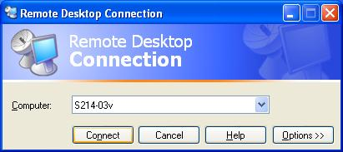
- Go to any other machine in the room – this will be the Client Machine. It can be logged in with any account. Click Start, All Programs, Accessories, Communications, Remote Desktop Connection.
- In the Remote Desktop Connection window, enter your Remote Machine’s name, as shown in the figure to the right on this page. Click Connect. Log in with your usual account.
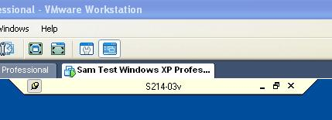
- On the Client Machine, you will see a little bar on the top of the desktop like the example shown to the right on this page, with your remote machine's name instead of sequoia. This bar indicates that the desktop you are seeing is on the remote machine, not the client computer. Click the Restore Down button on the bar (the center button on the top right, with two squares).
- Notice that the remote desktop has no background image. That’s done to reduce the amount of data that has to be transferred over the network.

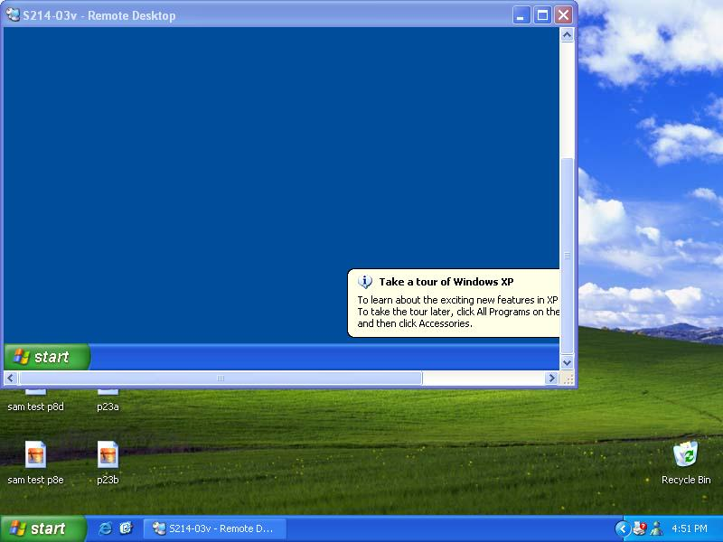
- Resize the Remote Desktop window so it uses up about 3/5 of the virtual desktop. Scroll down in the remote desktop window so that you can see both the client virtual machine's start button (at the bottom of the screen) and the remote virtual machine's start button (in the window), as shown to the right on this page. Press PrntScn to copy this entire screen to the Clipboard.
- Click the lower Start button – the one on the virtual desktop, not the one in the Remote Desktop window. Click Run. Enter the command mspaint and press the Enter key. Paint opens.
- Press Ctrl+V on the keyboard to paste the image into the Paint window. Save the document in the Shared Documents folder with the filename Your Name Proj 24a. Select a Save as type of JPEG. Close Paint.
- In the Remote Desktop window, click Start, Log Off, Log Off. The Remote Desktop window closes.
Forcing a Logoff Remotely From the Client Machine
- On your original machine (the Remote Machine), log in with the Waldo account.
- On your Client Machine, click Start, All Programs, Accessories, Communications, Remote Desktop Connection.
- In the Remote Desktop Connection window, enter your machine’s name, if it's not already there. Click Connect. Log in as with your usual account.
- You will see the Logon Message box shown below. Press Alt+PrntScn to copy this window to the Clipboard.
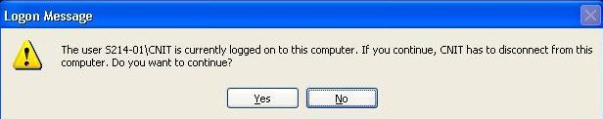

- On the Start menu, click Run. Enter the command mspaint and press the Enter key. Paint opens.
- Press Ctrl+V on the keyboard to paste the image into the Paint window. Save the document in the Shared Documents folder with the filename Your Name Proj 24b. Select a Save as type of JPEG. Close Paint.
- If the Logon Message box has closed, repeat step 14 to open it again.
- In see the Logon Message box, click Yes. Look at your Remote Machine – there is a Request For Connection box warning the user that they will be logged off. After a few seconds, that machine logs off and the Remote Desktop window opens on the Client Machine.
Closing a Remote Session Without Logging Off
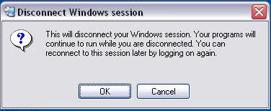
- On the Client Machine, in the Remote Desktop window, open Notepad. Type in some text, but do not save the file or close Notepad.
- Close the remote desktop window with the X. You get a message as shown to the right on this page. Click OK. The Remote Desktop window closes, but Notepad is still running in the background on the remote computer – your data has not been lost.
Attempting to Shut Down Remotely
- On the Client Machine, click Start, All Programs, Accessories, Communications, Remote Desktop Connection.
- In the Remote Desktop Connection window, enter your machine’s name, if it's not already there. Click Connect. Log in as with your usual account.
- Notice that your Notepad file is still open with the text you typed in visible.
- In the Remote Desktop window, click Start, and look for the Shut Down option – it’s not there. You can’t shut down remotely, all you can do is Log Off or Disconnect. Click Log Off. Confirm the Log Off and don’t save changes in the Notepad file. The Remote Desktop window closes.
Examining Remote Desktop Options
- On any machine, click Start, All Programs, Accessories, Communications, Remote Desktop Connection.
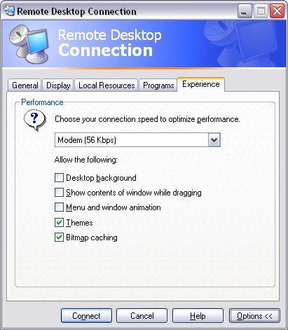
- In the Remote Desktop Connection window, click the Options button. Your window should resemble the example shown to the right on this page. Click through the tabs and observe the default settings. Find answers to these three questions:
- What is the default color depth of a Remote Desktop (shown under the heading Colors)?
- Will sounds from the remote computer be brought to the client computer by default?
- Click the Experience tab. Notice that by default it's set for Modem, and to save time it does not display the desktop background, as shown to the right on this page. Try the other connection speed settings: what connection speed(s) DO show the desktop background?
Turning in your Project
- Email the JPEG images to me as attachments to one e-mail message. Answer the questions in the body of the e-mail message. Send the message to: cnit.235@gmail.com with a subject line of CNIT 235 Proj 24 From Your Name, replacing Your Name with your own first and last name. Send a Cc to yourself.
Last modified 6-25-06

