This project can be done on any Windows XP Pro or Home Version machine.
Choosing an Account to Use
- I wrote these instructions assuming that you will use a Gmail account. I recommend that you create a new account for this project, so your personal mail does not end up on a lab machine where other students might read it. If you have some other email service that offers POP3 access, and you don’t mind using it, you can do that. Gmail is not an essential part of this project.
Creating a GMail Account
- You need an invitation to create a Gmail account. If you already have a Gmail account, you can invite yourself to create another one, but if you can’t do that, just send an email to CNIT.235@gmail .com asking me to invite you. To send that email, use any email account you like, such as the CCSF one, or Yahoo, or Hotmail, etc.
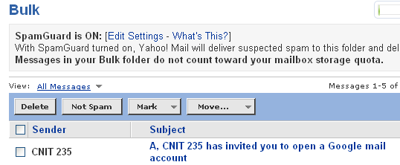
- Check your Email – you should have a message like the one shown to the right, with a subject line saying that someone has invited you to open a Google mail account. Caution: Yahoo throws those messages in the Bulk mail folder, so it’s easy to miss them.
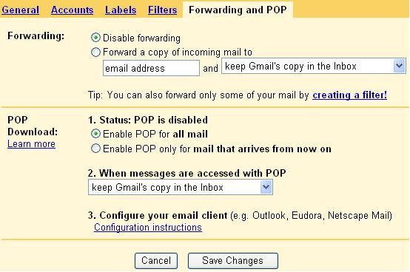
- Open that email, click on the link in it, and fill in the form to get a GMail account. When you see an Introduction to GMail screen saying Congratulations!, click the I'm ready - show me my account link.
Enable POP in your Gmail account
- Log in to your Gmail account.
- Click Settings at the top of any Gmail page.
- Click Forwarding and POP in the orange Mail Settings box.
- Select Enable POP for all mail, as shown to the right on this page.
- Click Save Changes.

Creating a Mail Account in Outlook Express
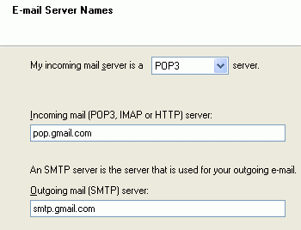
- Click Start, All Programs, Outlook Express.
- The Internet Connection Wizard may start automatically. If it does not, select Tools, Accounts from the menu bar, and then click Add, Mail to start it.
- In the Your Name box, enter your name.
- In the Internet E-mail Address box, enter your GMaill address, which will look like yourid@GMail.com
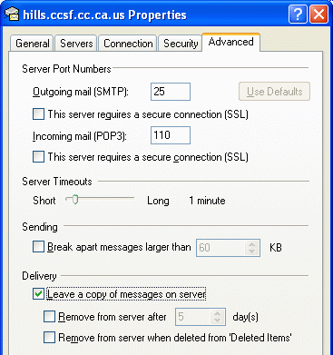
- In the Incoming mail (POP3, IMAP or HTTP) server box, enter pop.gmail.com. In the Outgoing mail (SMTP) server box, enter smtp.gmail.com. Your screen should look like the figure to the right on this page. Click the Next button.
- In the Internet Mail Logon box, enter your GMail user name and password. Leave the Remember password box checked. Note: Other students can potentially read email you access on these lab machines, so don’t read confidential email this way.
- In the Internet Mail Logon box, click Next. In the Congratulations box, click Finish.
Adjusting the Mail Account for GMail’s Servers
- Click Tools, Accounts. In the Internet Accounts box, on the Mail tab, verify that pop.gmail.com is highlighted and click the Properties button.
- In the pop.gmail.com Properties box, click the Advanced tab.
- Under Outgoing Mail (SMTP), check the box next to This server requires a secure connection (SSL).
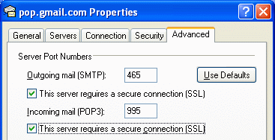
- In the Outgoing mail (SMTP): box, enter 465. This is the port number GMail uses to send mail.
- Under Incoming mail (POP3), check the box next to This server requires a secure connection (SSL). The port will change to 995 – the port number GMail uses for POP3 service. Your pop.gmail.com Properties box should look like the figure to the right on this page.

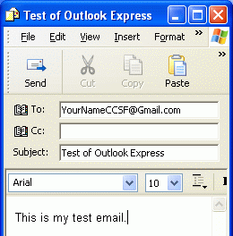
- In the pop.gmail.com Properties box, click the Servers tab. Check the box next to My server requires authentication. Click OK.
- In the Internet Accounts window, click Close.
Sending Yourself a Message
- In the Outlook Express window, click the Create Mail button. Compose an email to your GMail account, like the example shown to the right on this page, and click the Send button.
- In the Outlook Express window, click the Send/Rev button. Compose an email to your GMail account, like the example shown to the right on this page, and click the Send button.
- You should see a 1 appear next to the word Outbox in the left pane of the Outlook Express window. Wait a few seconds and it should send the mail, and the 1 should vanish.
- In the toolbar at the top of the Outlook Express window, click the Send/Recv button. You should see the test message you sent yourself appear in the Inbox, as shown to the right on this page.
Receiving E-mail With Outlook Express
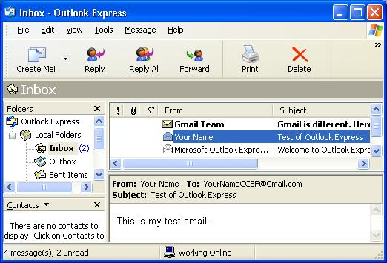
- In the Outlook Express window, if necessary, expand the Local Folders in the folder pane and select Inbox. Then click the Send/Recv button on the toolbar to get your mail.
- You should see the test message you sent yourself appear in the Inbox, as shown to the right on this page. If you do not, return to the GMail POP settings and adjust them again. Sometimes GMail is slow to change.

- Click an actual e-mail message in the Folders pane so that it shows in the Preview pane. You will not get full credit if you only have the "Welcome to Outlook Express" message in your Inbox, because that does not show that you properly configured Outlook Express to receive mail.
- Press Alt+PrtScn to copy the Inbox – Outlook Express window to the clipboard.
- On the Start menu, click Run. Enter the command mspaint and press the Enter key. Paint opens.
- Press Ctrl+V on the keyboard to paste the image into the Paint window. Save the document in the Shared Documents folder with the filename Your Name Proj 25a. Select a Save as type of JPEG. Close Paint.

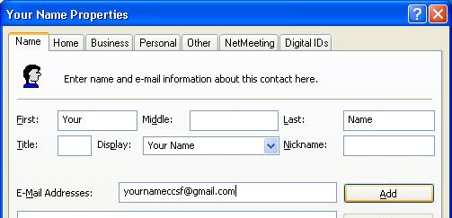
Using Address Book
- On the Outlook Express toolbar, click Addresses.
- In the Address Book – Main Identity window, click the New button on the upper left, and click New Contact from the drop-down list.
- In the Properties box, enter your own name and e-mail address, as shown to the right on this page. Click OK to save your address.
Viewing the Address Book Files
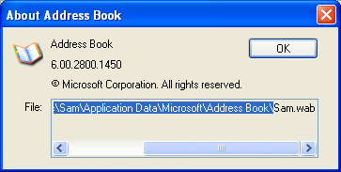
- In the Address Book – Main Identity window, click Help, About Address Book from the Menu bar. This shows the location of the file that contains the Address book. Highlight this path, not including the filename at the end, as shown to the right on this page.
- On the keyboard, press Ctrl+C to copy the highlighted path to the clipboard.
- Click Start, Run and press Ctrl+V on the keyboard to paste the address into the Run box. Press the Enter key.
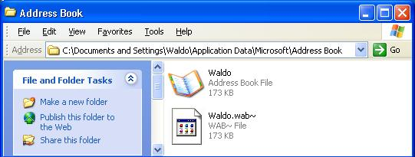
- A window should open showing a folder as shown below on this page. There should be two files with filenames starting with your logon name (which may not be Waldo) in this window. The .wab file is the Address Book, and the .wab~ file is the backup of your address book. If you do not see the .wab~ file, close Address Book and Outlook Express and restart them. Press Alt+PrtScn to copy this window to the clipboard.

- On the Start menu, click Run. Enter the command mspaint and press the Enter key. Paint opens.
- Press Ctrl+V on the keyboard to paste the image into the Paint window. Save the document in the Shared Documents folder with the filename Your Name Proj 25b. Select a Save as type of JPEG. Close Paint.
- Close Address Book.
Viewing the Message Store
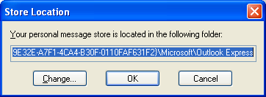
- On the Outlook Express toolbar, click Tools, Options. On the Maintenance tab, click the Store Folder button.
- In the Store Location box, highlight the whole folder name. You will have to scroll to the right in the box to get it all – notice that it has a long hexadecimal number in the middle of it, which is a good reason for moving it to some other folder you can find more easily.
- On the keyboard, press Ctrl+C to copy the highlighted path to the clipboard.
- Click Start, Run and press Ctrl+V on the keyboard to paste the address into the Run box. Press the Enter key.
- A window should open showing the message store files as shown below on this page. There should be several files, including Inbox.dbx and Outbox.dbx. Press Alt+PrtScn to copy this window to the clipboard.
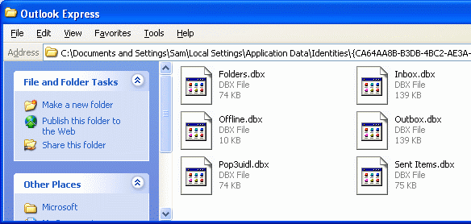

- On the Start menu, click Run. Enter the command mspaint and press the Enter key. Paint opens.
- Press Ctrl+V on the keyboard to paste the image into the Paint window. Save the document in the Shared Documents folder with the filename Your Name Proj 25c. Select a Save as type of JPEG. Close Paint.
Turning in your Project
- Email the JPEG images to me as attachments to one e-mail message. Send the message to: cnit.235@gmail.com with a subject line of CNIT 235 Proj 25 From Your Name, replacing Your Name with your own first and last name. Send a Cc to yourself.

Last modified 6-25-06

