This project can be done on any Windows XP Pro machine for which you have administrative rights.
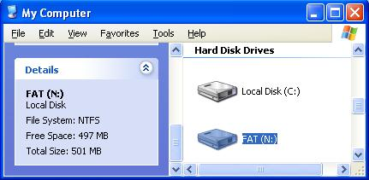
Work in Your Virtual Machine
- Log in to your Virtual machine with your usual account, which has administrative rights.
Making Sure You Have an Empty Volume to Practice Maintenance On
- Click Start, My Computer. You should see an N: volume with a size of approximately 500 MB, as shown to the right on this page. If you don’t have an N: drive, use Computer Management to create one.
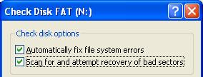
Check your N Drive for Errors
- In the My Computer window, right-click the N: drive and select Properties.
- In the FAT (N:) Properties window, click the Tools tab. Click the Check Now button.
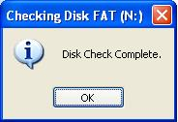
- In the Check Disk New Volume (N:) window, check both boxes, as shown to the right on this page, and click Start.
- Notice how fast this process is on such a small partition. On a real system drive, it could take half an hour or longer.
- When aChecking Disk FAT (N:) box pops up saying Disk Check Complete, as shown to the right on this page, press Alt+PrtScn to copy the window to the clipboard.
- On the Start menu, click Run. Enter the command mspaint and press the Enter key. Paint opens.
- Press Ctrl+V on the keyboard to paste the image into the Paint window. Save the document in the Shared Documents folder with the filename Your Name Proj 27a. Select a Save as type of JPEG. Close Paint.
Disk Cleanup
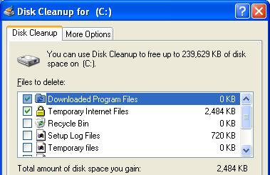
- Before backing up your data, or defragmenting your hard drive, you should use Disk Cleanup to remove unnecessary files.
- Click Start, All Programs, Accessories, System Tools, Disk Cleanup.
- In the Select Drive box, select C:. Click OK.
- A Disk Cleanup for (C:) window opens as shown in to the right on this page. Press Alt+PrtScn to copy the window to the clipboard.
- On the Start menu, click Run. Enter the command mspaint and press the Enter key. Paint opens.

- Press Ctrl+V on the keyboard to paste the image into the Paint window. Save the document in the Shared Documents folder with the filename Your Name Proj 27b. Select a Save as type of JPEG. Close Paint.
- In the Disk Cleanup window, click the More Options tab. Read through the options – you can remove Windows components, Installed Programs, and System Restore points. We don’t want to remove any of those things now.
- In the Disk Cleanup window, click OK.
- In the Are you sure you want to perform these actions box, click Yes. When the wizard is done, your disk is cleaned up.
Defragmenting the N: Drive
- Open My Computer. Right-click the N: drive and select Properties.
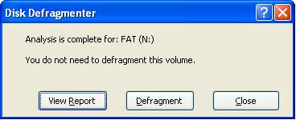
- In the Local Disk (N:) Properties window, click the Tools tab. Click the Defragment Now button.
- In the Disk Defragmenter window, select your N: drive in the upper pane and click the Analyze button. The analysis only takes a second or two, and a little Disk Defragmenter box opens as shown to the right on this page, saying You do not need to defragment this volume. That’s because you have not put any files on the N: drive, so there is no fragmentation.
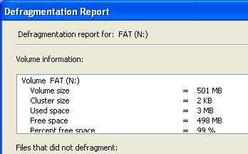
- Even if the Windows says the defragmentation is not needed, you can force a defragment anyway. In the Disk Defragmenter box, click the Defragment button. A box pops up instantly saying Defragmentation is complete. That’s because there was nothing to defragment – defragmenting a drive that is in actual use can take hours. Click the View Report button in the little Disk Defragmenter box.
- A Defragmentation Report window opens as shown to the right on this page.
- Press Alt+PrtScn to copy the window to the clipboard.
- On the Start menu, click Run. Enter the command mspaint and press the Enter key. Paint opens.
- Press Ctrl+V on the keyboard to paste the image into the Paint window. Save the document in the Shared Documents folder with the filename Your Name Proj 27c. Select a Save as type of JPEG. Close Paint.
- In the Defragmentation Report window, click Close. Close the Disk Defragmenter window.

Backing up “My documents and settings”
- Click Start, All Programs, Accessories, System Tools, Backup.
- In the Welcome to the Backup or Restore Wizard screen, click Next.
- In the Backup or Restore screen, accept the default selection of Back up files and settings and click Next.
- In the Want to Back up screen, accept the default selection of My documents and settings and click Next.
- In the Backup Type, Destination, and Name screen, click the Browse button. In the Save As… box, navigate to N:, change the file name to MyDocs, and click Save. In the Backup Type, Destination, and Name screen, click Next.
- In the Completing the Backup or Restore Wizard screen, click Finish.
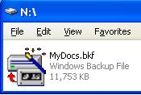
- A Backup Progress box appears, with a green progress indicator. Wait until you see the message The backup is complete. Then click the Report button to see a report. Read through it and close it. Close the Backup Progress window.
- Open My Computer. Double-click the N: drive. You can see the file created by Backup: all your files are contained in the single file MyDocs, as shown to the right on this page.
- Press Alt+PrtScn to copy the window to the clipboard.
- On the Start menu, click Run. Enter the command mspaint and press the Enter key. Paint opens.
- Press Ctrl+V on the keyboard to paste the image into the Paint window. Save the document in the Shared Documents folder with the filename Your Name Proj 27d. Select a Save as type of JPEG. Close Paint.
Turning in your Project
- Email the JPEG images to me as attachments to one e-mail message. Send the message to: cnit.235@gmail.com with a subject line of CNIT 235 Proj 27 From Your Name, replacing Your Name with your own first and last name. Send a Cc to yourself.

Last modified 6-25-06

