This project can be done on any Windows XP Professional computer.
Viewing the System Log
- It would be best to do this on your own computer, if you have one, so you can fix a real problem it has. But if you prefer to use the lab, log onto your virtual machine with your usual account, which has Administrator privileges.
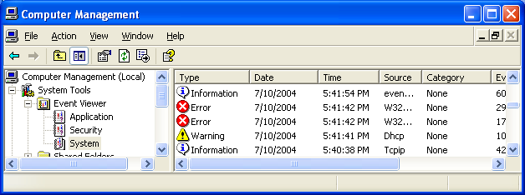
- Click Start, right-click My Computer, and click Manage. In the left pane, make sure System Tools is expanded, and expand Event Viewer. Click System in the left pane. Scroll down and see if you can find examples of the three types of events: Information events with a blue i, Error events with a red X, and Warning events with a yellow triangle and a !, as shown below.
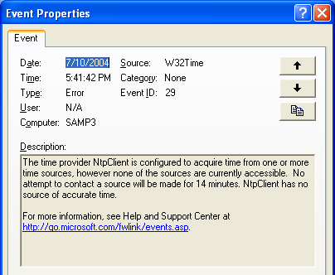
- Choose an interesting event – an Error, if you can find one. Double-click the event to see its details, as shown to the right on this page. Read the details. Find the Event ID number and the Source in the top part of this window and write them in the box below.

Event ID: ______________

Source: ______________

- Press Alt+PrtScn to copy the window to the clipboard.
- On the Start menu, click Run. Enter the command mspaint and press the Enter key. Paint opens.
- Press Ctrl+V on the keyboard to paste the image into the Paint window. Save the document in the Shared Documents folder with the filename Your Name Proj 28a. Select a Save as type of JPEG. Close Paint.
When you need to understand error codes better, there are many ways to learn more: clicking the link in the Event Properties, Eventid.net, and Google.com – search by the Event ID number.
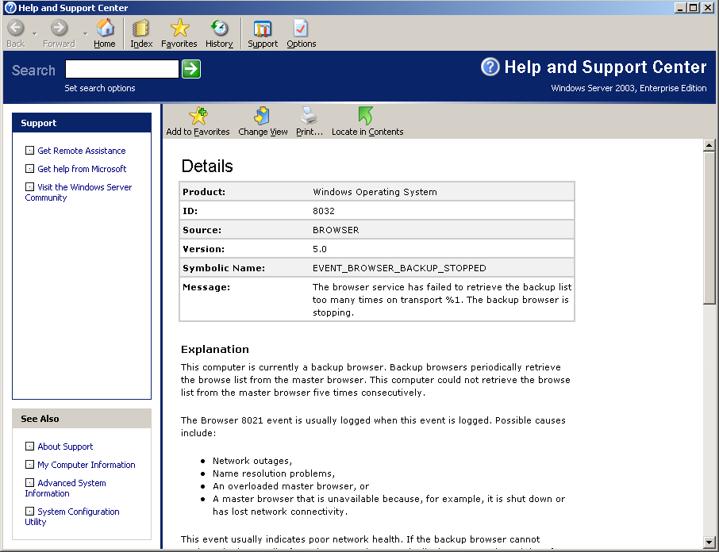
Using Microsoft Help to Learn about Events
- Click the blue link in the Event Properties window. An Event Viewer box opens, saying Event Viewer will send the following information across the Internet. Is this OK? Click Yes.
- Help and Support Center opens, showing information about your event. Read the information and learn as much as you can about your event – don’t just copy the screen, but read it, because part of this project is to explain the meaning of your event in your own words.
- Press Alt+PrtScn to copy the Help and Support Center window to the clipboard.
- On the Start menu, click Run. Enter the command mspaint and press the Enter key. Paint opens.
- Press Ctrl+V on the keyboard to paste the image into the Paint window. Save the document in the Shared Documents folder with the filename Your Name Proj 28b. Select a Save as type of JPEG. Close Paint.
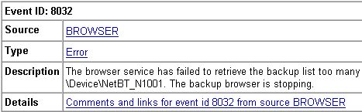
Using Eventid.net Learn about Events
- Open a browser and go to eventid.net. Enter your Event ID in the Event ID box and click the GO button.
- You should see a page with some information about your event, as shown to the right on this page. Make sure you are looking at events with the correct Source. Click the blue link in the Details section to see comments about this event that other users of Eventid.net have posted.

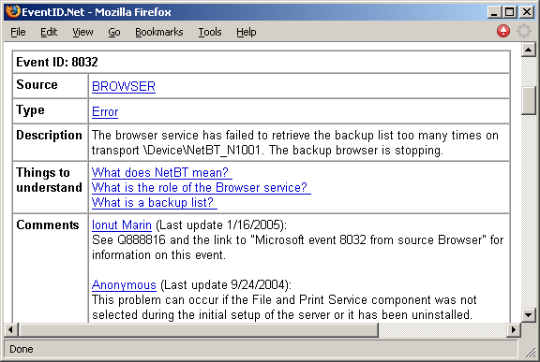
- You should see a page with Things to Understand and Comments about your event, as shown to the right on this page.
- Make sure the Event ID number is visible, and that the Comments section is also visible (at least the start of the first comment). Press Alt+PrtScn to copy the window to the clipboard.

- On the Start menu, click Run. Enter the command mspaint and press the Enter key. Paint opens.
- Press Ctrl+V on the keyboard to paste the image into the Paint window. Save the document in the Shared Documents folder with the filename Your Name Proj 28c. Select a Save as type of JPEG. Close Paint.
Describe The Problem And Solution In Your Own Words
- Based on what you have read, compose a description of the problem and how to solve it, in your own words. If you did not get any help from the sources above, try typing the Event ID into Google.
Turning in your Project
- Email the JPEG images to me as attachments to one e-mail message. Put your description of the problem and how to solve it, in your own words in the body of the email message. Send the message to: cnit.235@gmail.com with a subject line of CNIT 235 Proj 28 From Your Name, replacing Your Name with your own first and last name. Send a Cc to yourself.

Last modified 6-25-06

