Starting Your Computer – Work in the Virtual Machine
- Start your virtual machine, and log in with your usual account, which has Administrative rights.

Setting a Restore Point in the Virtual Machine
- Before doing anything risky with your computer, it is a good idea to create a Restore Point so you can undo changes to your system if you need to. In the Virtual PC, click Start, Help and Support. In Help and Support Center window, in the Pick a Task section, click Undo changes to your computer with System Restore. In the next screen, select Create a Restore Point and click Next. In the next screen enter a Restore Point Description of Your Name Restore Point for Project 29 and click Create.
- When you see the Restore Point Created message, click Close.

Making Changes to the Computer: Desktop and Software Installation
- Now let’s make some changes to this computer to see what System Restore fixes, and what it does not.
- Desktop Background: Right-click the Desktop and select Properties. On the Desktop tab, choose a different Background and click OK.
- Placing a File on the Desktop: Click Start, Run. In the Run box, enter \\192.168.3.1 and press the Enter key. Open the CNIT235 folder. Open the _Software folder and open the Irfanview folder. Drag the iview397 file to your desktop. (If you are working at home, download the file from Irfanview.com.) Then restore the Virtual PC window and drag the iview397 file to the desktop of the virtual PC.
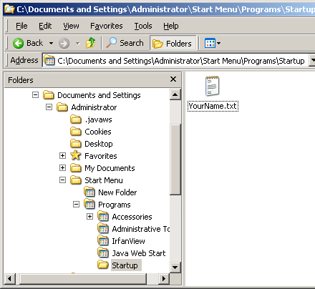
- Installing New Software: On your desktop, double-click the iview397 file. In the Open File—Security Warning box, click Run. This starts an installation process – just accept all the default choices and click Next several times, clicking Done in the last window. This installs a harmless graphics utility on the virtual machine. After the installation is complete, close all windows and then double-click the Irfanview icon on the desktop to make sure Irfanview opens. Close the Irfanview window.
- Placing a File in the Startup Folder: Right-click the Start button and select Explore. A Windows Explorer window opens, showing the contents of the Start Menu folder. Open the Programs folder in the left pane, and click the Startup folder, as shown to the right on this page. Right-click in the right pane and select New, Text Document. Name the new text document with your name. If a Windows AntiSpyware Notice box opens, click Allow.
- Log off and Log in again – notice that the file launches in Notepad when you log in. Items in the Startup folder launch each time you log in.

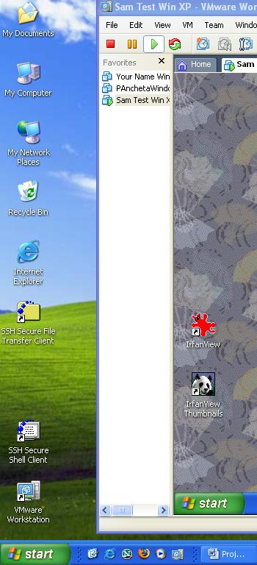
Saving the Screen Image
- Your virtual PC desktop should now show the iview397 file and the IrfanView shortcut, as shown to the right on this page.
- Move the mouse pointer out of the virtual machine window. Click an empty portion of the host Windows XP desktop, so that the virtual machine’s title bar is dimmed.
- Press the PrintScrn key in the upper-right portion of the keyboard. That will copy the whole desktop to the clipboard.
- Click Start, Programs, Accessories, Paint. In the untitled - Paint window, select Edit, Paste from the menu bar. The desktop appears in the Paint window, with only a corner of it visible.
- In the untitled - Paint window, click File, Save. Save the document in the My Pictures folder (or any other place where you can find it, such as a floppy disk) with the filename Your Name Proj 29d. Select a Save as type of JPEG.

Using System Restore
- In the virtual machine, click Start, Help and Support. In Help and Support Center window, in the Pick a Task section, click Undo changes to your computer with System Restore. In the next screen, select Restore my computer to an earlier time and click Next.
- When the Select a Restore Point screen appears, select the restore point with your name on it as below on this page. Press Alt+PrtScn to copy the window to the clipboard.
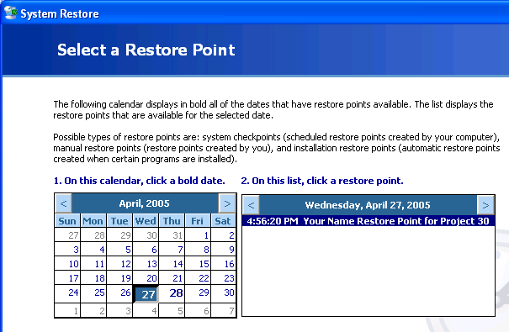

- On the Start menu, click Run. Enter the command mspaint and press the Enter key. Paint opens.
- Press Ctrl+V on the keyboard to paste the image into the Paint window. Save the document in the Shared Documents folder with the filename Your Name Proj 29e . Select a Save as type of JPEG. Close Paint.
- Click Next. Click Next again to perform the System Restore. When you are prompted to restart your virtual machine, do so.
- After the Restoration is complete, examine your machine and answer the following questions.

A: Did System Restore change the desktop background back to its previous setting?

B: Did System Restore remove the iview397 file you placed on the desktop?

C: Did System Restore remove the Irfanview icon from the desktop?

D: Did System Restore remove the file you placed in the Startup folder?

Turning in your Project
- Email the JPEG images to me as attachments to one e-mail message. Answer the questions in the body of the email message. Send the message to: cnit.235@gmail.com with a subject line of CNIT 235 Proj 29 From Your Name, replacing Your Name with your own first and last name. Send a Cc to yourself.

Revised 6-25-06

